Instructions to submit a (LOMA) Letter of Map Amendment
These instructions will allow you to start the process to amend FEMA’s requirement that we have flood insurance for the portions of the Park Meadows community. [Before calling FEMA please do steps 3 and 4 to see if your home was impacted by FEMA’s flood map changes]
- Call: 1-877-336-2627, #3 to connect to FEMA Map Department
- They will instruct you to raise a LOMA to FEMA to start the map revision process to remove your home from FEMA REQUIRED Special Flood Hazard Area which they implemented on November 17th, 2022.
- Go to the following website: https://msc.fema.gov/portal/home
- Type in your address in the “search bar” and click Search.
  - You will see a map like this with your property. Blue = FEMA deemed you as requiring flood insurance. If your property is NOT shaded in blue, no action is required.
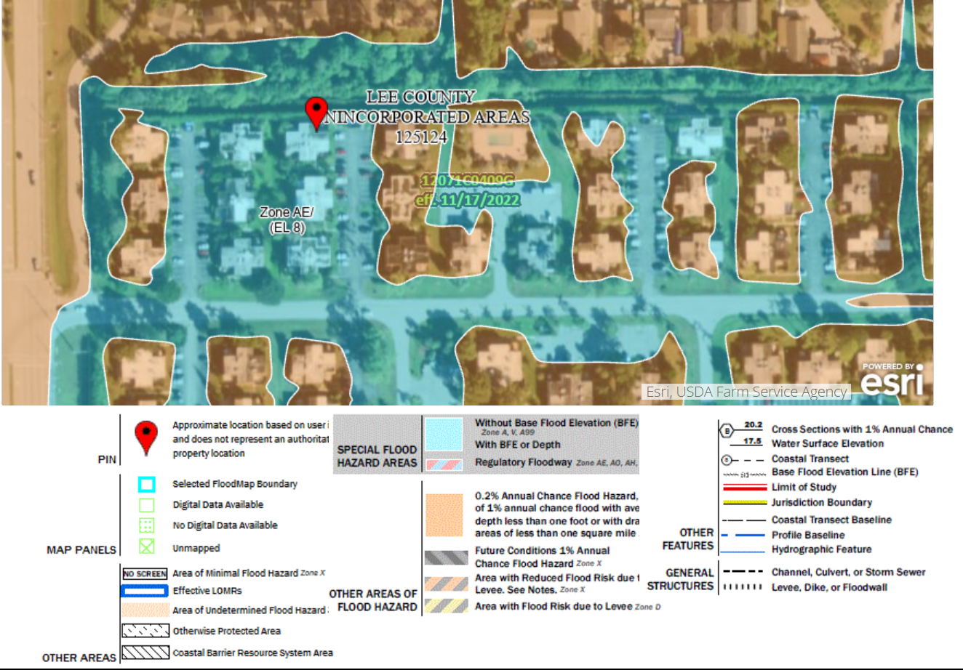
- You will need to gather the following information to submit your LOMA request which can take up to 60 days.
  - Your property Deed (copy) OR Tax Assessors office Map (PLAT Map)
  - You can NOT get your Elevation Certificate from the Lee County recorder’s office because they did not start officially recording them until 1984 and our phase was built in 1980. Lee County did provide a list of surveyors that we can call to get a quote and timing to get an elevation certificate. See the list provided in Appendix A below.
  - Go to: https://hazards.fema.gov/femaportal/onlinelomc/signin
  - Create an account and then start your LOMA/LOMC FEMA flood zone dispute process.
  - You will need your legal property plat name, all forms mentioned here, etc. in order to complete the dispute process.

Lee County surveyors who submit Elevation Certificates and LOMA/LOMR-F
to the County for review

Mark O. Allen, Land Surveyor, (239) 992-8900
Keith Clay, Reliable Land Surveying, (239) 340-3318
Clinton Finstad, F.L.A. Surveys Corp., (239) 250-2792
John B. Harris, Harris Jorgensen, Inc., (239) 772-9939
Judith H. McCarrier, JH McCarrier Land Surveying, Inc., (239) 277-7821
Charles D. Knight, Bean Whitaker Lutz and Kareh, (239) 481-1331
Thomas or John Rhodes, Rhodes and Rhodes Surveying, (239) 405-8166
Ron or Jim Starnes, Starnes Surveying, (239) 543-3335
Scott Whitaker, Bean Whitaker Lutz and Kareh, (239) 481-1331
Kenny Pufahl, KP Surveying, Inc., (239) 462-1901

