George Rodman
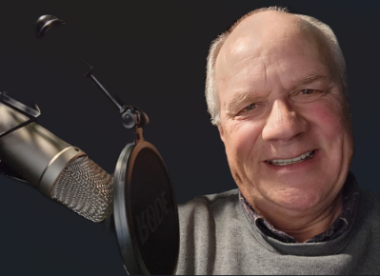
Voiceover Actor
Glenville, Pennsylvania

I provide studio quality voiceovers delivered on-time and on budget. To hear what your next voice over project can sound like, please take a quick listen to the demos on my website.
Services include:
- Radio/TV Commercials
- Movie/TV Trailers
- Phone Systems/ Voicemail Greetings
- YouTube Video Narration
- Explainer Videos/ Corporate Presentations
- e-Learning Voiceover
- Cartoons & Video Games
- Kiosk & In-Store Announcements
- App Voiceover
- Character Voices
- Virtual Reality Experiences
Voiceover Credits

- Theater: “ALL THINGS EQUAL The Life and Trials of Ruth Bader Ginsburg”
  - Voice of Chief Justice Warren Burger
  - https://www.scottstander.com/rbg.html
  - Casting Director: Mark Paladini - http://www.markpaladini.com/

- Documentary: “Eyewitness WWII: Invasion Italy” - National Geographic TV (non US release) and “Forgotten Front: The Invasion of Italy” on Fox Nation (streaming)

  - Voice of Lt. General Lucian Truscott
  - https://www.redafilms.com/
  - Director: Marc Reda
  - IMDB Page

- Animation: “Captain New York”
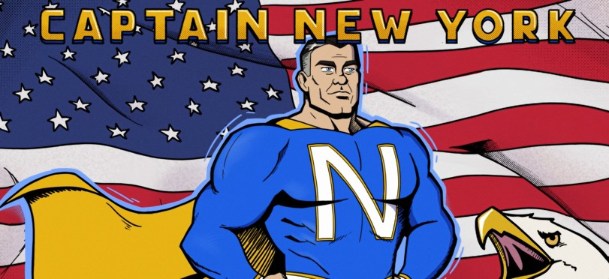

  - Voice of Captain New York
  - Voice of the President
  - https://www.mediadiffusion.eu/
  - End of Multimedia studies for Belgium students.
  - YouTube Link

- Commercial: “Already Done” PSA for Montana DMV

  - Announcer
  - Cleverly Company - https://www.thecleverlycompany.com/
  - Director: Dillon Davies
  - YoutTube Link

- Commercial: Preserving Your True Wealth With CIMB Private Wealth

  - Announcer/Narrator
  - Director: Yuhyi Lestari
www.yuhyilestari.com
  - YouTube Link

- Commercial: What Does It Mean To Build True Wealth?
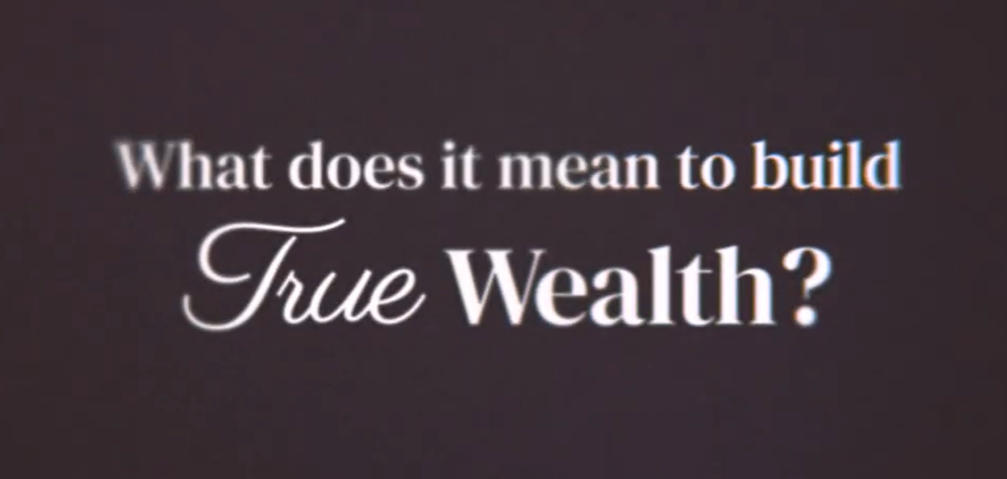
  - Announcer/Narrator
  - Director: Yuhyi Lestari
www.yuhyilestari.com
  - YouTube Link

- Short Film: “Unfrozen”
  - Voice of Jack
  - Hustle Up Productions
  - Director: Jyrki Mäkelä
  - IMDB Page

- Audio Drama: Ayn Rand’s “The Fountain Head”
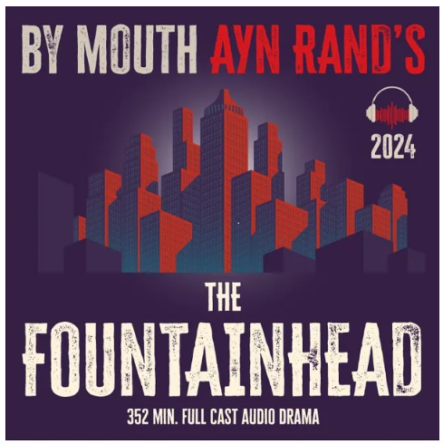
  - https://bymouth.org/thefountainhead
  - Mr. Sanborn
  - Board Member #3
  - Policeman
  - Client #2
  - Director: Martin Garrison
- Audio Drama: Eugene O’Neills “The Iceman Cometh”
  - https://bymouth.org/icemancometh
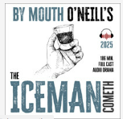
  - Detective#2
  - Director: Martin Garrison

- Downloadable Audio Tour: LaGrange Audio Tour
  - Charlie
  - https://www.bigideacompany.com/
  - Casting: Jill Klinedinst, Vice President

- Video Game: Soviet Soldier

  - Voice of KGB Agent
  - Go Up Gaming
  - Casting: Joseph Gaupp, Sole Developer
  - Steam Platform Link
  - YouTube Link

- Biltmore House English Audio Tour

  - Voice of Richard Moris Hunt, Architect
  - Voice of Frederick Law Olmstead, Landscape Architect
  - Voice of Colonel Joseph Hyde Pratt, Professor and Geologist
  - Q Media Productions
  - Casting: Stashia Boyd, President and Creative Director
Mike Lutz, Vice-President & Technical Director
  - Biltmore.com
  - YouTube Link

- Commercial: Elevated Managed Print

  - Narrator
  - Link
  - Prestwich Films
  - Casting: Sophia & Israel Prestwich

- Radioactive Man | Issue 1 | Dr. Crab's Commie Comics
  - Voice of Committee Member 1 (16:42)
    - “That’s enough evidence for me”

- ACX/Amazon Audio Books – Narrator
  - Vanished in Nashville – by Sammi Starlight
Recording Studio
Home recording studio is an isolated room with acoustic wall panels and ceiling tiles.
- Microphone: 5th Generation RODE NT with Pop filter
- Audio Interface & Software: VOLT 1 / Audacity
- Music: Licensed user of Soundstripe https://app.soundstripe.com/ and can add background music of your choice.
Work History
- Over four decades in the financial industry as a Financial Advisor, Qualified Plan Specialist and Director of Broker Dealer Services for a FinTech Company. This included hundreds of public speaking engagements and product/training demonstrations.
- Eleven years in the Army National Guard, including six years as a TAC Officer (Drill Instructor) for the Pennsylvania Army National Guard Officer Candidate School (think a combination of Lou Gossett Sr. in “An Officer and a Gentlemen” and R. Lee Ermey in “Full Metal Jacket”.
Hobbies/Special Interests
- Cross Country Motorcycle Touring, Motorcycle Safety Instructor for Pennsylvania, Downhill Skiing, Craftsman/Woodworking Home Improvement

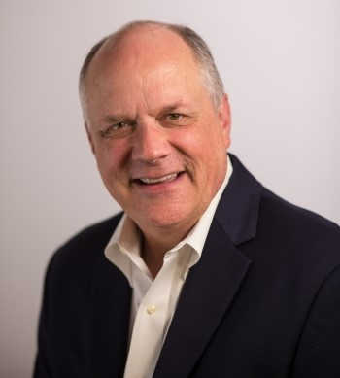

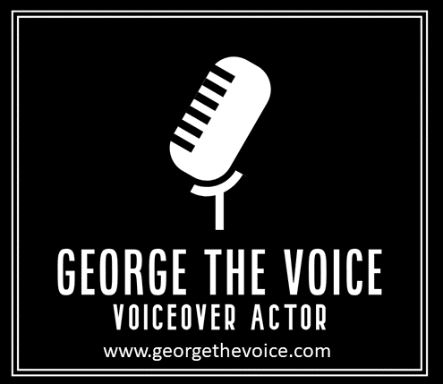

Links
BACKSTAGE
IMDB
Instagram
Voices.com
Voices123
VOPlanet

WWW.GEORGETHEVOICE.COM

