Title of the presentation (no more than two lines)

John Smith¹, Michael King¹, Laura Adams²(underline on the presenting author)
¹Affiliation, Email: j.smith@univ.edu, m.king@univ.edu
²Affiliation: Email: l.adams@lab.com

ABSTRACT
The abstract should include the motivation of the work, a problem statement, the approach and methodology and a summary of the main findings.One page maximum.
The final abstract must be converted to a pdf document and submitted through http://web.address.tbd, following the instructions given there, by the abstract submission deadline. The file name should have the following pattern: Lastname of presenting author_njams.pdf. (Example: smith_njams.pdf)
Prepare your one-page extended abstract on a Letter size paper 8 1/2" x 11". In formatting your paper, it is best to simply use this template.Use the Times New Roman font and try to follow the font sizes specified in Table 1. Use the margin of this template (top margin: 0.85”, bottom margin: 1.25”, left and right margins: 0.9”). The column width is 3.22 inches with 0.3 inches space between the two columns.You should left- and right- justify your columns. Please do not number this page.
You can include at most 1 figure and 1 table as needed. Figure caption should be below the figure; table caption should be above the table.
The papers in the reference list must be cited in the text. In the text, the citation should appear in square brackets [1]. In the Reference list, the font should be Times New Roman with 10 point size. The Author name list should be terminated by a comma. The citation number should be enclosed in brackets.

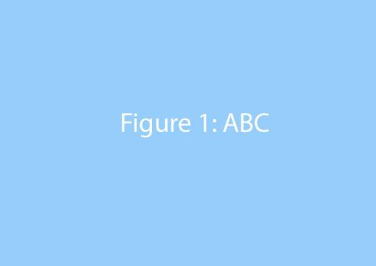
Figure 1: ABC

Table 1: Font Styles for Print-Ready Paper
Size | Bold | Italic | Text Type (example)
16 | Yes |  | Paper Title
12 |  |  | Authors’List
11 |  | Yes | Affiliation
11 |  |  | Main Text
10 |  |  | Reference

ACKNOWLEDGEMENTS
Add appropriate acknowledgements as needed.

REFERENCES
- Smith, J., King, M, and Adams, L. “Title of the Article,” Reference Information such as Journal or Conference Proceedings, Vol. X, pp. 0000-1111, 2013.

