The Cuban Connection

Friend Days

Thank you Daryl Varble, Kelly LaBlanc, Jerry Gifford, Matt Morse, Mike Stacey, Mark Partin, Mike Bradey and Tony Brown. These pastors have preached the word at Friend Days. This promotion is used to encourage church members to invite unsaved family and friends. At the end of the service we provide a snack and beverage. The response has been overwelming. Churches have been full with people standing in the streets. We have had 16 Friend Days with 165 professions of faith. All evangelistic services have resulted in over 300 professions of faith. New believers attend 12 disipleship classes, then will be baptized.

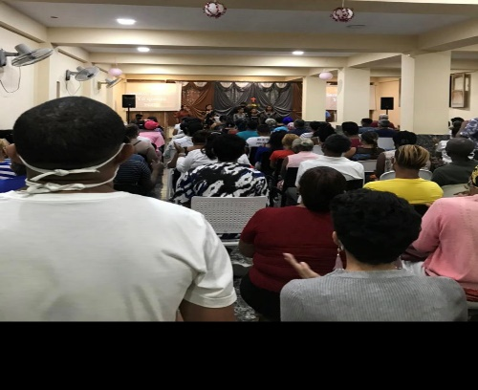

Praises:

1. Covid testing and vaccinations no longer required to enter Cuba.
2. Building dedication at River of God. It is the first church building in 60 years to have government approval to build from the ground up.
3. Building dedication for a mission of 8th Baptist in Santiago.
4. Three successful Pastors/Wives Conferences where we can bring spiritual encouragement and fellowship as will as medicines, personal hygiene items and clothing.
5. New opportunity to expand ministry into Manzanillo, a city with a population of 130,000.

Prayer requests:

1. Travel-flights to eastern Cuba would be available at a reasonable cost.
2. God to grow the number of churches and individual who will partner with us to support national pastors.
3. God would send mission team members willing to travel in August and November.
4. Physical needs of the Cuban people, food and medicine shortages continue. Now there are rolling black outs also.
5. Spiritual strength, guidance and comfort for Cuban Christians.

WE ARE: [WWW.CUBANCONNECTION.LIVE](http://WWW.CUBANCONNECTION.LIVE)

Phone: 270-403-7898

Our sending church can be found at: [www.freedomchurch.us](http://www.freedomchurch.us) and the place where you can give online TO:

Great commission ministries