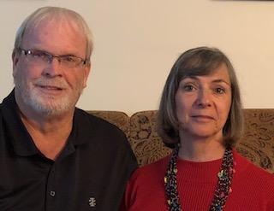The Cuban Connection

Cuba remains closed for the time being. We are looking forward to going late summer and early fall. According to the news, the vaccine will roll out in Cuba starting in June. By the middle of July many will have taken the vaccine and teams should be able to resume. Contact us at: 270-403-7898 or [www.Cubanconnection.live](http://www.Cubanconnection.live)

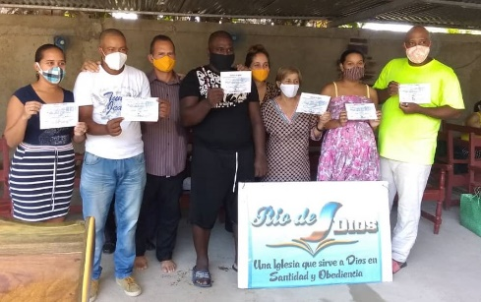There has been reported across Cuba of churches experiencing multiple baptism. Many churches are recording as many as 20-30 being baptized quarterly. God is moving during the pandemic while churches remain closed. Many churches are open for prayer every morning. Pastors greet the people with a smile and the hope of Jesus Christ. Many small discipleship classes have been formed to accommodate the people. God is utterly amazing. If you would like to support a pastor and a church contact us at: [www.cubanconnection.live](http://www.cubanconnection.live) or 270-403-7898.

During March and April, I had the privilege of hosting one of our pastors from Cuba. Julio Machado traveled to the United States January of 2020 and was stranded here. God was able to use him to tell the story of God’s care and provision in Cuba. Using ZOOM, Allan Morales was able to interpret from Cuba. While Julio was in Kentucky, I took him to the Ark Encounter. If you cannot go, will you help by sending? Contact us at: [www.cubanconnection.live](http://www.cubanconnection.live) or by phone: 270-403-7898

The ministry to pastors’ wives has continued via long distance. Marian is a part of a group from Santiago on WhatsApp. A daily devotion is shared, prayer requests are given and stickers and songs of encouragement are posted. The group recently completed 12 hours of continuous prayer. Praying for churches, families, the pandemic and our countries. God will answer in a powerful way.

WE ARE: [WWW.CUBANCONNECTION.LIVE](http://WWW.CUBANCONNECTION.LIVE)

Phone: 270-403-7898

Our sending church can be found at: [www.freedomchurch.us](http://www.freedomchurch.us) where you can give online TO:

Great commission ministries