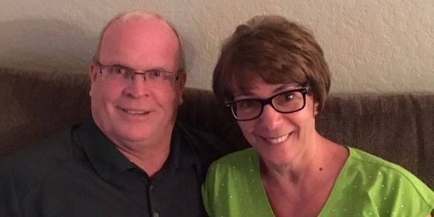
The Cuban Connection
As the year 2021 winds down, covid 19 continues to impact missions around the word. But, there is hope around the corner. We hear of reports throughout the country that Missionaries are reaching their destinations. Marian & I have tickets for January and are bound for Cuba. We are presently preparing our bags and have made plans to meet our brothers and sisters in Santiago de Cuba. There are many needs and, in time, we plan to help all those who need both spiritual and physical healing. We are told that medicians are welcomed, without added expense from the government. If you would like to send needed supplies please Contact us at: 270-403-7898 or email us at: thecubanconnectiongcm@gmail.com
Larry & Marian Frisby
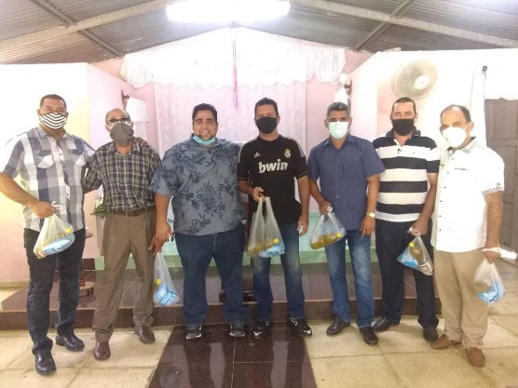
This picture represents the many Cuban Pastor Families Great Commission Ministries have helped over past year. This ministry has sent thousands of dollars to help feed those who would have gone without food. We need to say thank you to all our supporters who have assisted us in this effort. Many tears were shed as they received your gift of love and hope. There are many that we were not able to help but we thank God for those we were able to reach in this effort. If you would like to assist us in this effort of feeding pastors and their families, please contact us: 270-403-7898 and leave a message. We are a ministry of: www.freedomchurch.us

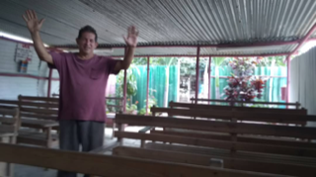
People have asked if we are able to assist churches in needs other than food and medicine. Simply put, the answer is yes. This church needed a new roof and we were able to send the needed resources to buy this roof. Many people/churches are interested in construction projects as well as VBS and evangelism outreach. Let us assist you in planning your next international mission trip. While many countries are still recovering from the COVID crisis, still they maintain a limited number of visitors through mission organizations. As this continues to get better for our world, we should remember Jesus said, “Go into all the world and preach the Gospel”. Yes, that is still our mandate and I pray we never forget that Jesus is still our GREATEST NEED.

WE ARE: WWW.CUBANCONNECTION.LIVE
Phone: 270-403-7898
Our sending church can be found at: www.freedomchurch.us and the place where you can give online TO:
Great commission ministries

