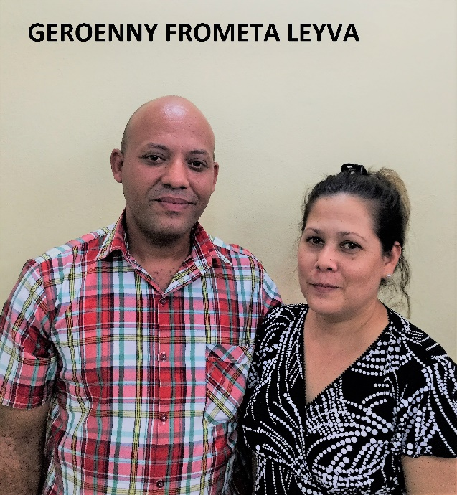
Full name: Geroenny Frometa Leyva (SUPPORTED)
Church and location: 3rd Baptist Church in Bayamo
Email address: geroenny@nauta.cu
Telephone number: mobile: +53 5 4678454 / home: +53 23484062
Average attendance of the church: 105 Adults: 70 children: 35
Average monthly offering: 4,500.00 - $180.00 USD
What are the five major needs in your church?
- Construction of Sunday school classrooms youth.
- To give a better care to the needy people of the church
and to senior adults
- A water filter unit to provide drinking water for the church
and community
- Musical instruments (guitar)
- A tricycle (taxi) for the transportation of those in need

What are the five major needs of your family?
How many in your family? 2
- A motorcycle for my family transportation
- Kitchen appliances
- Electric fans
- Shoes 41 (European size) man’s trousers size 36

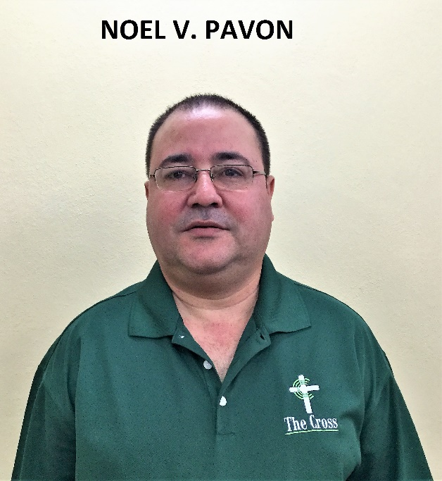
Full name: Noel V. Pavon Nieto (SUPPORTED)
Church and location: First Baptist Church in Bsayamo
Email address: noel76@nauta.cu
Telephone number: mobile: +53 53979856
Average attendance of the church: 700 Adults: 600 children: 100
Average monthly offering: 2,500.00 - $100.00 USD
What are the five major needs of your church?
- Financial support for the missionaries (mission churches)
- Audio and music equipment
- Build up facilities in the mission churches
- Support for the children ministry
- Support for the leadership of the church
What are the five major needs of your family?
How many in your family? 2 I don’t have children
- My wife’s health is not in good shape
- Financial needs
- A means of transportation
- A home for retirement one day

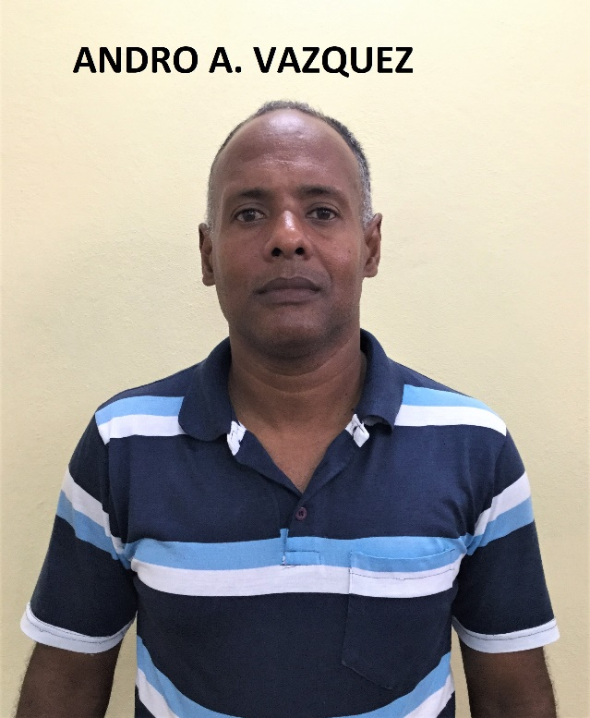
Full name: Andro Alfredo Vazquez Dieguez
Church and location: 4th Baptist Church in Bayamo
Email address: androalfredo@nauta.cu
Telephone number: mobile: +53 5 55345616
Average attendance of the church:71 Adults: 55 Children: 15
Average monthly offering: 460.00 - $18.40 USD
Which are the five major needs in your church?
- Building of the parsonage
- Building of the temple
- Audio equipment
- Electric fans
- Benches and chairs

Which are the five major needs of your family?
How many in your family? 5
- A refrigerator
- A washing machine
- A blender
- A motor scooter
- Clothes and shoes for my family

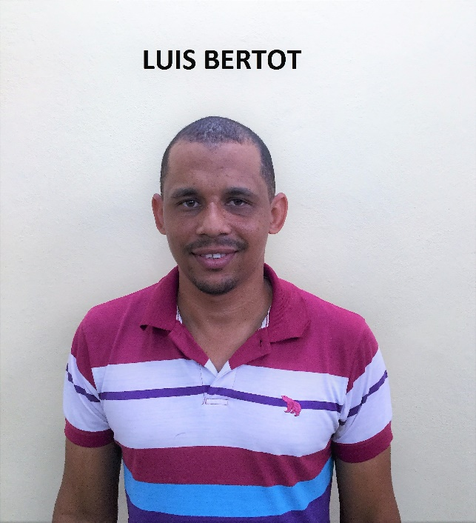
Full name: Luis Bertot Mena
Church and location: El Dorado (ISCAB) Bayamo
Email address: luisbertot@nauta.cu
Telephone number: mobile: +53 58401655
Average attendance of the church: 96 Adults: 67 Children: 53
Average monthly offering: 2,000.00 - $80.00 USD
What are the five major needs in your church?
- Classrooms for Sunday School
- Kitchen and dining room
- A projector
- A computer and printer
- An audio console of 12 channels or more

What are the five major needs of your family?
How many in your family? 3
- A house
- A bicycle or motor scooter
- Clothes and shoes

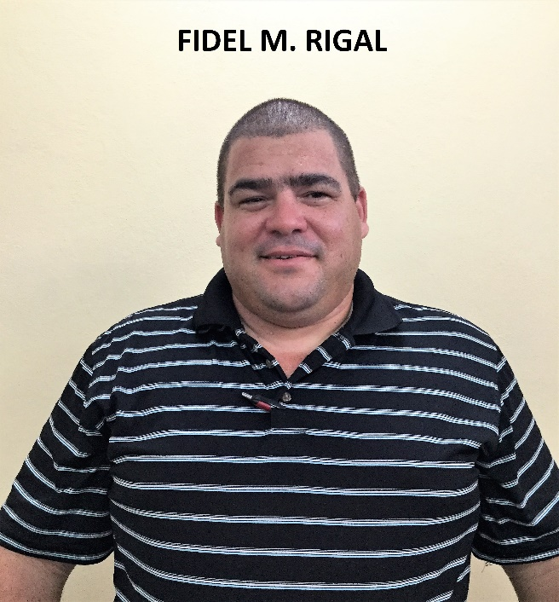
Full name: Fidel Manuel Rigal Frias (SUPPORTRD)
Church and location: El Almirante, Bayamo
Email address: pastorfidel81@gmail.com
Telephone number: mobile: +53 54276227
Average attendance of the church: 90 Adults: 70 Children: 20
Average monthly offering: 3,000.00 - $120.00 USD
What are the five major needs in your church?
- Support for mission churches
- Building project
- Building project in missions of the church
- Resources for the printing of discipleship tracts
- Prayer for us

Which are the five major needs of your family?
How many on your family? 4
- Have a house for my family

- A means of transportation
- Improve the condition of life for my wife in our home
- Improve the finances for the bare needs of the family
- Be able to support my son in his studies

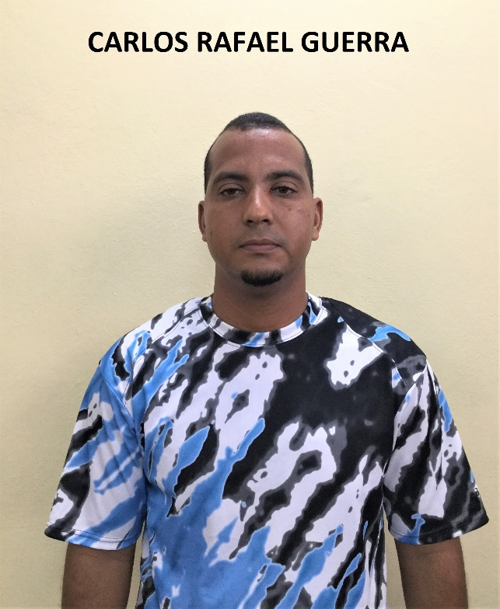
Full name: Carlos Rafael Guerra Fonseca (SUPPORTED)
Church and location: Baptist Church Ebenezer. La Pedrera. Bayamo
Email address: cadjef@nauta.cu
Telephone number: mobile: +53 58584321
Average attendance to the church: 125 Adults: 80 children: 45
Average monthly offering: 3,500.00 - $140.00 USD
What are the five major needs in your church?
- Reparation of the parsonage
- Construction of the temple
- Construction of a children’s classroom
- Construction of bathrooms
- Audio equipment

What are the five major needs of your family?
How many in your family? 5
- A refrigerator
- A motor scooter
- A TV set
- A blender
- A washing machine

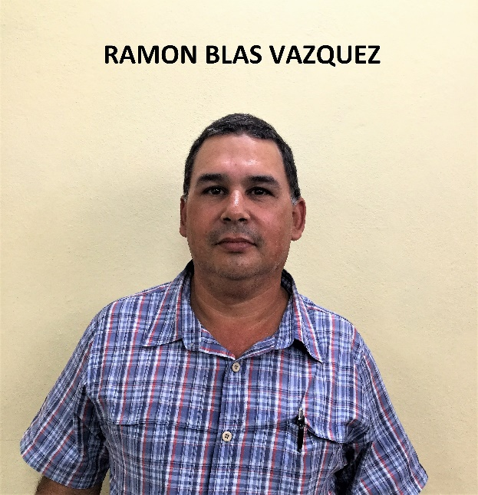
Full name: Ramon Blas Vazquez Martinez
Church and location: 11th Baptist Church in Bayamo
Email address: ramonblas@nauta.com.cu
Telephone number: Mobile: +53 52065841
Average attendance of the church: 49 Adults: 30 Children: 19
Average monthly offering: 1,040.00 - $41.60 USD
What are the five major needs of your church?
- We don’t have a facility of our own as a church. We are
meeting in the living room of a sister’s house
- We don’t have a parsonage. We are living in a rented house
which is 8.00 CUC monthly
- The children of all ages meet in the living room of my home
- We need support financially for the work of the church.
- We need benches, piano, audio equipment and freezer

What are the five major needs of your family?
How many in your family? 2
- A bicycle
- A double size bed (Full)
- Kitchen appliances
- Antacid medication
- Dishes, glasses, electric fan, bed linen, sport shoes (41) European size

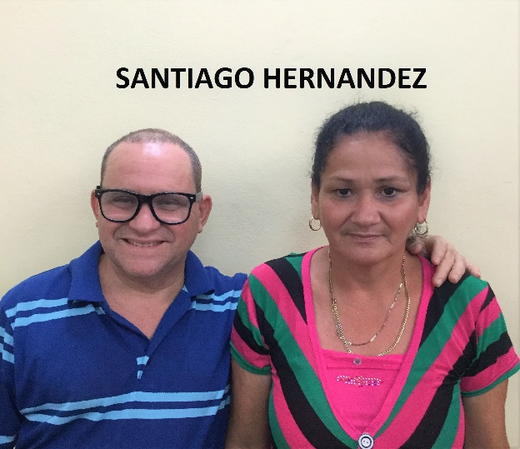
Full name: Santiago Hernadez Asencio
Church and location: 5th Baptist Church in Bayamo
Email address: -
Telephone number: mobile: +53 53971933 / home: +53 23439660
Average attendance to the church:150 Adults: 100 Children: 50
Average monthly offering: 1,500.00 - $60.00 USD
What are the five major needs of your church?
- Audio equipment
- A piano.
- Chairs for the children
- Rebuild the roof of the temple
- Repairs for the church

What are the five major needs of your family?
How many in your family? 3
- A computer
- Construction of a bathroom
- A tricycle (bici-taxi)
- A washing machine
- An electric fan

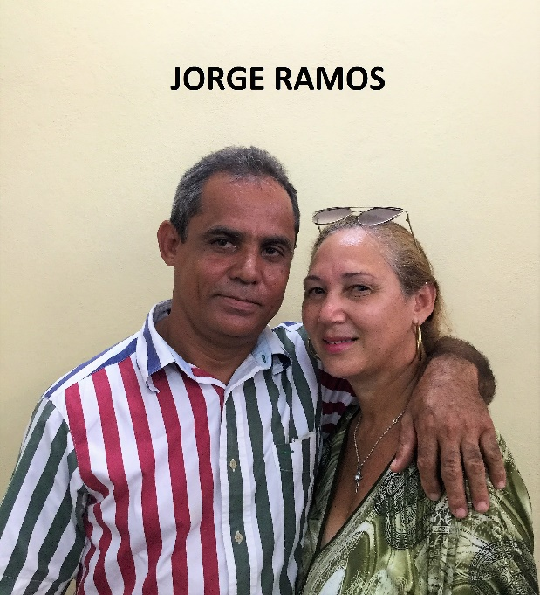
Full name: Jorge Ramos Martinez (SUPPORTED)
Church and location: Baptist Church in Guasimilla. Bayamo
Email address: ir.ma@nauta.cu
Telephone number: mobile: +53 58163635
Average attendance of the church: 68 Adults: 50 Children: 18
Average monthly offering: 1,700.00 - $68.00 USD
What are the five major needs of your church?
- Finish the construction of the temple. Cross Beams Level
- Reparation of the parsonage, which is in a bad shape
- Musical instruments
- Benches. the ones we have now are in bad shape
- Electric fans

What are the five major needs of your family?
How many in your family? 2

- A washing machine
- Kitchen appliances ( a rice cooker)
- Electric fans
- An iron
- A water filter unit

