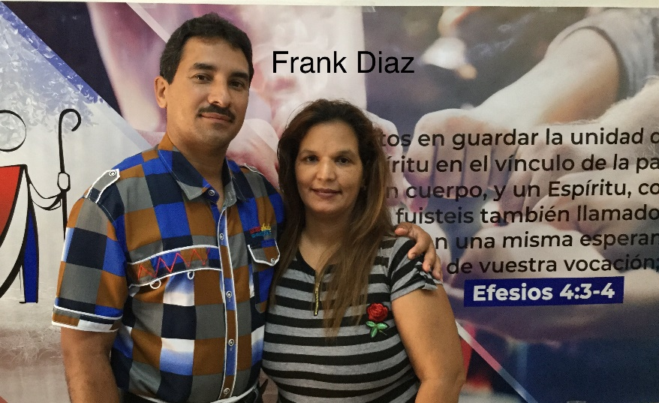
Full Name: Frank Diaz Carbó
Church and location: 5th Baptist Church in “Eben-ezer”. Guantanamo.
Email address: fdk@nauta.cu
Average attendance of the church: 140 adults: 95 children: 45
Average monthly offering: $208.00 USD
What are the five major needs in your church?
- Construction of a building in our lot
- A projector with the singing of the hymns.
- An audio system, including microphones
- Musical instruments
- A computer
What are the five major needs of your family?
How many in your family? 5
- A washing machine
- Rice cooker of multiple use, pots to cook, a coffee maker, a frying pan, a microwave
- Two fans and some help to upholster the furniture
- A laptop for my daughters to study
- Financial help to finish repair a motor cycle.

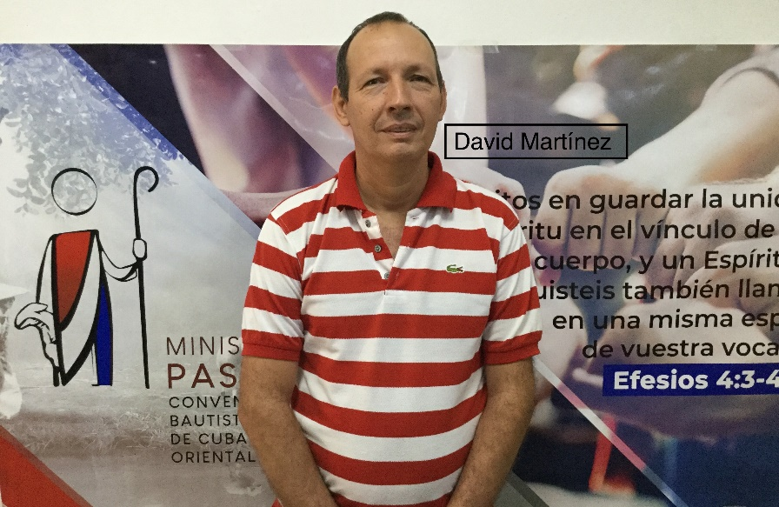
Full Name: David Martinez Gonzalez
Church and location: Baptist Church in Imias. Guantanamo
Email address: davidmg05@nauta.cu
Average attendance of the church: 200 adults: 150 children: 50
Average monthly offering: $145.00 US
What are the five major needs in your church?
- Sound system
- A laptop and a projector
- 3 or 4 new microphones
- Benches for our classrooms
- A freezer and 3 bicycles for three
Missionaries
What are the five major needs of your family?
How many in your family? 4
- I am 52 years old, in just 8 years I will be retiring and have no house of my own to live after getting retired
- A refrigerator. Ours is deteriorated having using it in the church
- A personal computer
- A bicycle for my wife. When visiting we use mine. Three of the family use it and it is difficult
- A mattress (twin bed)

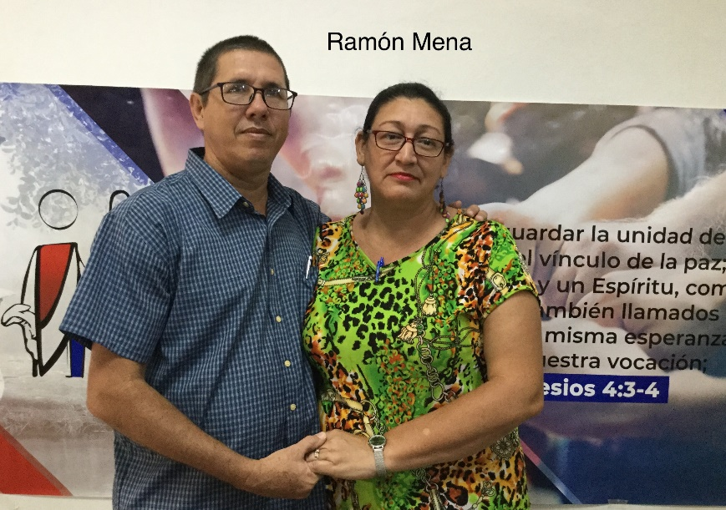
Full Name: Ramon Mena Reyes
Church and location: 4th Baptist Church “Bet-el. Reparto Obrero. Guantanamo
Email address: menareyesramon86@gmail.com
Average attendance of the church: 97 adults: 70 children: 17
Average monthly offering: $120.00 US
What are the five major needs in your church?
- Finish the construction of our church,
which is already started
- Build the parsonage.
- Technological classroom
- Audio system and music player for the church
- Fans or air conditioner for the temple
What are the five major needs of your family?
How many in your family? 6
- General reparation of our own house it doesn’t have the essential in order to be inhabitable
- Cellphone for my wife
- Refrigerator (the one we have now is not our own)
- Motor scooter
- Air conditioner

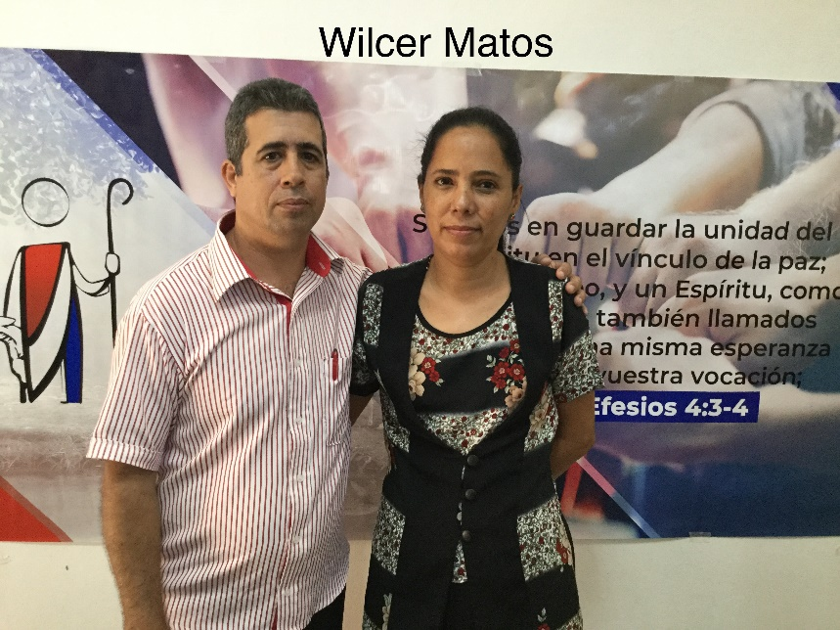
Full Name: Wilcer Matos Hernandez (SUPPORTED)
Church and location: Baptist Church of Jamaica. 367, Jose Faisan street. Guantanamo
Email address: wilcer@nauta.cu
Average attendance to the church: 60 adults: 40 children: 20
Average monthly offering: $104.00 US
What are the five major needs in your church?
- Build a classroom and a bedroom
- A freezer.
- An electric set of drums
- A projector
- An audio system
What are the five major needs of your family?
How many in your family? 4
- A washing machine (my wife suffers from neuropathy)
- A house of our own
- A bed with a mattress
- A computer to better up the work
- A cellphone

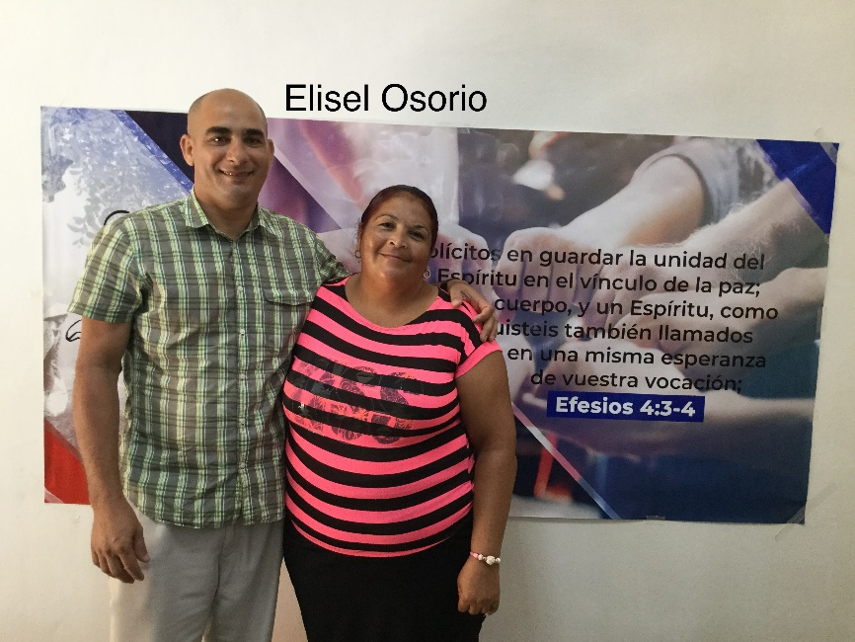
Full Name: Elisel Osorio Osorio
Church and location: 7th Baptist Church in Guantanamo. Barrio Luis Raposo
Email address: elisel78@nauta.cu
Average attendance to the church: 70 adults: 54 children: 16
Average monthly offering: $37.50
What are the five major needs in your church?
- Bibles
- Study materials for the different ages.
- We don’t have a temple where to meet,
we are meeting in small house
- Audio system and music player
- Electric fans

What are the five major needs of your family?
How many in your family? 3
- We need a house of our own.
- A bed
- A tv set
- A dining room set (four chairs and a table)
- A computer to do all the work

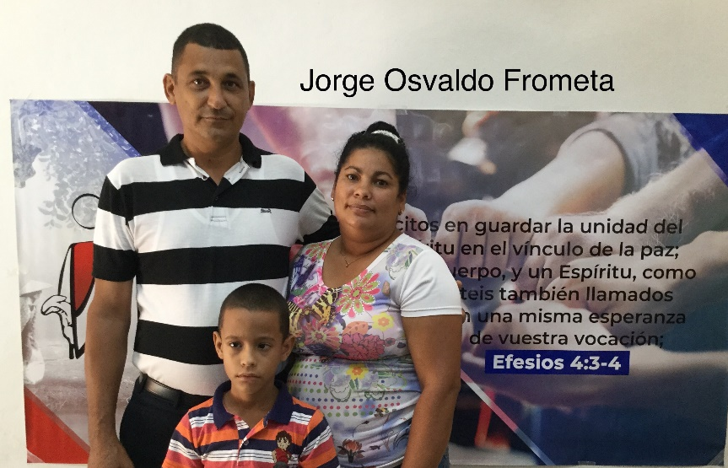
Full Name: Jorge Osvaldo Frometa Arguelles
Church and location: Emanuel Baptist Church. Costa Rica. Guantanamo
Email address: jorgeosvaldo70@nauta.cu
Average attendance to the church: 75 adults: 60 children: 20
Average monthly offering: $33.50 US
What are the five major needs in your church?
- An audio system, a projector
- Finish the concrete roof of the parsonage
- Materials to work with children and create
a classroom with the conditions needed for
Sunday school
- Musical instruments
- Buy a house for a mission field where we have 20 people between adults and children
What are the five major needs of your family?
How many in your family? 3
- A TV set for our son
- A mattress
- Kitchen goods, including a water filter and an electric fan
- Bed sheets and towels and shoes
- Prayer, for a transportation in order to visit

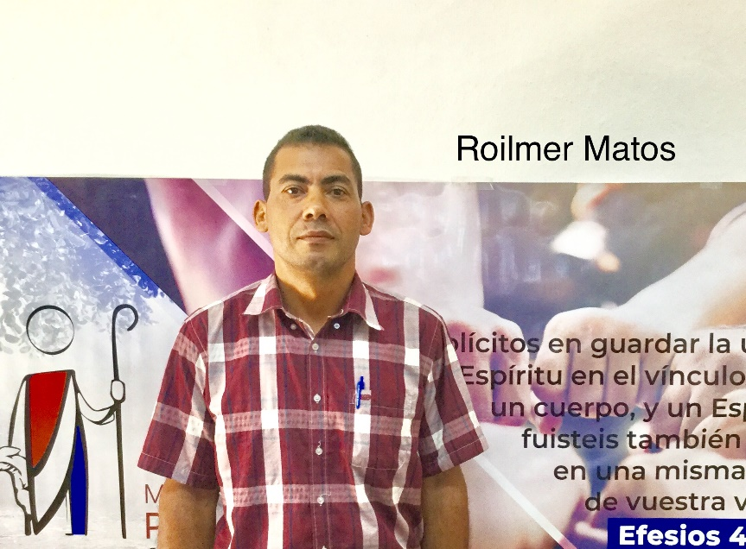
Full Name: Roilmer Matos Rodriguez
Church and location: Baptist Church in San Antonio del Sur. El Corojo. Guantanamo
Email address: -
Average attendance to the church: 120 adults: 90 children: 30
Average monthly offering: $159.00 US
What are the five major needs in your church?
- Finances to build the temple
- Finances to build the parsonage
- An audio system (amplifier, speakers and
console
- Classrooms for the children
- Financial support for the ministry with the
senior adults
What are the five major needs of your family?
How many in your family? 4
- Finances to build or buy a house of our own for the retirement
- A bicycle for my daughter who studies far from home
- A computer
- Bed and mattresses
- Sun screen for my wife who suffers with skin cancer

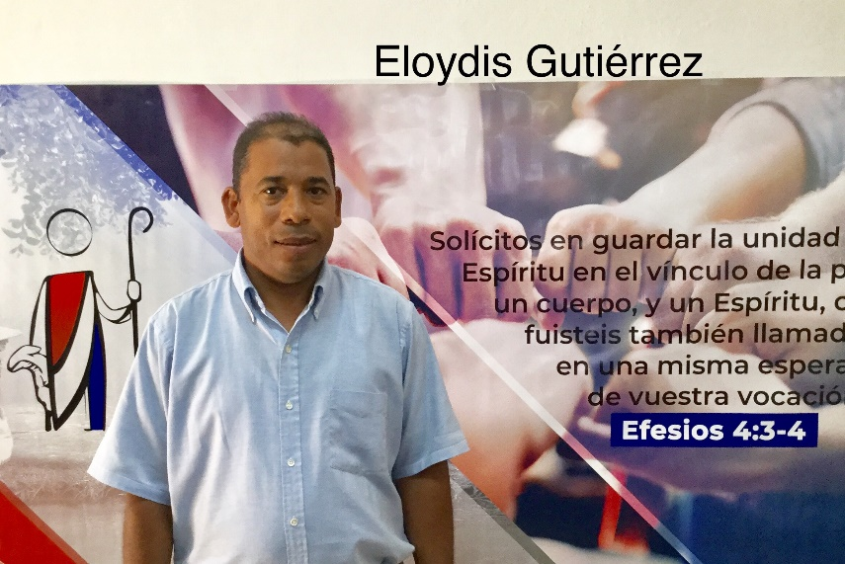
Full Name: Eloydis Gutierrez Mendez
Church and location: Baptist Church in Felicidad de Yateras. Guantanamo.
Email address: egutierrez77@nauta.cu
Average attendance to the church: 70 adults: 60 children: 16
Average monthly offering: $62.50 US
What are the five major needs in your church?
- Acquire a place for the meetings of the
church, the one we have is deteriorated
- Buy a parsonage, since the one we are
living is borrowed
- Bibles and materials for the children
- A freezer
- Musical instruments as drums. An audio system with microphones
What are the five major needs of your family?
How many in your family? 2
- A house of our own
- A mattress
- A refrigerator, a washing machine and a TV set
- A computer in order to finish the master’s degree
- Living-room set

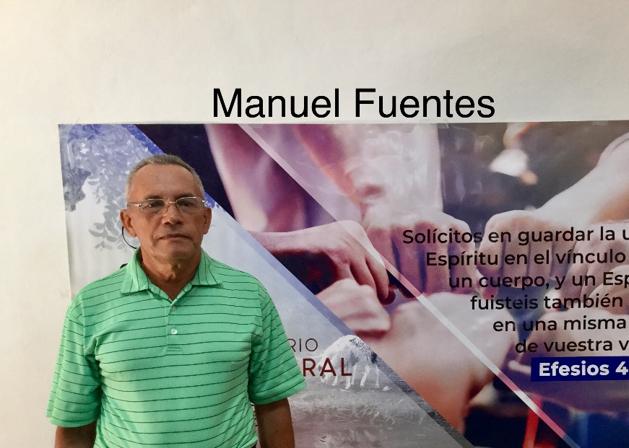
Full Name: Manuel Fuentes Tamayo
Church and location: II Baptist in San Antonio del Sur. Guantanamo
Email address: -
Average attendance to the church: 80 adults: 50 children: 30
Average monthly offering: $83.00 US
What are the five major needs in your church?
- Build up a temple (Ours has a thatch roof
without walls)
- A computer and amplifier (audio system)
- Music player (we have a small piano
“keyboard”
- Finish the bathroom (80% completed)
- Build a bedroom off the parsonage with a concrete roof to work as a shelter during hurricane time.
What are the five major needs of your family?
How many in your family? 3
- Build my house or finish its construction it was totally damaged by hurricane Matthew
- A washing machine
- An electrical fan
NOTE: finishing my house is my greatest need since I will be 65 years soon and I don’t have where to live if I get retired this year. I will turn 65 in June this year. I just have the foundation of the house, and have the 80% of the materials. The greatest need is the finances to finish it.

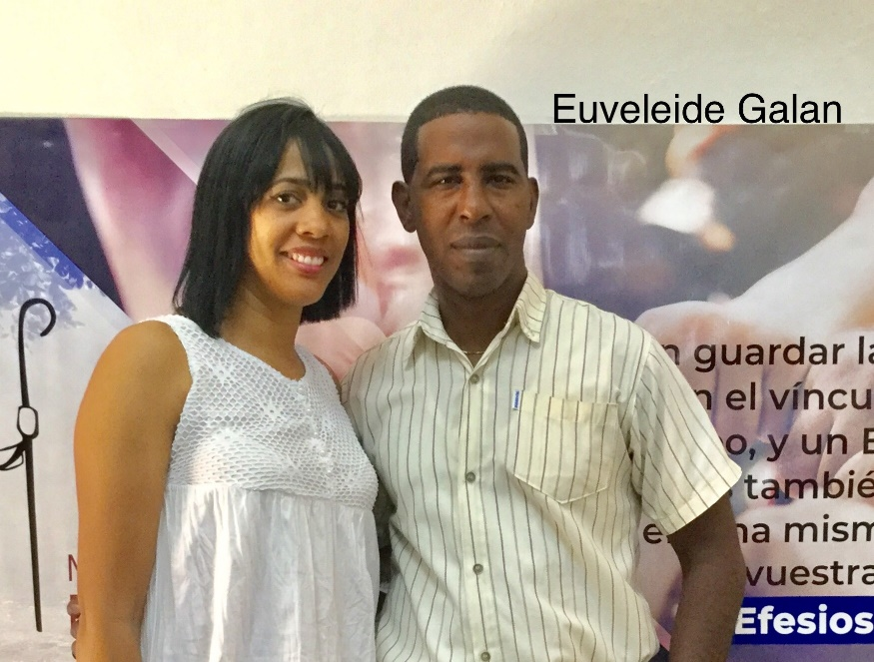
Full Name: Euveleide Galan Calzado
Church and location: 8th Baptist church. Oeste y 14 Sur
Email address: uver@nauta.cu
Average attendance to the church: 120 adults: 90 children: 30
Average monthly offering: $145.00 US
What are the five major needs in your church?
- Finish the parsonage
- Musical instruments and audio system
- Finances to support 3 workers of the
church full time
- Communion set
- Computer for the church

What are the five major needs of your family?
How many in your family? 5
- Finish the house
- Create a budget to better the transportation
- Electric fans
- A good bed with its mattress
- Bed sheets and towels for the family

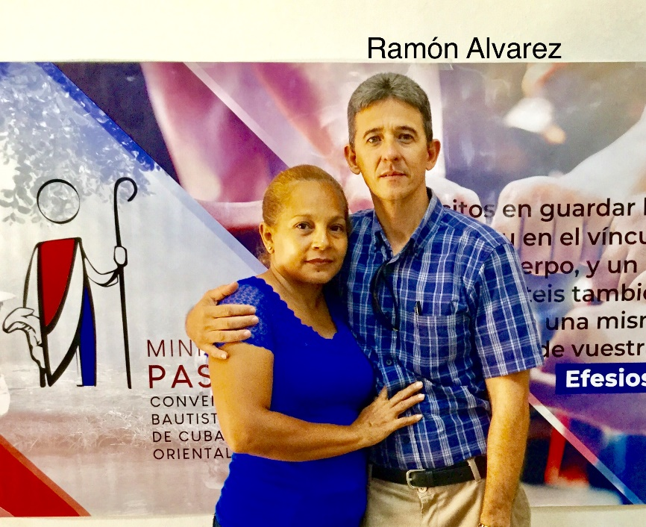
Full Name: Ramon Alvarez Rodriguez
Church and location: 10th Baptist church in Guantanamo. 8 Sur entre 15 y 16 Oeste
Email address: ramonalvarezr@nauta.cu
Average attendance to the church: 70 adults: 50 children: 20
Average monthly offering: $83.00 US
What are the five major needs in your church?
- To build the temple
- Buy a pastoral house (parsonage)
- Audio system (baffles or speakers, console)
- Freezer
- A computer
What are the five major needs of your family?
How many in your family? 5
- To build a bedroom, finish the bathroom
- A water tank and a pump
- A motor scooter for the transportation
- A bed with its mattress
- An air conditioner

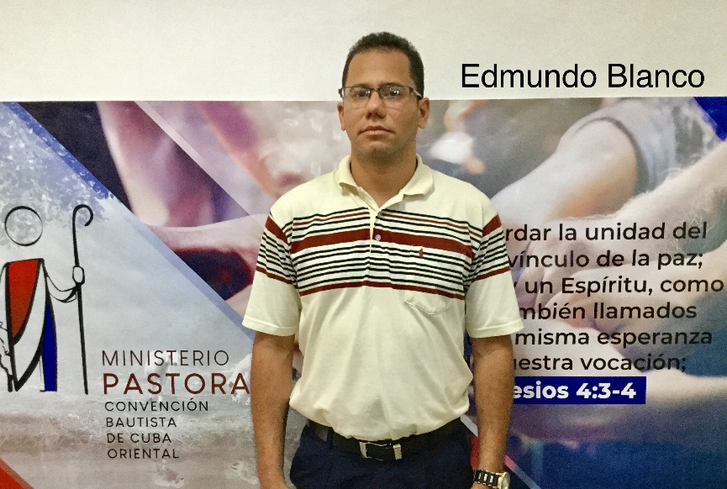
Full Name: Edmundo Blanco Fuentes
Church and location: 9th Baptist “The New Jerusalem”. 4 Oeste esquina Varona
Email address: lanuevajerusalen@nauta.cu
Average attendance to the church: 70 adults: 40 children: 18
Average monthly offering: $66.50 US
What are the five major needs in your church?
- A water tank and a pump
- The construction of a classroom, a
bedroom and a staircase
- Chairs or benches and electric fans
- A computer, a printer and a projector
- To buy a new facility because we are meeting in part of the road
What are the five major needs of your family?
How many in your family? 1
- A bed and a mattress
- A bicycle and an electric fan
- A refrigerator and a computer
- Washing machine
- A house for my own

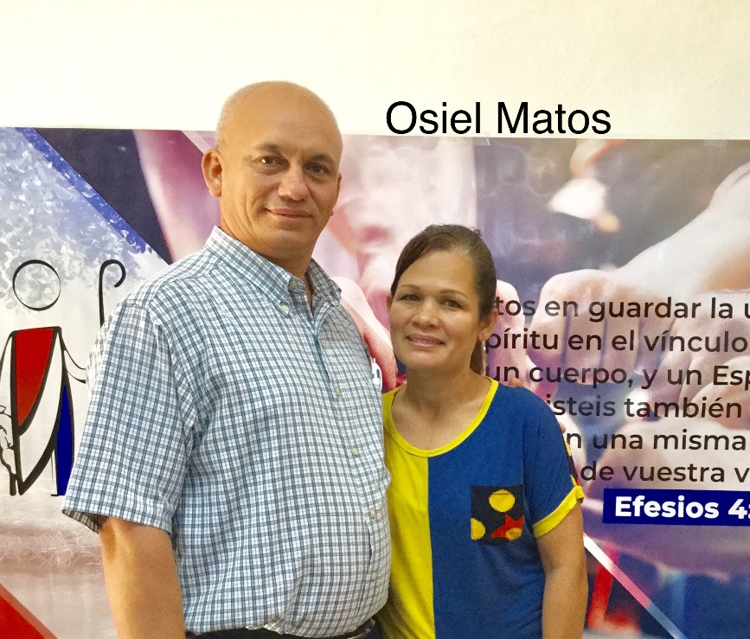
Full Name: Osiel Matos Hernandez
Church and location: 2nd Baptist Church. Prado esq. Serafin Sanchez. Guantanamo
Email address: osiel.mh@nauta.cu
Average attendance to the church: 400 adults: 330 children: 70
Average monthly offering: $270.00 US
What are the five major needs in your church?
- Educative and evangelistic material
- Three Classrooms with fans and chairs
- Roofing for the parsonage
- Printing equipment for the church
- Bicycles for the missionaries
What are the five major needs of your family?
How many in your family? 5
- Refrigerator
- Home of my own
- Three electric fans
- Two bicycles
- Furniture for the living room and for the dining room

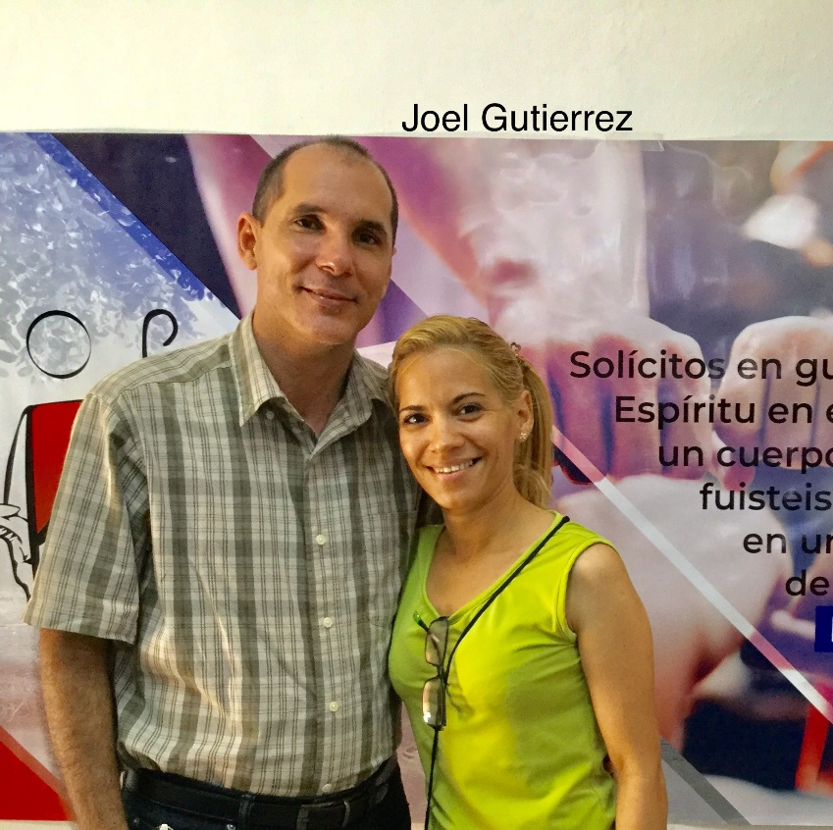
Full Name: Joel Gutierrez Cabrera
Church and location: 1st Baptist Church in Guantanamo
Email address: joelgc242@gmail.com
Average attendance to the church: 300 adults: 240 children: 60
Average monthly offering: $208.00 US
What are the five major needs in your church?
- Bibles
- More chairs for the church services
- Electric fans
- Teaching material (especially children’s)
- Evangelistic tracts
What are the five major needs of your family?
How many in your family? 4
- A refrigerator
- A bicycle for our daughters to go to school
- Electric fans for the bedrooms
- A cellphone: My daughter attends university
- Buy our own house

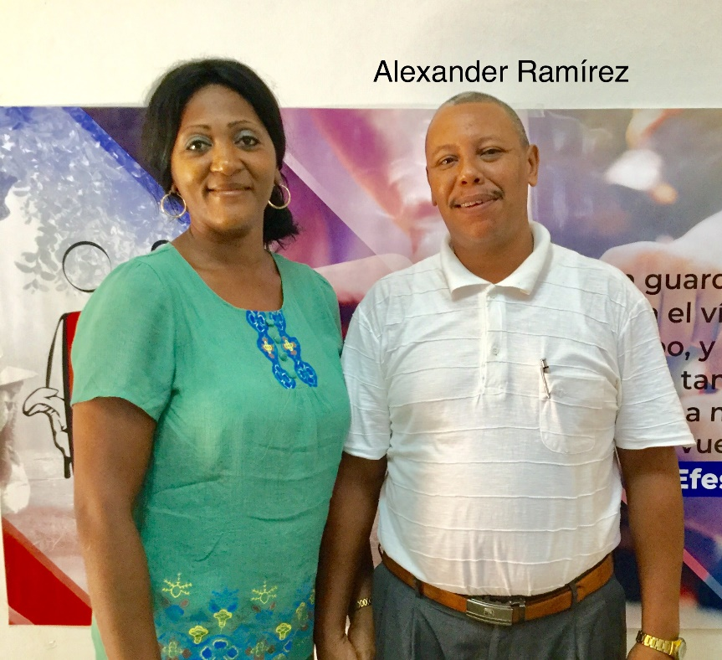
Full Name: Alexander Ramirez Paumier
Church and location: Baptist Church in El Salvador. Guantanamo
Email address: pastoralexrp@nauta.cu
Average attendance to the church: 80 adults: 50 children: 30
Average monthly offering: $54.25 US
What are the five major needs in your church?
- Audio System (whole set)
- Building classrooms for Sunday school
- Repair and fit out the pastor’s office
- A freezer (700.00 USD) “we give food to
the church every last Sunday and it it
difficult to store all the food”
- A table Computer with a printer
What are the five major needs of your family?
How many in your family? 6
- A house of our own
- A refrigerator
- Three air conditioners (the parsonage is very low and enclosed so it’s too hot
- A motor cycle for the pastoral work
- A laptop for our oldest daughter she is getting ready to enter the university.

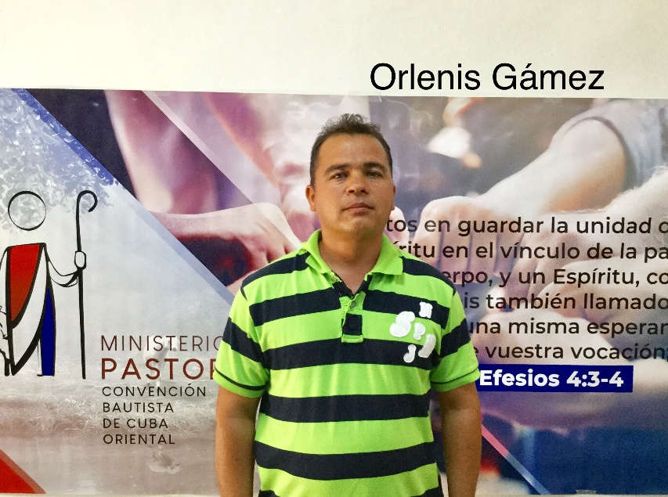
Full Name: Orlenis Gamez
Church and location: Emanuel. Guaibano. Guantanamo
Email address: orlenisgames@nauta.cu
Average attendance to the church: 200 adults: 155 children: 45
Average monthly offering: $250.00
What are the five major needs in your church?
- Build 4 bathrooms
- A projector for the programs of the church
- Build offices for the different ministries
- A piano for the worship services
- Finances to buy a farm for the support of
the church and ministries

What are the five major needs of your family?
How many in your family? 5
- A house of my own for my retirement. Need 300 CUC to celebrate my daughter’s sweet 15
- A bicycle for the missionary work, a refrigerator
- A computer
- Clothes and shoes for the family
- A motor scooter for the visitation

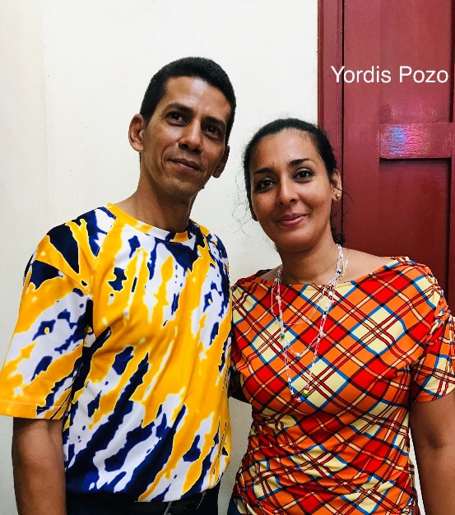
Full name: Yordis Pozo Rondón
Church and location: Macambo, San Antonio del Sur. Guantánamo
Email address: yordis.pozo@nauta.cu
Telephone number: cell +53 55641424
Average attendance of the church: Total 85 adults: 67
children: 18
Average monthly offering: 1700.00 - $68.00 USD
What are the five major needs of your church?
- Finish the construction of the temple,
which was started a year ago.
- Total rebuild of the parsonage which was
damaged 7 years ago by a hurricane.
- 2 bicycles for the pastoral and missionary
work.

- Audio system, microphones, guitar strings.
- Computer and projector.

What are the five major needs of your family?
How many in your family? 6
- Matresses for our beds.
- Clothes for the family. (me, my wife and four children)
- Furniture for the living room and dining room.
- A washing machine and an iron.
- Kitchen equipment such as, electric cookers and blender.

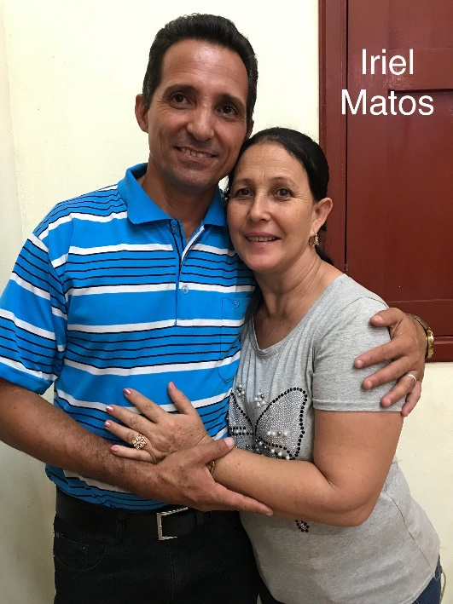
Full name: Iriel Matos Alba
Church and location: First Baptist Church, San Antonio del Sur, Guantanamo
Email address: iriel.matos@nauta.cu
Telephone number: home: + 53 / cell: +53 54272806
Average attendance of the church: 80 Adults: 60 Children: 20
Average monthly offering: 2000.00 - $80.00 USD
What are the five major needs of your church?
- Finish the building of the temple.
- Economic to help the missionaries and ministries.
- Musical instruments and church benches.
- Literature to work with the different ministries.
- Finish construction of three classrooms.
What are the five major needs of your family?
How many in your family? 5
- A house of my own for after retirement.
- Economic help to meet the bare needs.
- A computer for my personal studies.
- A refrigerator and a washing machine.
- Clothes and shoes.

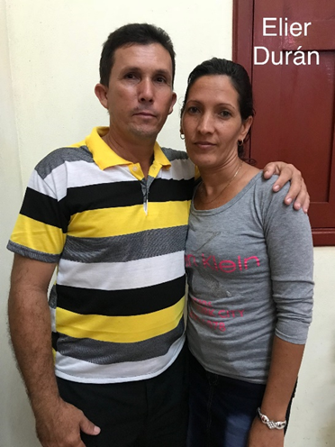
Full name: Elier Durand Rodriguez
Church and location: Baptist Church “El Naranjo” San Antonio del Sur. Guantanamo.
Email address: -
Telephone number: cell +53 54689232
Average attendance of the church: Total 45 Adults: 33 Children: 12
Average monthly offering: 850.00 - $34.00 USD
What are the five major needs of your church?
- Construction of the parsonage.
- Music equipment
- Economic help for a growing church
- Literature for the work in different departments or ministries
- Electric fans for the temple
What are the five major needs of your family?
How many in your family? 5
- A bicycle in order to visit those who live far off and a mission
- Economic for the support of the family
- Clothes for the family
- Domestic appliances
- A computer to study

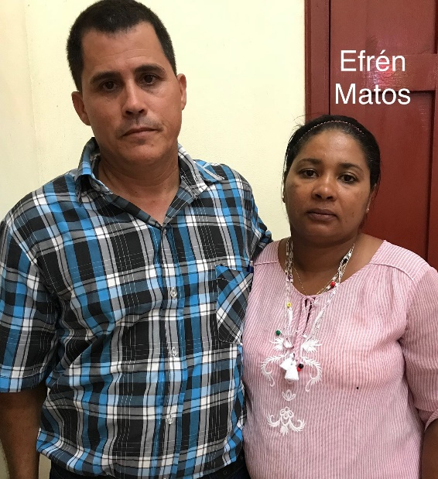
Full name: Efren Matos Matos
Church and location: Yateritas. San Antonio del Sur. Guantanamo.
Email address: -
Telephone number: home: + 53 21872530 and +53 21872532 / cell: +53 55641158
Average attendance of the church: 79 Adults: 58 Children: 21
Average monthly offering: 1,500.00 - $60.00 USD
What are the five major needs of your church?
- Finish construction of the parsonage. We have the foundation.
- Repair classrooms and build classrooms for the children
- Hurricane Sandy damaged the temple and we need to rebuild.
- Help the missionaries since many of them don’t have support
- Buy properties so that each mission has a place to meet.

What are the five major needs of your family?
How many in your family? 5
- I need a house of my own when I retire.
- A computer to study since I am in postgraduate studies
- Motor scooter for visitation
- A TV set
- Clothes for the family

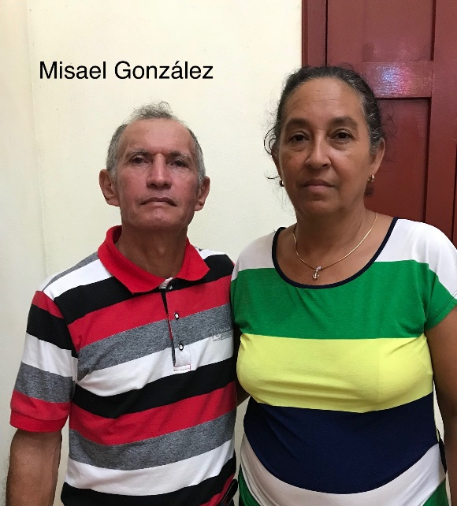
Full name: Misael Gonzalez Jardinez
Church and location: Mariana de Caujeri. San Antonio del Sur. Guantanamo
Email address: misaelg@nauta.cu
Telephone number: cell: +53 54272804
Average attendance of the church: 54 Adults: 40 Children: 14
Average monthly offering: 800.00 - $32.00 USD
What are the five major needs of your church?
- To buy a freezer
- A keyboard
- To build classrooms
- To have funds for the ministries and supplies
- To buy literature for the church

What are the five major needs of your family?
How many in your family? 3
- Personal income for family/salary
- To build a house for my retirement
- Be able to save some money so that I can have the necessary finances to face health issues and others
- To buy a washing machine
- To rebuild the furniture

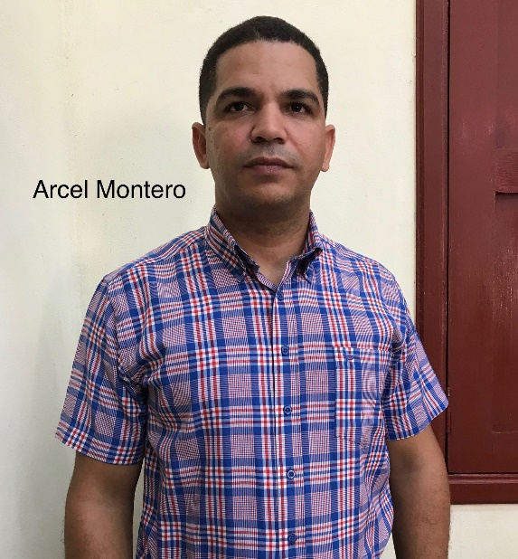
Full name: Arcel Montero Gomez
Church and location: Baptist Church in Centeno de Caujeri. Guantanamo
Email address: arcelmg@nauta.cu
Telephone number: cell: +53 53438950
Average attendance of the church: 50 Adults: 35 Children: 15
Average monthly offering: 500 - $20.00 USD
What are the five major needs of your church?
- The reparation of the parsonage
- Bibles
- The reparation of the chapel
- Musical instruments
- Clothes for the children of the church

What are the five major needs of your family?
How many in your family? 3
- A house for my family
- A refrigerator
- A computer for my studies
- Clothes for my family
- A means of transportation

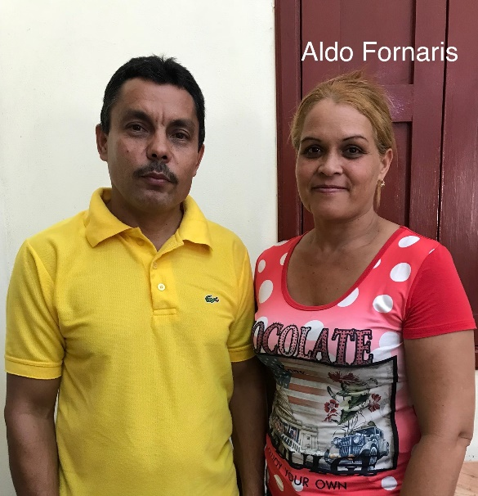
Full name: Aldo Fornaris Llorente
Church and location: Baptist Church “Gethsemane” Manuel Tames. Guantanamo.
Email address: bianeiry.manzanet@nauta.cu
Telephone number: home: cell: +53 54721649
Average attendance of the church: 100 Adults: 65 Children: 35
Average monthly offering: 1350
What are the five major needs of your church?
- Benches for the temple
- Microphones
- Biblical literature especially bibles
- Building materials for the floor of the temple and classrooms.
- Fans, projector and a printer to reproduce material

What are the five major needs of your family?
How many in your family? 4
- Bicycle to visit the missions
- A washing machine
- A refrigerator
- Electric cookers (rice cooker, pressure cooker, etc.)
- Electric fans (2 or 3) it is too hot in the summer!

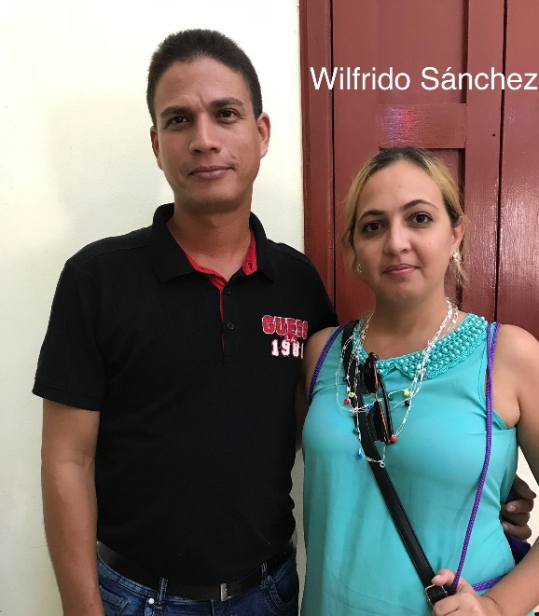
Full name: Wilfrido Sanchez Ramirez
Church and location: 5th Baptist church in Guantanamo.
Email address: wsanchezramirez83@gmail.com
Telephone number: cell: +53 52400256
Average attendance of the church: 190 Adults: 80 Children: 30
Average monthly offering: 3,000 - $120.00 USD
What are the five major needs of your church?
- Finish the construction of the parsonage
- Church benches
- Chairs for the children’s classrooms
- An electric bass
- A printer
What are the five major needs of your family?
How many in your family? 5
- Repair the house

- A piano for my oldest son. (he is studying music)
- Medication for an 8 years old child (hair loss)
- Hairdressing appliances (hair dryer, curling iron…)
- A means of transportation

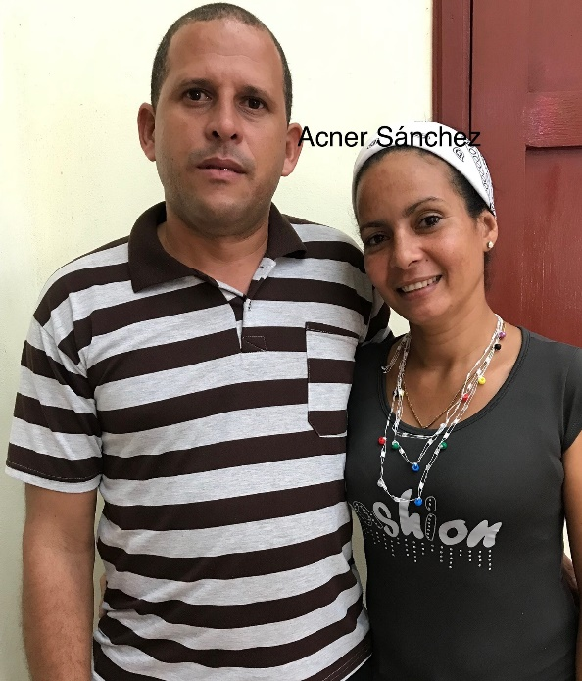
Full name: Acner Sanchez Fiffe
Church and location: Baptist Church in Caimanera. Guantanamo
Email address: acnersanchez79@gmail.com
Telephone number: cell: +53 56390368
Average attendance of the church: 43 Adults: 38 Children: 5
Average monthly offering: 1,000 - $40.00 USD
What are the five major needs in your church?
- Leadership training
- Materials for leadership training
- Reconstruction of a collapsing temple.
- A piano
- An audio system
What are the five major needs of your family?
How many in your family? 4
- A house of my own
- A TV set
- Furniture for my house
- A guitar for my son and a flute for my daughter
- A bicycle

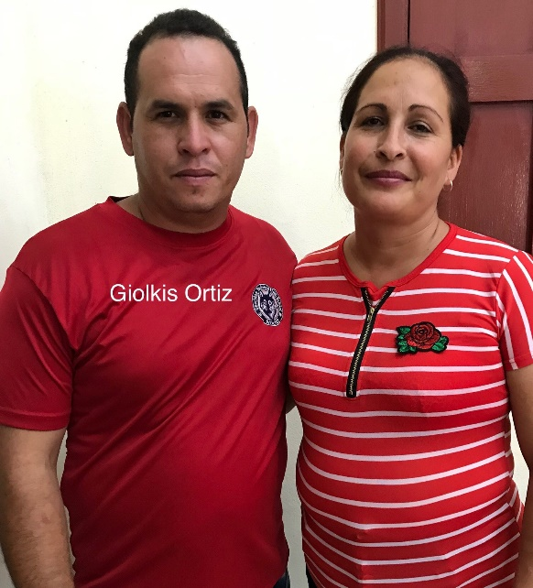
Full name: Giolkis Ortiz Mosqueda
Church and location: Baptist Church “Gethsemane” Baldos de Yateras. Guantanamo
Email address: giolkis.ortiz@nauta.cu
Telephone number: cell: +53 56525891
Average attendance of the church: 60 Adults: 42 Children: 18
Average monthly offering: 900 - $36.00 USD
What are the five major needs of your church?
- Audio equipment
- A horse with carriage for the missionary work
- A house for the mission
- Electric fans for the temple
- Church benches

What are the five major needs of your family?
How many in your family? 5
- Aquire a house
- A TV set
- A bedroom set
- Electric fans
- Livingroom set

