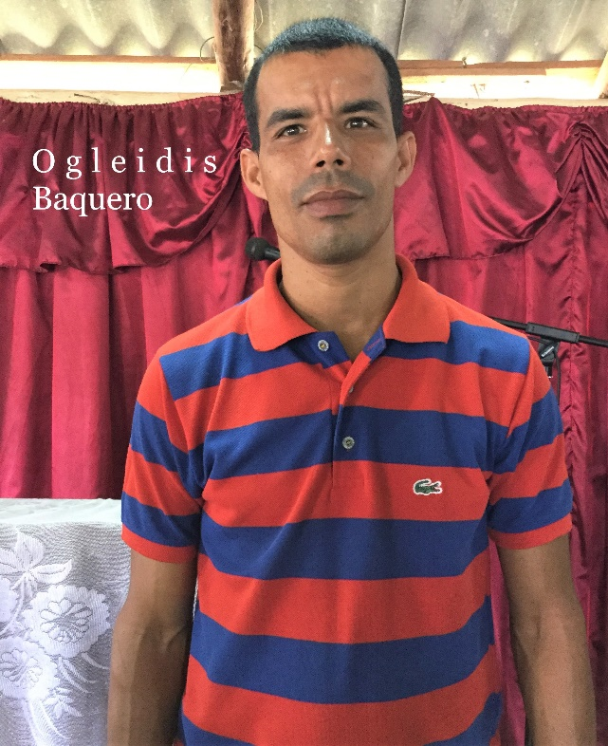
Full Name: Ogleidis Baquero Rojas (SUPPORTED)
Church and location: Monte Horeb, Pueblo Viejo. Maisi
Email address: ogleidis.baquero@nauta.cu
Average attendance to the church: 110 adults: 80 children: 30
Average monthly offering: $5.20 US Dollars
What are the five major needs on your church?
- Construction of classroom for the children
- Repairing of the temple
- Finish the pastoral house
- A water pump
- A water tank for the parsonage
What are the five major needs of your family?
How many on your family? 4
- A bicycle for transportation between churches I pastor
- A refrigerator
- Bed sheets
- Shoes and clothes for the family
- A hair clipper

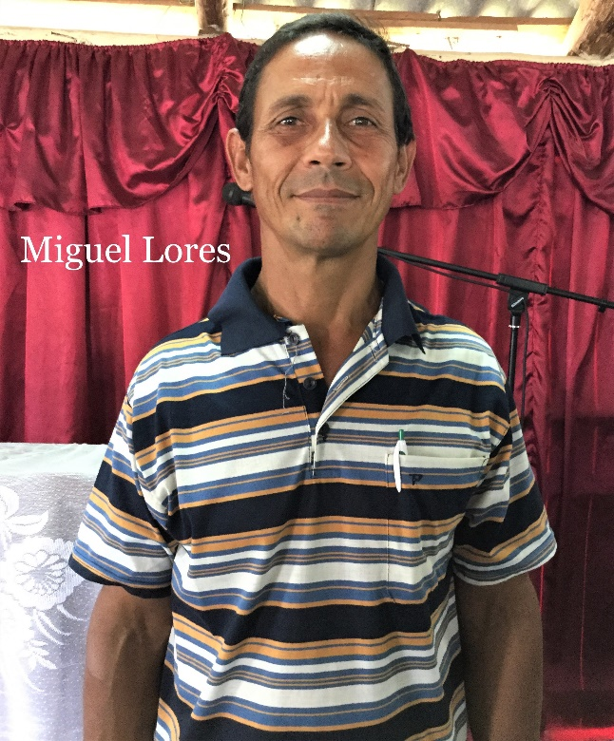
Full Name: Miguel Lores Romero (SUPPORTED)
Church and location: Puriales arriba
Email address: -
Average attendance to the church: 100 adults: 87 children: 23
Average monthly offering: $20.85 US Dollars
What are the five major needs on your church?
- Construction of the pastoral house
- Concrete roof of the temple
- A keyboard and other musical instruments, audio system
- Electric stove with oven
- Finish construction of a classroom.
What are the five major needs of your family?
How many on your family? 5
- A refrigerator
- A bicycle
- A computer.
- A gas stove
- Multipurpose electric pressure cooker

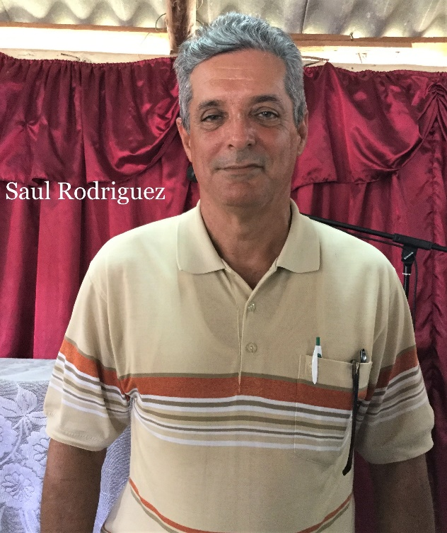
Full Name: Saul Rodriguez Legra
Church and location: “Los Olivos”. Chafarina. Maisi. Cuba
Email address: -
Average attendance to the church: 60 adults: 30 children: 30
Average monthly offering: $25.00 US Dollars
What are the five major needs on your church?
- Audio system
- Musical instruments
- Pews
- Microphones
- Study Bibles for the leadership
What are the five major needs of your family?
How many on your family? 5
- Prayer
- Clothes
- Shoes
- Kitchen
- Medicine, vitamins…

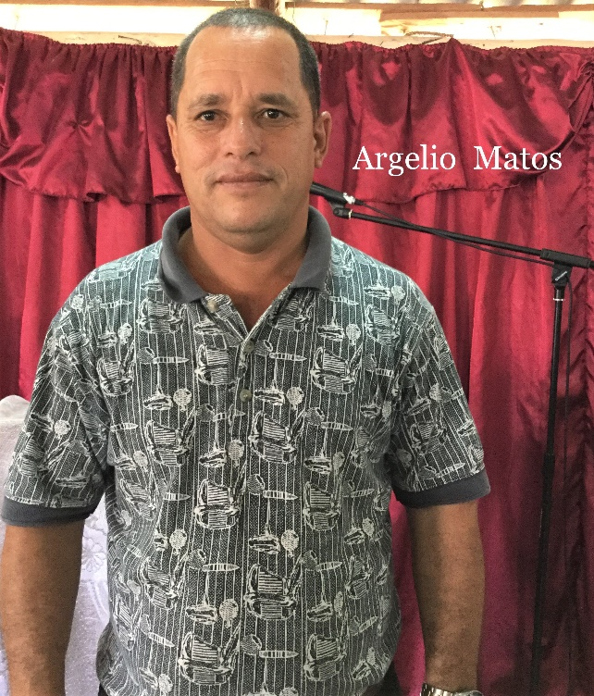
Full Name: Argelio Matos Columbie (SUPPORTED)
Church and location: Iglesia Bautista de Los Ranchos. Maisi.
Email address: argelio.matos@nauta.cu
Average attendance to the church: 70 adults: 54 children: 16
Average monthly offering: $58.35 US Dollars
What are the five major needs on your church?
- Finish the construction of the temple
- Audio system and amplifier
- Keyboard
- Microphones
- Materials to work with children
What are the five major needs of your family?
How many on your family? Four (4)
- A Bicycle
- Shoes for my children and my wife
- Kitchen goods (rice cooker, pressure cooker…)
- Mattresses (2) twin beds
- Medication for allergies, vitamins, arthritis-gouts

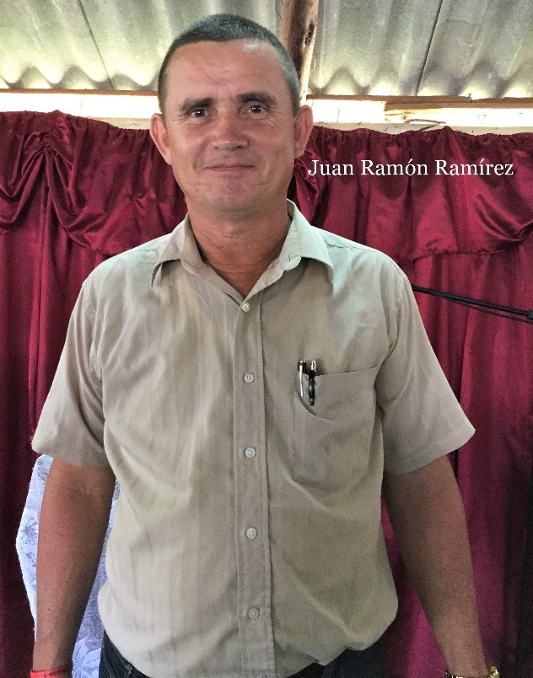
Full Name: Juan Ramon Ramirez Salazar
Church and location: Faro de Maisi. Punta de Maisi
Email address: juan69@nauta.cu
Average attendance to the church: 121 adults: 81 children: 40
Average monthly offering: $35.40 US Dollars
What are the five major needs on your church?
- A classroom for the children (now meeting under the sun)
- A computer and projector, Audio system
- Paint
- Bible tracts and bibles.
- Build two bathrooms
What are the five major needs of your family?
How many on your family? Four (4)
- Buy a house
- A refrigerator or a freezer
- Shoes and clothes
- A means of transportation
- Three mattresses

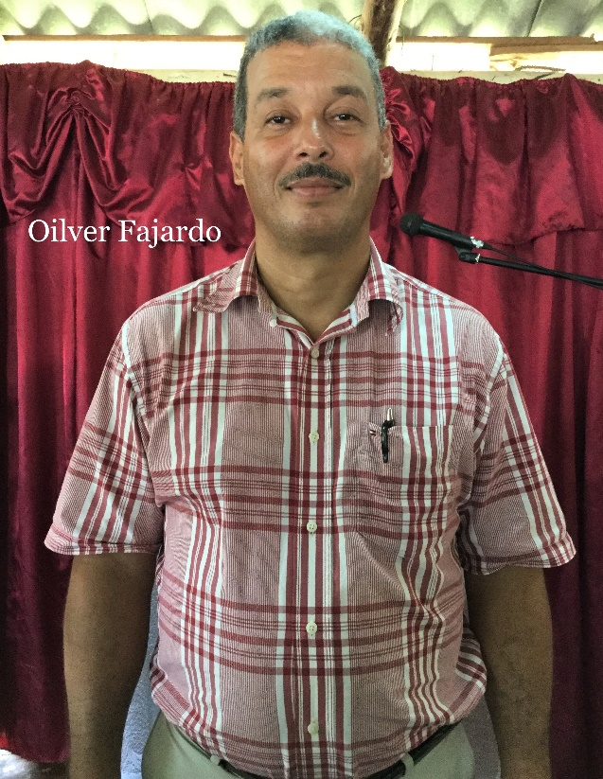
Full name: Oilver Fajardo Vera - President of the district
Church and location: Iglesia Bautista Ebenezer. Casimba- Maisi
Email address: oilver@nauta.cu / oilverfv75@gmail.com
Average attendance to the church: 160 adults: 110 children: 50
Average monthly offering: $91,70 US Dollars
What are the five major needs on your church?
- A water well (cistern)
- A septic tank
- Electric goods for the kitchen.
- Three beds for visitors
- Bibles and evangelistic tracts, Study center.
What are the five major needs of your family?
How many on your family? 4
- A means of transportation (motor-cycle)
- Medicine (pain killer, antihistamine, omega 3, anti-
inflammatory, antibiotics).
- A house for my family.
- Three (3) mattresses
- Refrigerator.

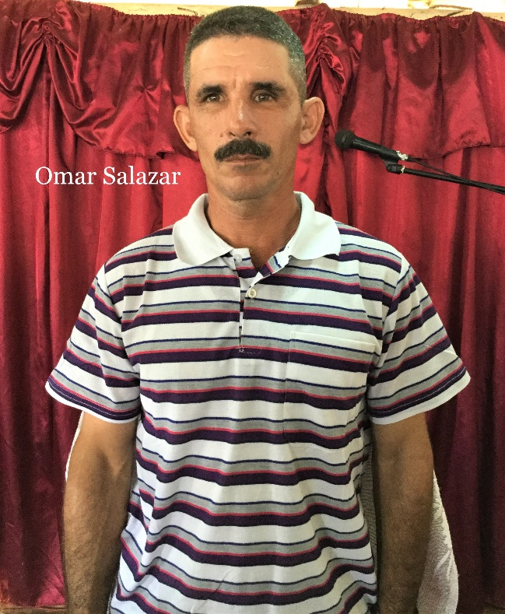
Full Name: Omar Salazar Regalado
Church and location: Cristo Vive. La tinta de Jauco. Maisi
Email address: -
Average attendance to the church: 80 adults: 60 children: 20
Average monthly offering: $41.70 US Dollars
What are the five major needs on your church?
- Evangelistic tracts.
- Bibles for new believers
- A keyboard. (Lost ours during hurricane Matthew)
- Discipleship materials for children.
- Rebuilding of the temple. (Again, hurricane Matthew)
What are the five major needs of your family?
How many on your family? 5
- A wooden closet.
- A sewing machine
- Medicine for my wife. (Glucosamine)
- Three electric fans.
- Two mattresses (twin beds)

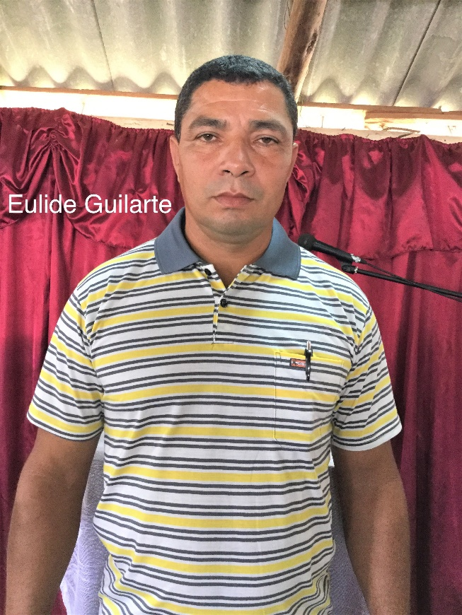
Full Name: Eulide Guilarte Acosta
Church and location: Iglesia Enmanuel. Cantillo. Maisi.
Email address: eulides.guilarte@nauta.cu
Average attendance to the church: 130 adults: 80 children: 50
Average monthly offering: $62.50 US Dollars
What are the five major needs on your church?
- A console
- Sound System with 4 microphones
- A USB music player to work with the children
- Finances to finish class & dining-rooms (3 000.00 CUC)
What are the five major needs of your family?
How many on your family? 4
- Finish my house $83.00 US dollars
- A washing machine
- A bicycle
- Shoes and clothes
- A refrigerator

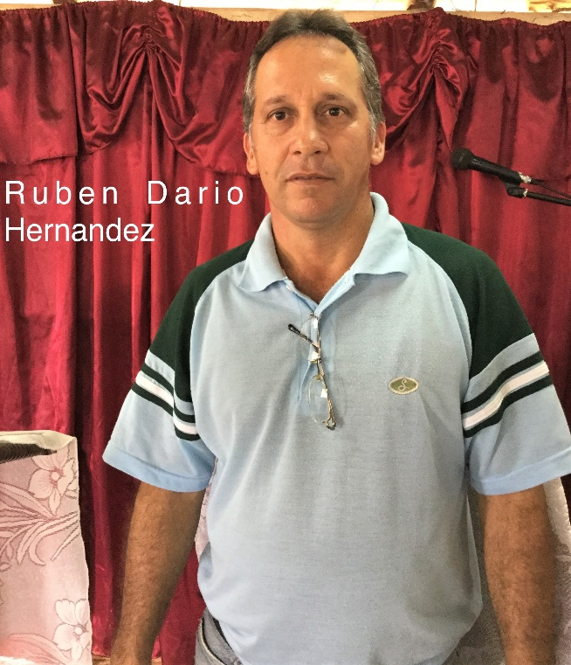
Full Name: Ruben Dario Hernadez Pelegrin
Church and location: iglesia Sinai. La Máquina. Maisi
Email address: shalomruben@nauta.cu
Average attendance to the church: 105 adults: 85 children: 20
Average monthly offering: $35.40 US Dollars
What are the five major needs on your church?
- Building of the temple (we have the foundation already)
- Musical instruments (drums, bass)
- Evangelistic tracts
- A bicycle for the visitation
- Discipleship materials
What are the five major needs of your family?
How many on your family? 3
- Refrigerator
- Shoes for our son (university student)
- Finish my house
- Literature for my ministry (theology, others.)

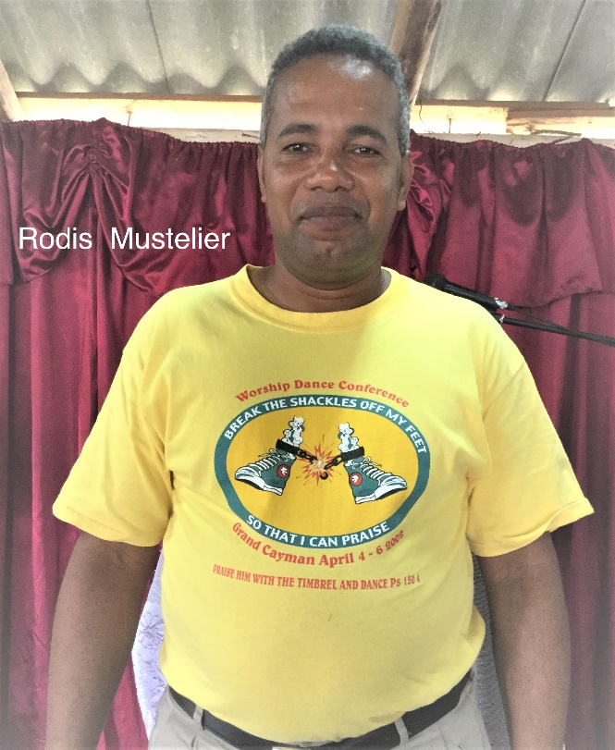
Full Name: Rodis Mustelier Barroso
Church and location: La asuncion. Maisi. Guantanamo
Email address: rodis73@nauta.cu
Average attendance to the church: 75 adults: 50 children: 25
Average monthly offering: $16.70 US Dollars
What are the five major needs on your church?
- Finances to build the temple and the pastoral house
- Finances for a pastoral house
- A laptop and a printer
- An audio system, microphones, console
- A keyboard and a guitar
What are the five major needs of your family?
How many on your family? 2 wife is pregnant
- A refrigerator
- Kitchen utensils
- Bed sheets. Shoes for me and my wife
- A laptop
- A house

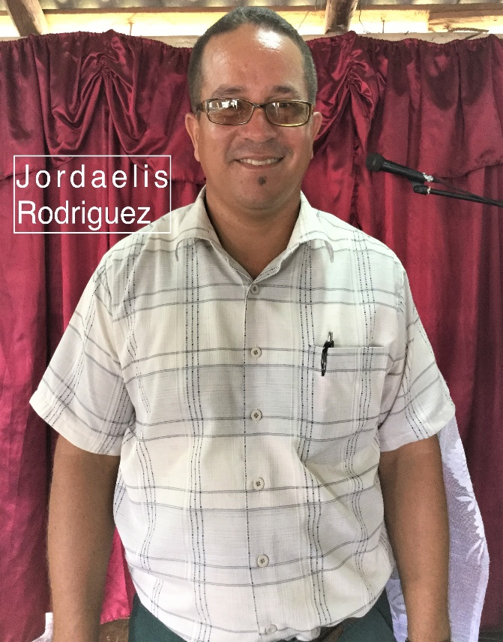
Full Name: Jordaelis Rodriguez Hernandez
Church and location: Iglesia Bautista de Sabana. Sabana. Maisi
Email address: jordaelis.rodriguez@nauta.cu
Average attendance to the church: 198 adults: 145 children: 53
Average monthly offering: $56.25 US Dollars
What are the five major needs on your church?
- Finish the dining-room
- Finish the classrooms and bathrooms
- Finish the carpentry of church, pews & paint the temple
- Buy electric fans
- Sound System
What are the five major needs of your family?
How many on your family? 4
- Children vitamins especially vitamin E
- Shoes for my children, bed sheets and towels
- A bicycle for the ministry
- Air conditioner or electric fan for my children’s room
- A prayer ministry that pray for my children. They suffer
from a disease that don’t allow them to grow.

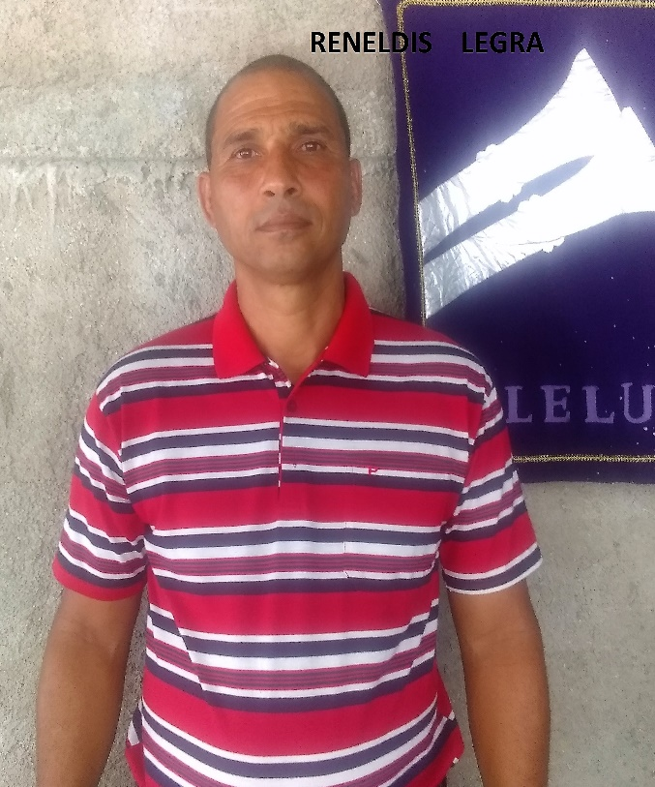
Full Name: Reneldis Legra Vera
Church and location: Iglesia Bautista Los Cedros, Vertiente. Maisi.
Email address: roneldy.legra@nauta.cu
Average attendance to the church: 157 adults: 112 children: 45
Average monthly offering: $ 27.00 USD
What are the five major needs on your church?
- Rebuild the temple
- Buy 8 electric fans
- We need $21.00 monthly to use for evangelism
- We need soaps, deodorant & safety razors for senior
adult ministry
- We need more benches or chairs for church
What are the five major needs of your family?
How many on your family? 5
- Prayer for my family with young children
- Rebuild the parsonage
- A motor cycle or a bicycle for the visitation
- Buy a washing machine
- Clothes and shoes for the family

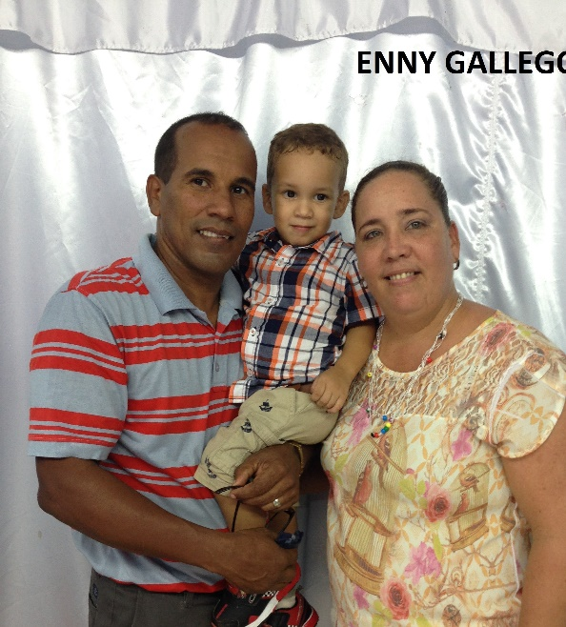
Full name: Enny Gallego Hernandez
Church and location: Baptist Church “Los Llanos” Maisi. Guantanamo.
Email address: alirt@nauta.cu
Telephone number: cell +53 55293566
Average attendance of the church: 120 adults: 90 children: 30
Average monthly offering: 1,500.00 - $60.00 USD
What are the five major needs in your church?
- Build bathrooms for our church.
- Finish the construction of the classrooms
- Make church benches
- Music equipment and musical instruments
- Children’s materials and resources.

What are the five major needs of your family?
How many in your family? 4
- Bicycles for the missionary work.
- Clothes for the children.
- Mattress and sheets
- Study Resources
- Laptop

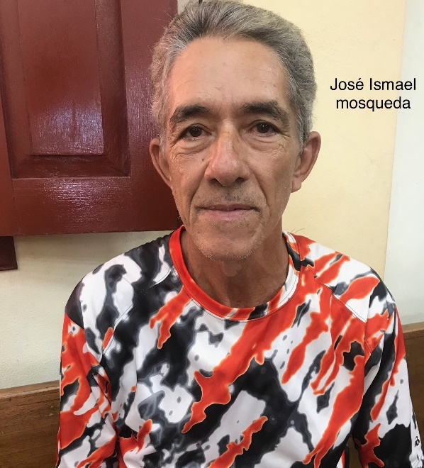
Full name: Jose Ismael Mosqueda Carnet
Church and location: Baptist Church Mesa Abajo. Sabana. Maisi
Email address: -
Telephone number: home: cell: +53 56065808
Average attendance to the church: 55 Adults: 40 Children: 15
Average monthly offering: 700.00 - $28.00 USD
What are the five major needs in your church?
- Audio equipment
- Electric fans for the temple
- Resources for the construction of the parsonage
- To build a water cistern
- Musical instruments (guitar, keyboard)

What are the five major needs of your family?
How many in your family? 4
- A refrigerator
- A TV set
- A laptop
- A washing machine
- A bicycle.

