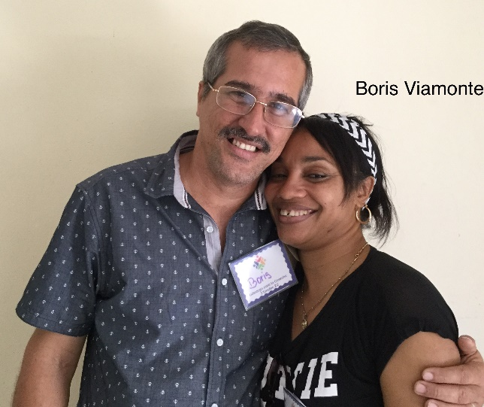
Full Name: Boris Viamonte Fernandez
Church and location: 13th Baptist Church in Santiago de Cuba. El Polvorin, Chicharrones.
Email address: borisviamontes@nauta.cu
Average attendance of the church: 65 adults: 35 children: 15
Average monthly offering: $33.30 US
What are the five major needs in your church?
1. Security border for the property
2. Roofing for the temple
3. Audio system
4. Water reservoir
5. Pump and pipes to fit out the bathrooms

What are the five major needs of your family?
How many in your family? 2
- Washing Machine
- Ceiling
- Clothes for the pastor (Shoes, trousers, shirts)
- Freezer
- Means of transportation (Motor cycle)

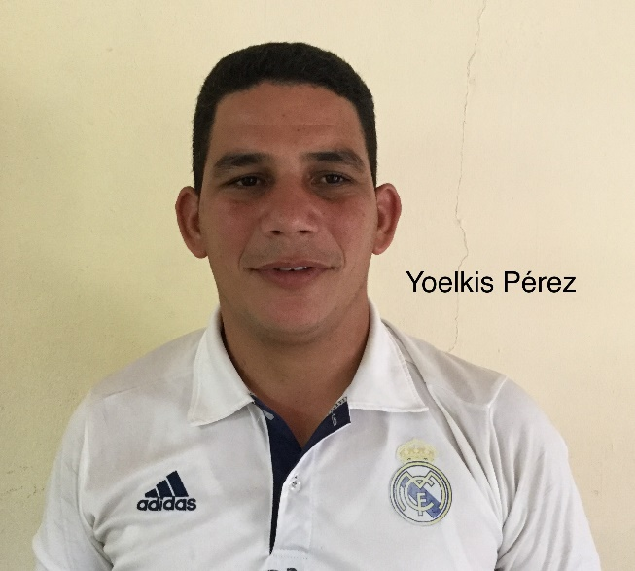
Full Name: Yoelkis Pérez Martinez
Church and location: 5th Baptist Church in Santiago de Cuba. Distrito Jose Marti.
Email address: yoelkispm@nauta.cu
Average attendance of the church: 75 adults: 60 children: 15
Average monthly offering: $75.00 US
What are the five major needs of your church?
1. Construction of church $45,000 USD
2. Training for the work with children, teenagers and
young adults
3. Maintenance to the apartment 2nd floor water from the
3rd leaks (this same apartment where we live is where
the church meets.)
4. Program of support to brothers and sisters in need
(food, house reparation)
5. Audio system.
What are the five major needs of your family?
How many in your family? 3
- An apartment for my family to live in
- Budget to provide the needs of my family (electricity bill, food)
- Reparation of a motorcycle ( Russian model) for transportation
- Clothes for the family
- Repairing of the apartment (create conditions that are missing)

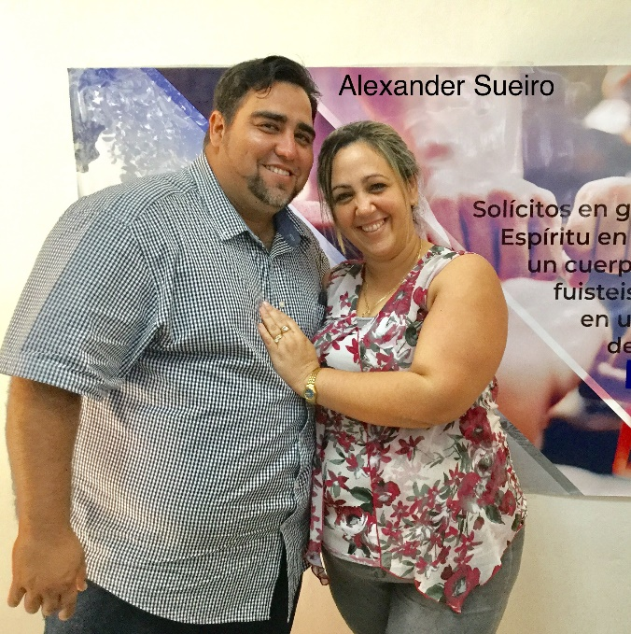
Full Name: Alexander Sueiro Coronado
Church and location: Valle de Bendicion Baptist Church. El Cobre. Santiago de Cuba
Email address: alex8101@nauta.cu
Average attendance of church: 220 adults 140 children 80
Average monthly offering: $167.00 US
What are the five major needs in your church?
- Build bathrooms
- Build classrooms
- Security border for the property
- Buy chairs & tables for the dining room
- Build bedrooms
What are the five major needs of your family?
How many in your family? 5
- Living room set
- Gas cooker
- 2 mattresses
- Washing machine
- Refrigerator

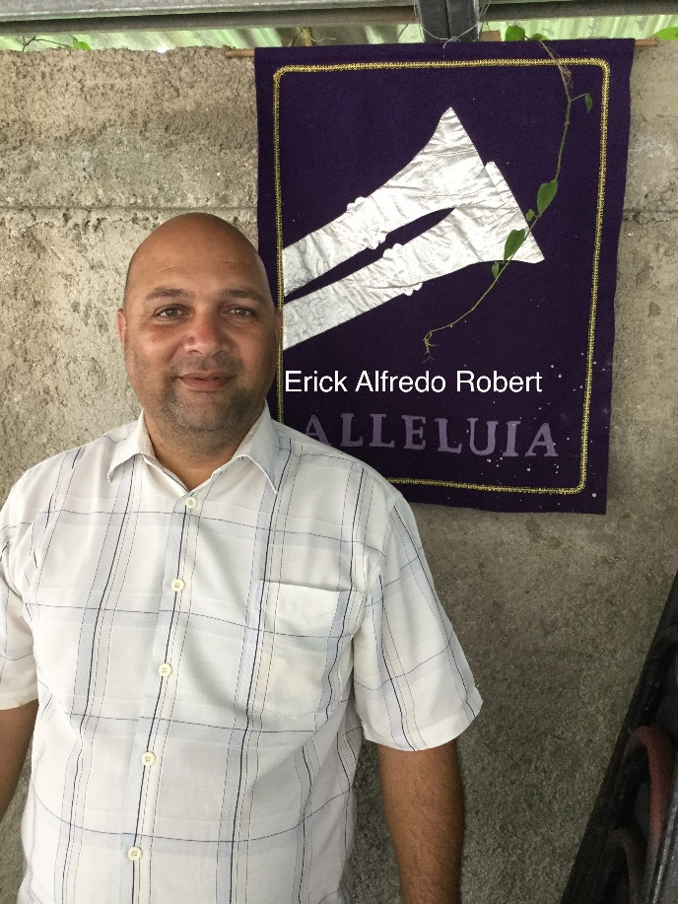
Full Name: Erick Alfredo Robert Carpio
Church and location: 14th Baptist Church in Santiago.
Email address: -
Average attendance of church: 150 adults: 120 children: 30
Average monthly offering: $62.50 US
What are the five major needs of your church?
- Change the roof (it’s deteriorated)
- Audio system with microphones
- 30 benches and 30 chairs
- Piano
- Pay a debt of 500.00 CUC
What are the five major needs of your family?
How many in your family? 5
- A house (we are sleeping on the floor of the temple
since over a year ago)
- A refrigerator
- An electric cooker
- A rice cooker
- Dressing trouser (size 38)

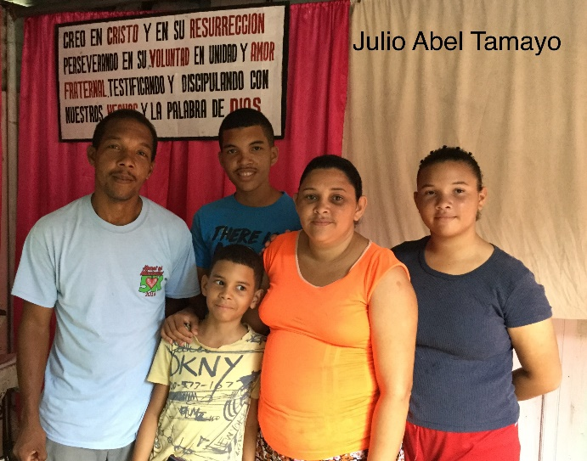
Full Name: Julio Abel Tamayo Despaigne (SUPPORTED)
Church and location: Baptist Church in San Vicente, Carretera Central del Cristo. Santiago de Cuba.
Email address: julioabel.tamayo@nauta.cu
Average attendance of the church: 80 adults: 60 children: 20
Average monthly offering: $41.60 US
What are the five major needs of your church?
- Building materials to finish the building of the temple,
Buy benches (no room on Sunday School services)
- Musical instruments (piano, guitar, others) and a
- motor scooter to go to the mission
- Buy a house for the mission and finances to support
the missionary
- Financial help to give food (lunch) to the children in Sunday School, sick people and seniors of the community
What are the five major needs of your family?
How many in your family? 5
- A refrigerator, a TV set and a washing machine
- Sheets and towels for the family
- Rice cooker, pressure cooker and a blender
- Shoes and clothes for my three children
- Mattresses for the beds

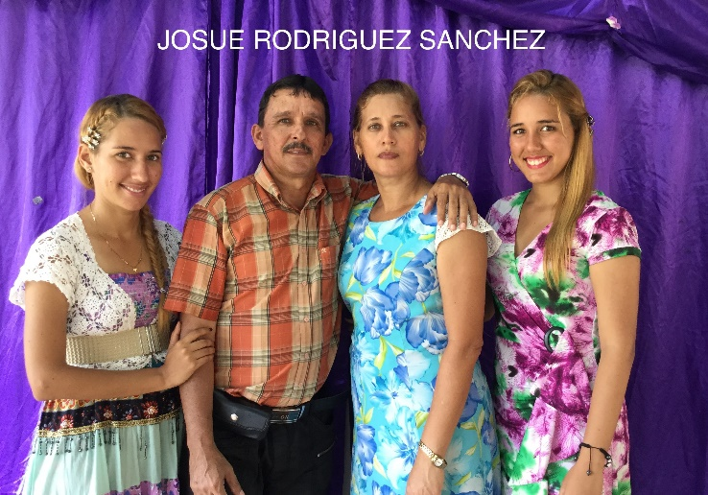
Full Name: Josue Rodriguez Sanchez (SUPPORTED)
Church and location: 8va Iglesia Bautista. Micro 3. Abel Santamaria. Santiago de Cuba
Email address: josue.rs@nauta.cu
Average attendance of the church: 190 adults: 110 children: 80
Average monthly offering: $250.00 US
What are the five major needs of your church?
- Training, materials like Bibles, study Bibles, Bible
dictionary
- Construction of the building where the church will meet
- Computer and printer to print all the material for the
church
- Benches for the church Many must stand during church
- Musical instruments and microphones
What are the five major needs of your family?
How many in your family? 5
- We have great challenges. We need your prayers for the finances of our staff.
- Financial help for the food
- Financial support to buy clothes and shoes
- Electrical appliances
- I was given a car (polsky, fiat-126) we need help to repair it. We live far from church.

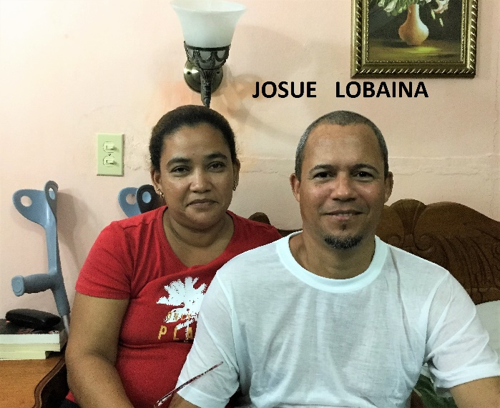
Full Name: Josue Lobaina Marzo (SUPPORTED)
Church and location: Iglesia Bautista “Ríos de Agua”. La Maya. Santiago de Cuba
Email address: josue.lobaina@nauta.cu
Average attendance of church: 110 adults: 80 children: 30
Average monthly offering: $ 83.30 USD
What are the five major needs in your church?
- Finish the construction of the parsonage
- Finish an enlargement (amphitheater) in the backyard
of the church building for the church celebration and
children’s meeting area
- A power generator (blackouts occur in our country)
- Audio system, microphones, computer, and printer
- Electric fans
What are the five major needs of your family?
How many in your family? 4
- A washing machine
- Air conditioner
- A refrigerator or a freezer
- Clothes and shoes for the family
- A water tank

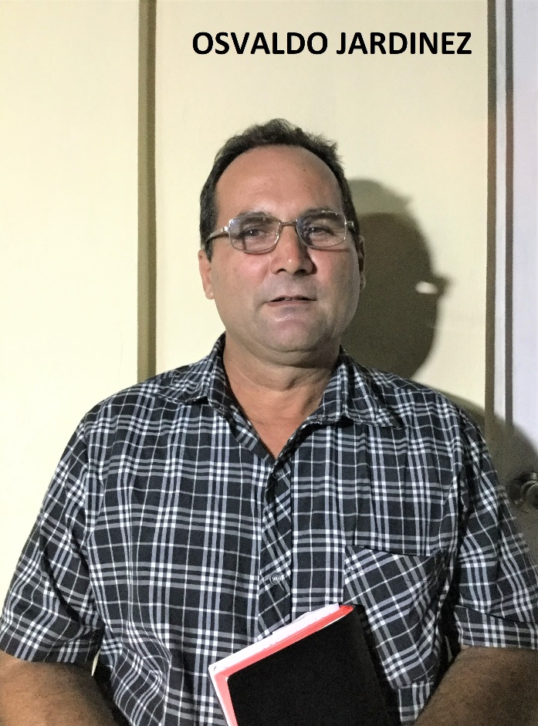
Full Name: Osvaldo Jardinez Ramirez (SUPPORTED)
Church and location: Iglesia Bautista “Mahanaim”. El Modelo. Santiago de Cuba
Email address: osvaldo.jardinez@nauta.cu
Average attendance of the church: 70 adults: 53 children: 17
Average monthly offering: $62.50 USD
What are the five major needs in your church?
- Finish the construction of the parsonage
- Finish construction of the bathrooms of the church
- Build a water tank on top of the bathrooms
- Build the classrooms (out of concrete)
- Build an outside tabernacle (the church needs a wider
space where to meet)
What are the five major needs of your family?
How many in your family? 5
- Acquire a house.
- Buy a refrigerator
- Buy an air-conditioner
- Buy a rice cooker
- Buy an electric pressure cooker

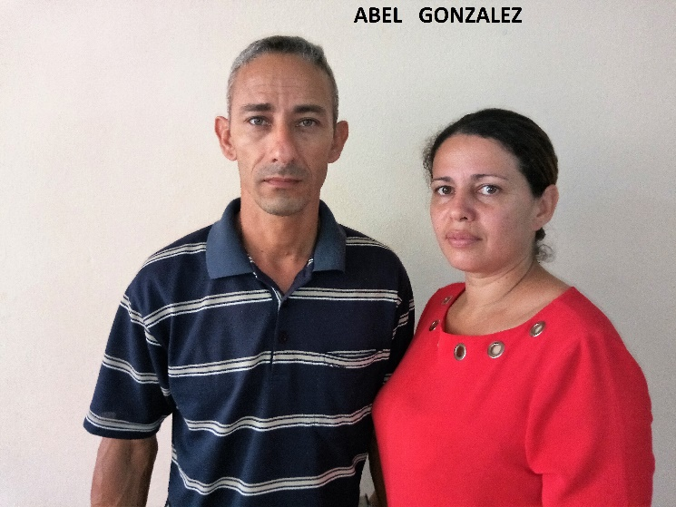
Full Name: Abel Gonzalez Matos (SUPPORTED)
Church and location: Iglesia Bautista Gerizim. Alto Songo. Santiago de Cuba
Email address: yanyrd302@gmail.com
Average attendance of church: 130 adults: 75 children: 55
Average monthly offering: Cuban pesos. =
What are the five major needs of your church?
- Build a classroom for the young adults ministry
- Waterproof for the roof
- A water tank
- Financial help for missionaries
- Teaching materials for the children’s ministry(to
make craft: foam paper, pipe cleaners, crayons, white glue and others)
What are the five major needs of your family?
How many in your family? 5
- Motor scooter
- Clothes and shoes for my children
- A gas stove
- An electric fan or air conditioner
- Buy our house for our retirement

Full name: Diorlis Hernandez Hernandez
Church and location: 6ta Iglesia Bautista. San Juan. Santiago de Cuba
Email address: diorlis@nauta.cu
Average attendance of the church: 150 adults: 100 children: 50
Average monthly offering: $ 208.30 USD
What are the five major needs of your church?
- Benches or chairs
- Light food for the children
- A piano
- Financial support for a missionary
- A bicycle
What are the five major needs of your family?
How many in your family? 4
- A mattress
- A rice cooker

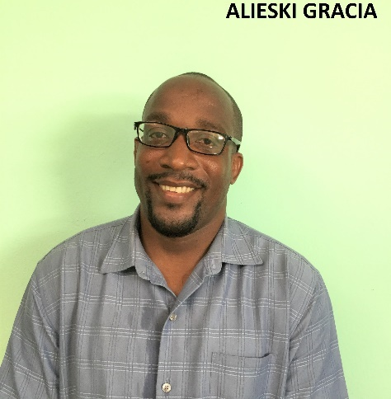
Full name: Alieski Gracia Luis
Church and location: Baptist Church “Familia Cristiana” Carretera Caney, Santiago de Cuba.
Email address: alieskygl@nauta.cu
Telephone number: mobile: +53 54247481
Average attendance of the church: 56 adults: 30 children: 26
Average monthly offering: 600.00 $24.00 USD
What are the five major needs of your church?
- Build classrooms for children and young adults.
- Build bathrooms for the church
- Audio equipment and musical instruments
- Finish the parsonage and construction of the temple
- Electric fans for the temple

What are the five major needs of your family?
How many on your family? 2
- A full size bed and a mattress
- A refrigerator
- An electric fan
- A gas stove
- Medication for diabetes and blood circulation problems.

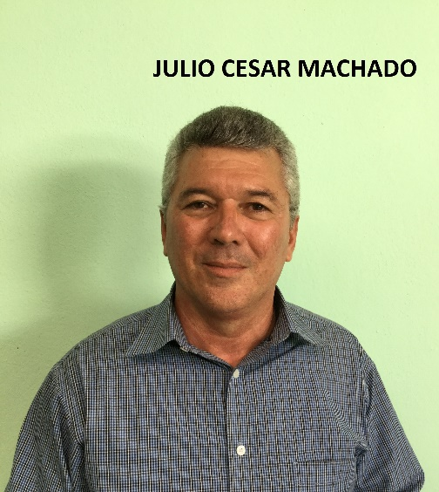
Full name: Julio Cesar Machado
Church and location: Ducureaux. El Caney. Santiago de Cuba
Email address: jcmachado963@gmail.com
Telephone number: cell: +53 53792352 / home: +53-
Average attendance of the church: 220 Adults: 100 Children: 120
Average monthly offering: 5.000.00 $200.00 USD
What are the five major needs of your church?
- To build the temple
- Our missions need to buy houses for church
- Financial support for the mission churches
- Resources to work with the children. (toys and craft material)
- Training for the leaders in their work

What are the five major needs of your family?
How many in your family? 6
- Food
- Transportation
- Study material
- Resources to serve

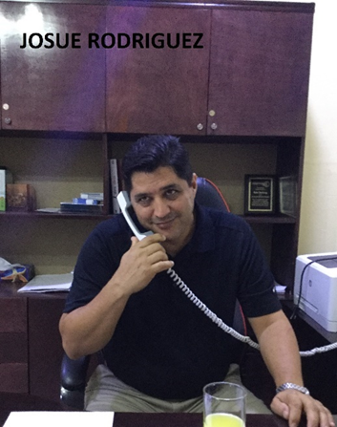
Full name: Josue Rodriguez Legra PRESIDENT OF THE CONVENTION
Email address:
Telephone number: +53 / home: +53

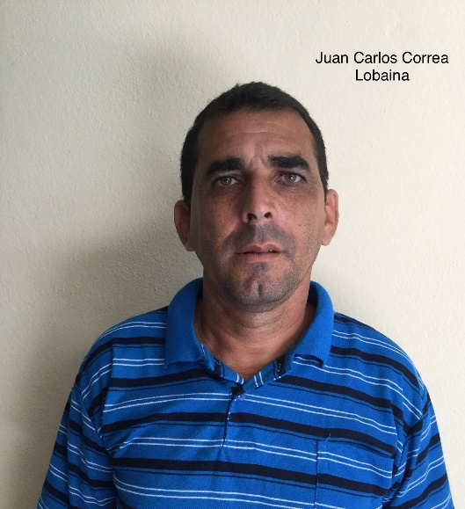
Full name: Juan Carlos Correa Lobaina
Church and location: 12th Baptist of Santiago de Cuba. San Juan Hill
Email address:
Telephone number: +53 54201158
Average attendance to the church: 70 Adults: 55 Children: 15
Average monthly offering: 4,000.00 $160.00 USD
What are the five major needs of your church?
- Finish building the temple and start building the parsonage
- Bibles
- Materials to work with the children ( crafts)
- Church benches
- Audio equipment, computer and printer.

What are the five major needs of your family?
How many in your family? 2
- A full size bed mattress
- Kitchen appliances
- Electric fans
- A bicycle
- Clothes and shoes (38 and 41 European size)

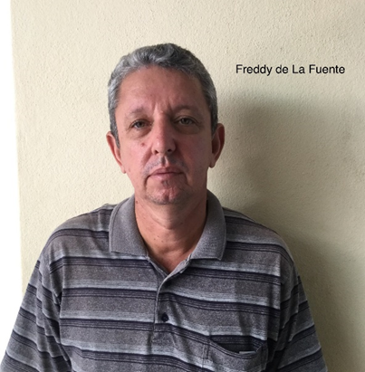
Full name: Freddy de la Fuente Legra
Church and location: Carretera Central km 14. Santiago de Cuba
Email address: fredydlfte@nauta.cu
Telephone number: mobile: +53 52401136
Average attendance of the church: 95 Adults: 75 Children: 20
Average monthly offering: 900.00 $36.00 USD
What are the five major needs of your church?
- To buy a parsonage
- Financial support for two missions
- Audio equipment
- Two bicycles
- A keyboard

What are the five major needs of your family?
How many in your family? 3
- To make some repairs in my house
- To make some repars on my car
- To rent or build a garage (Safety)

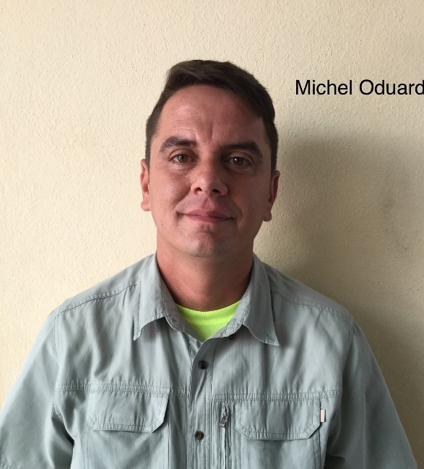
Full name: Michel Oduardo Garcia
Church and location: 10th Baptist of Santiago de Cuba.
Email address: michel.oduardo@nauta.cu
Telephone number: Mobile: +53 58149017 / home: +53 22625358
Average attendance of the church: 150 Adults: 100 Children: 50
Average monthly offering: 7,000.00 $280.00 USD
What are the five major needs of your church?
- Bibles
- Chairs or benches for the children
- To build bathrooms
- Electric fans
- Multipurpose pressure cooker and a rice cooker

Which are the five major needs of your family?
How many in your family? 4
- A multipurpose pressure cooker and a rice cooker
- Make some divisions in the bedrooms
- Finish the payment of the refrigerator (300.00 CUC)
- Backpacks for my children
- Bed sheets

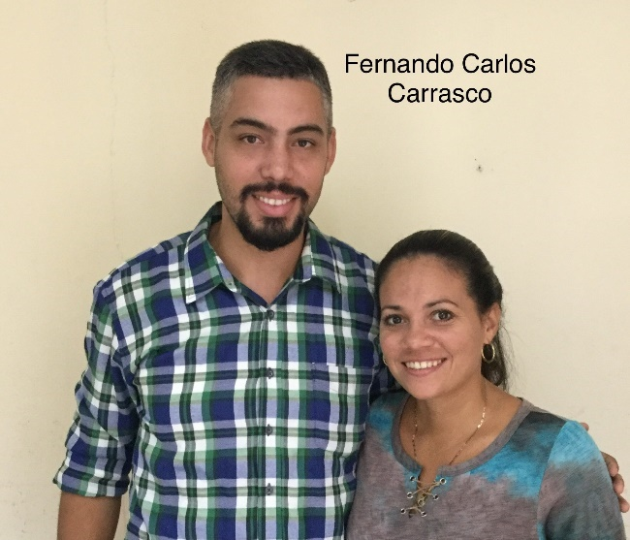
Full name: Fernando Carlos Carrasco Tamayo
Church and location: Baptist Church in San Benito de Mayari. Santiago de Cuba
Email address: fccarrascot@gmail.com
Telephone number: Mobile: +53 55073772
Average attendance of the church: 40 Adults: 32 Children: 8
Average monthly offering: 900.00 $36.00 USD
What are the five major needs of your church?
- Audio visual system ( computer, projector, console)
- Musical instruments (guitars, keyboard, tambourine)
- Construction of all phases
- Electric fans, lamps and curtains
- Biblical literature. Materials to work with children (crafts)
What are the five major needs of your family?
How many in your family? 2
- A motor scooter
- A laptop
- Electrical appliances (fans, washing machine, blender, gas stove)
- Clothes and shoes. Trousers size: 34 / shoes: 45 European size. Shirt: Medium. Wife’s shoes: 371/2 European size
- Bed sheets and towels

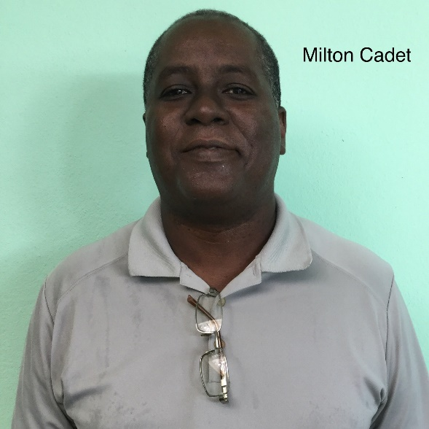
Full name: Milton Cadet Brown
Church and location: Baptist Church in Contramaestre. Santiago de Cuba
Email address: milton.cadet@nauta.cu
Telephone number: mobile: +53 22587104 / home: +53 53951355
Average attendance to the church: 370 Adults: 290 Children: 80
Average monthly offering: 18,000.00 $720.00 USD
What are the five major needs of your church?
- Major repairs of the temple. It includes a second floor.
- Either air condition or add more electric fans to the temple
- A newer audio system.
- Get another piano for the music school
- A printer and a projector for the classroom of the children

What are the five major needs of your family?
How many in your family? 4
- An air conditioner for the pastoral bedroom
- A cellphone
- A laptop
- A dining room set (a table and four chairs)
- Two beds for my children

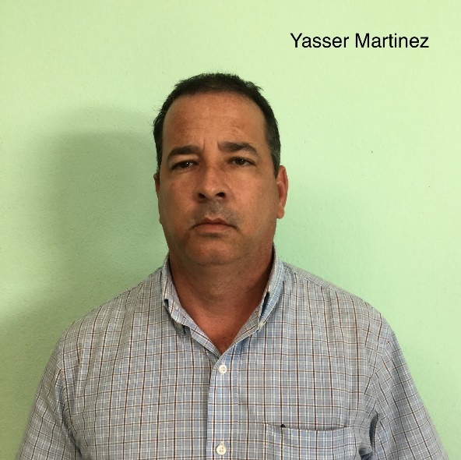
Full name: Yasser Martinez Rojas
Church and location: “Berea” Baptist Church. Mella. Santiago de Cuba
Email address: yasser.pastor@nauta.cu
Telephone number: mobile: +53 58566467
Average attendance of the church: 114 Adults: 90 Children: 24
Average monthly offering: 300.00 $12.00 USD
What are the five major needs of your church?
- Build classrooms for the different departments
- Audiovisual equipment
- A temple
- Chairs and benches
- Musical instruments such as keyboard, guitar

What are the five major needs of your family?
How many in your family? 4
- Clothes and shoes
- Furniture and closet
- Washing machine.
- clothes, pillows and blankets for the winter
- A new house (the current one is out of wood and was built in 1923

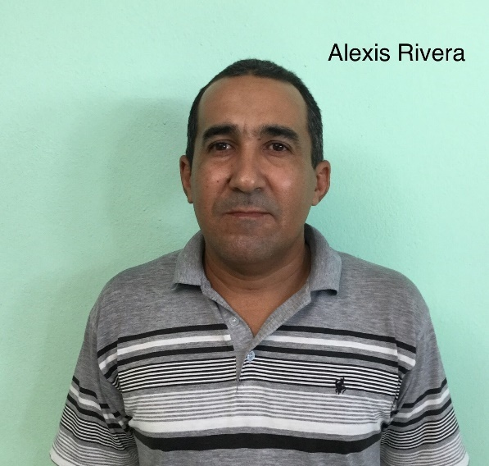
Full name: Alexis Rivera Alvarez
Church and location: 3rd Baptist church in Palma Soriano. Santiago de Cuba
Email address: alexis.rivera@nauta.cu
Telephone number: mobile: +53 54372700
Average attendance to the church: 150 Adults: 120 Children: 30
Average monthly offering: 5,000.00 $200.00 USD
What are the five major needs of your church?
- Construction of the temple
- Transportation for the church (horse carriage)
- Electric appliances: audio & music equipment, fans, printer
- Support for the missionaries/staff
- Chairs or benches

What are the five major needs of your family?
How many in your family? 3
- Furniture
- A means of transportation (motorcycle)
- Kitchen appliances
- Sewing machine
- A computer

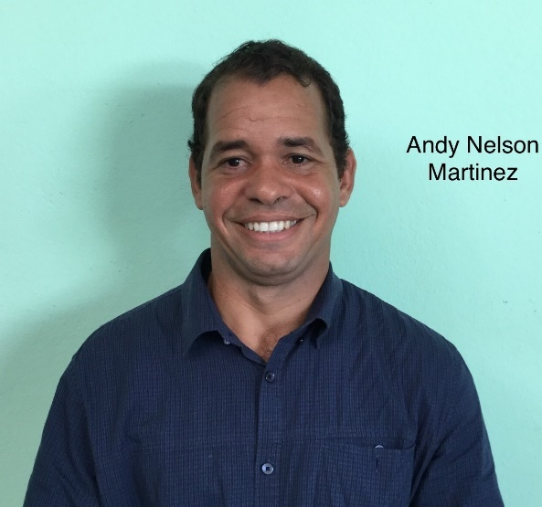
Full name: Andy Nelson Martinez Barroso
Church and location: Baptist Church “Los Olivos”. El Tamarindo. Contramaestre
Email address: andy7katy@nauta.cu
Telephone number: Mobile: +53 54687006
Average attendance of the church: 90 Adults: 70 Children: 30
Average monthly offering: 2,000.00 $80.00 USD
What are the five major needs of your church?
- Finish the building of the tabernacle- (3,500.00 CUC) floor,
windows, benches, materials
- Finish the kitchen of the church and enlarge a bedroom of
the parsonage- (1,500.00 CUC)
- Audio system ( we don’t have) (1,500.00 CUC)
- A freezer for the activities of the church (1,000.00 CUC)
- A TV set for the church (500.00 CUC)
What are the five major needs of your family?
How many in your family? 4
- A mattress for the children’s bed (200.00 CUC)
- A horse and carriage to visit the missions (700.00 CUC)
- A refrigerator 900.00 CUC)
- Electric fans two for each bedroom (100.00 CUC)
- A cellphone for my wife (150.00 CUC) medicine for kids

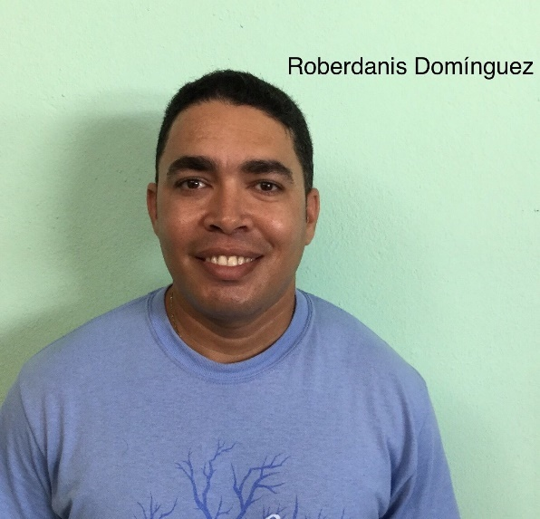
Full name: Roberdanis Dominguez Gomez
Church and location: 17th Baptist Church in Santiago de Cuba
Email address: roberdg86@nauta.cu
Telephone number: mobile: +53 53791091 / home: +53 -
Average attendance of the church: 40 Adults: 31 Children: 9
Average monthly offering: 600.00 $24.00 USD
What are the five major needs of your church?
- Classrooms for children and youth
- musical instruments and audio system
- Building of bathrooms, Paint
- Literature for the new believers. E.g. Bibles, booklets
- Laptop and a projector

What are the five major needs of your family?
How many in your family? 2
- A full size bed
- A washing machine
- A bicycle and a cooker
- A financial help to pay the bills (electricity, water, gas, etc.)
- A laptop for my studies

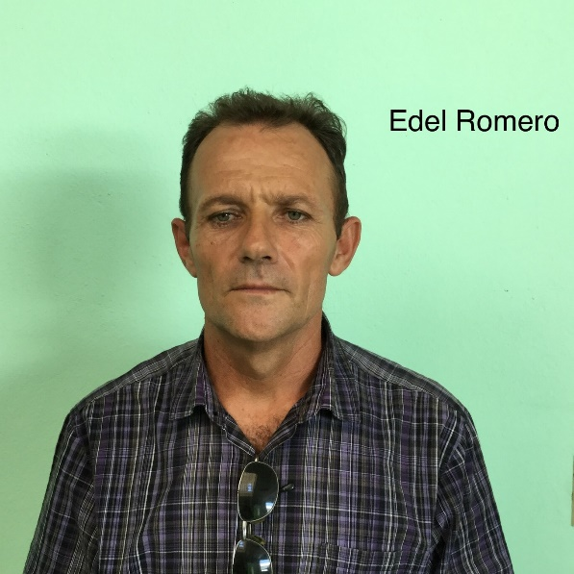
Full name: Edel Romero Fernandez
Church and location: Baptist Church in Maffo. Contramaestre. Santiago de Cuba
Email address: edel.re@nauta.cu
Telephone number: mobile: +53 55993769 / home: +53 22587565
Average attendance of the church: 126 Adults: 96 Children: 30
Average monthly offering: 3,000.00 $120.00 USD
What are the five major needs of your church?
- Support for full time missionaries/staff
- Musical instruments ( a keyboard, a set of drums)
- Shoes and reading glasses
- A projector
- Chairs or benches

What are the five major needs of your family?
How many in your family? 4
- A TV set
- A computer
- An electric cooker
- A closet
- A bicycle

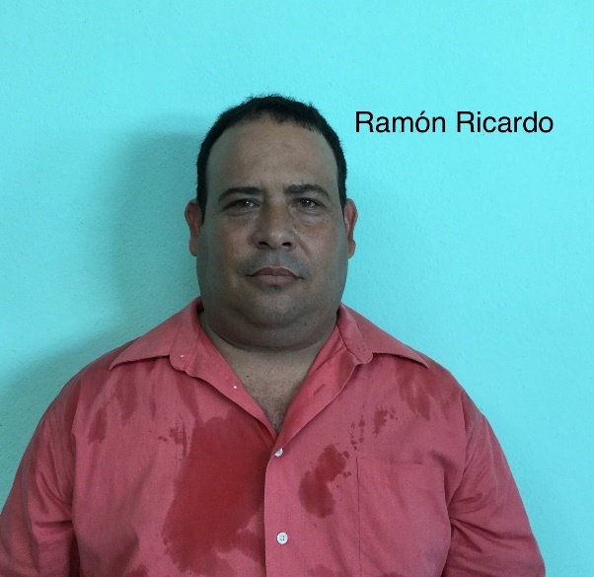
Full name: Ramon Ricardo Rodriguez
Church and location: Baptist Church “Ebenezer”. Mangos de Baragua. Santiago de Cuba
Email address: ramonricardo@nauta.cu
Telephone number: mobile: +53 54532305
Average attendance of the church: 60 Adults: 50 Children: 10
Average monthly offering: 300.00 $12.00 USD
What are the five major needs of your church?
- Repair the walls and the roof of the temple
- Musical instruments
- Benches
- Electric fans
- Music equipment

What are the five major needs of your family?
How many in your family? 5
- Shoes and clothes
- Computer
- Kitchen appliances
- Washing machine
- Mattresses

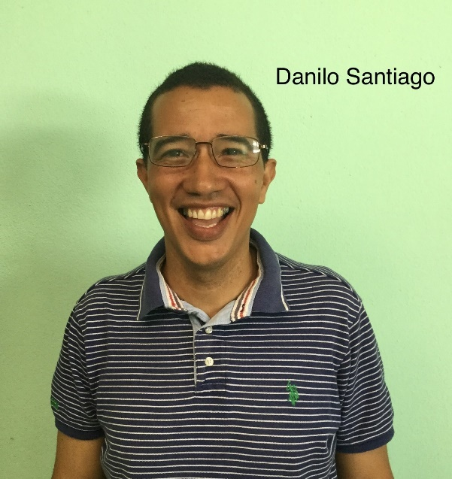
Full name: Danilo Santiago Moreno Grey
Church and location: 18th Baptist Church “Peña de Horeb” in Santiago de Cuba.
Email address: daniloirina@nauta.cu
Telephone number: mobile: +53 54960830
Average attendance of the church: 61 Adults: 46 Children: 15
Average monthly offering: 850.00
What are the five major needs of your church?
- Construction of the approved temple.
- Audio equipment, console
- An amplifier
- A drinking fountain
- A freezer
What are the five major needs of your family?
How many in your family? 3
- Medication for my wife who is sick. (Transfer-Factor Plus 500 mg Capsules)
- Washing machine
- Dining room set (chairs and table)
- A sponge mattress anti allergies.
- A bicycle

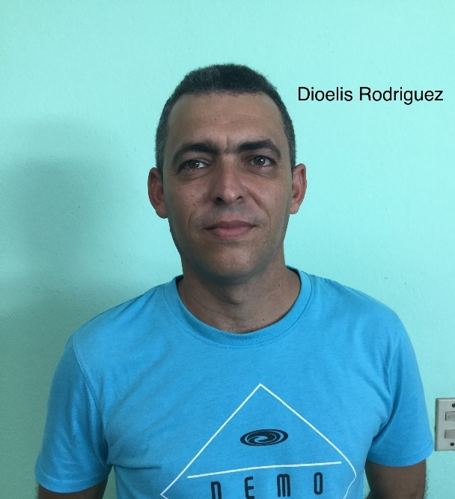
Full name: Dioelis Rodriguez del Rio
Church and location: “Maranatha” 20th Baptist Church in Santiago de Cuba.
Email address: drdelrio75@nauta.cu
Telephone number: mobile: +53 54445167
Average attendance of the church: 100 Adults: 80 Children: 20
Average monthly offering: 2,000.00 $80.00 USD
What are the five major needs of your church?
- Construction project. (it is already approved)
- Projector for classes( Bible institute, and Sunday School)
- Transportation to visit the members of the church
- Leaders who work full time
- Resources for children and for a sport ministries
What are the five major needs of your family?
How many in your family? 5 (3 children, 2 boys and a girl)
- A refrigerator
- A bed for my oldest son
- Please pray for my oldest son; he is high school and soon has to face an entry test to the university

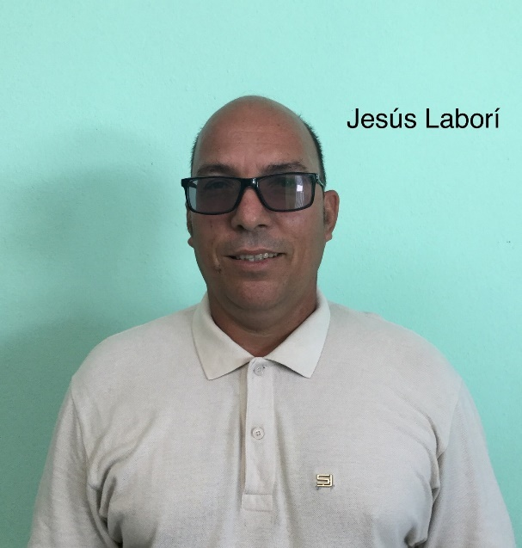
Full name: Jesus Labori Matos
Church and location: Baptist Church of Fomento. Santiago de Cuba
Email address:
Telephone number: mobile: +53 53886005 / home: +53 22641206
Average attendance of the church: 60 Adults: 40 Children: 20
Average monthly offering: 1,000.00 $40.00
What are the five major needs of your church?
- Property to build a church or tabernacle.
- Chairs and benches. No room already for the people
- Music equipment with microphones
- Bibles and evangelistic tracts
- A set for communion
What are the five major needs of your family?
How many in your family? 4 (two adults and two children)

- A fan for my son and daughter
- A bicycle for the pastoral work
- A sheet set
- A washing machine

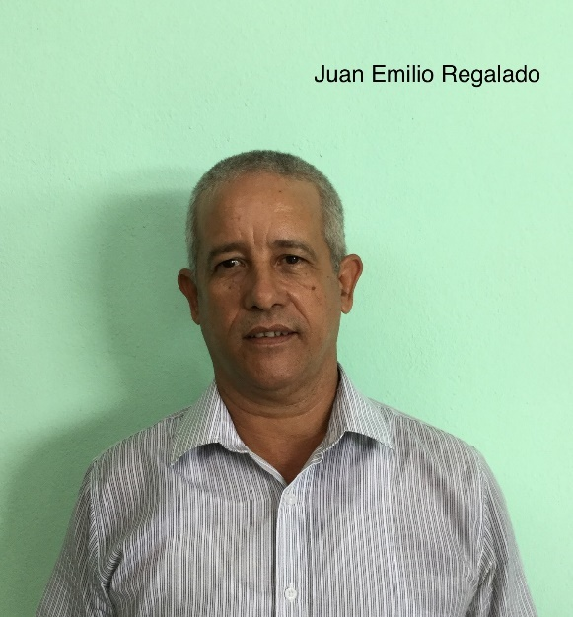
Full name: Juan Emilio Regalado
Church and location: Baptist Church in El Oasis. Santiago de Cuba.
Email address: jeregalado@nauta.cu
Telephone number: mobile: +53 54332817 / house: +53 -
Average attendance of the church: 70 Adults: 45 Children: 25
Average monthly offering: 1,400.00 $56.00 USD
What are the five major needs of your church?
- Support for two missionaries/Staff
- Support for snacks at Sunday School for children and senior
adults and also buy a freezer
- To purchase ink, printing cartridges, sheets of paper to make
tracts for evangelism and discipleship.
- Finances to support Evangelism

What are the five major needs of your family?
How many in your family? 4
- A refrigerator
- Clothes and shoes for the family
- A cellphone for me
- Bed sheets and towels
- A computer for a better development of my work.

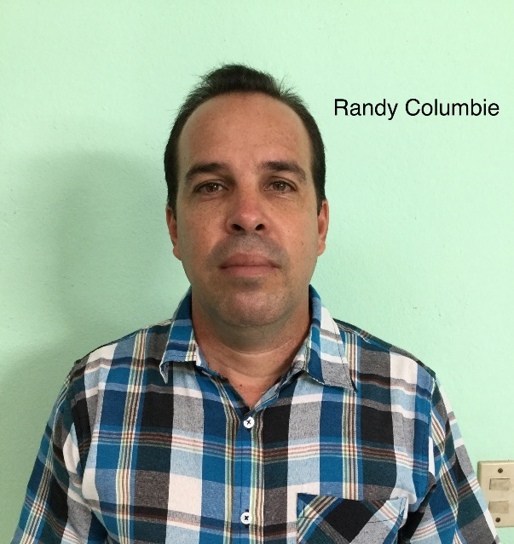
Full name: Randy Columbie Hechavarria
Church and location: 1st Baptist Church in Santiago de Cuba
Email address: randy.columbieh@gmail.com
Telephone number: +53 53737376 / home: +53
Average attendance of the church: 550 Adults: 490 Children: 60
Average monthly offering: 5,000.00 $200.00
What are the five major needs of your church?
- Rebuilding of spaces at the bottom part of the building,
given back after 55 years of government confiscation
- Establishment support Ministries to the Families, in order to
impact the community of Santiago.
- Establishment of new mission churches
- Printer for Discipleship program
- To develop a local Bible Institute. Fee for the professors.

What are the five major needs of your family?
How many in your family? 4 (my wife and two children, a boy and a girl)
- There are two pastoral families serving with me in the same church graduated from the Baptist Seminary
- Rev. Vismar Ramirez Oliveros (married 3 children) and Rev. Liusbel sabori Rodriguez ( single and takes of his two parents)
- Any help you can help our families with will always be gratefully received.

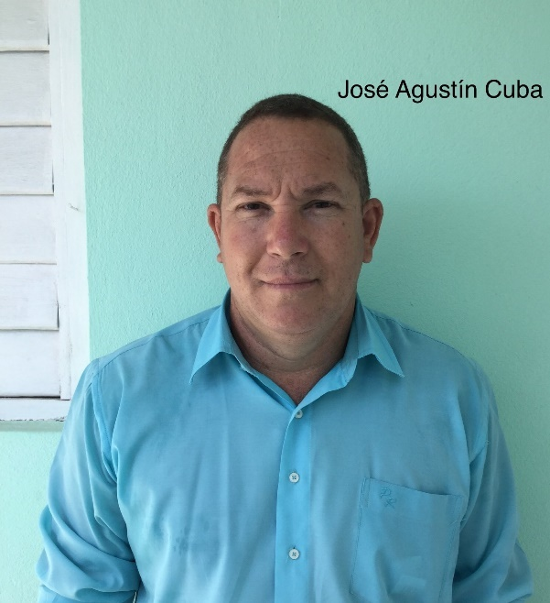
Full name: Jose Agustin Cuba
Church and location: 3rd Baptist Church in Mayari Arriba. Santiago de Cuba
Email address: joseacuba@nauta.cu
Telephone number: mobile: +53 53631541
Average attendance of the church: 150 Adults: 80 Children: 75
Average monthly offering: 1,400.00 $56.00
What are the five major needs of your church?
- To building a parsonage and a tabernacle in the back yard
- Instruction and training for the leadership
- Audio system since we have a lot of people
- Bible materials for children
- A power generator
What are the five major needs of your family?
How many in your family? 4
- An electric fan
- An iron
- Bed sheets
- A blender
- A means of transportation (a motor scooter)

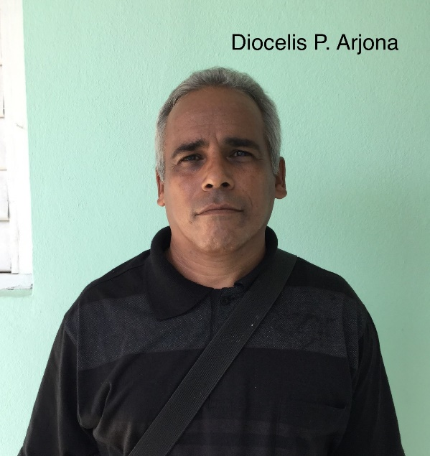
Full name: Diocelis Porfilio Arjona Cabrales
Church and location: Baptist Church in Los Negros. Contramaestre
Email address: darjonarafa45@nauta.com.cu
Telephone number: mobile: +53 56172403 / home: +53 22591391, 22591465
Average attendance of the church: 160 Adults: 120 Children: 40
Average monthly offering: 850.00 $34.00 USD
What are the five major needs of your church?
- Finances for the extension of the temple (6,000.00 CUC)
- A computer (Laptop)
- A cellphone for each missionary of the church (7 missionary)
- Musical instruments ( a piano, an electric guitar, a bass and
a drum set)
- A freezer from 250-260 liters (approximately 1,5 meters)

What are the five major needs of your family?
How many in your family? 3
- An automobile
- Finish construction of my own house (3,500.00)
- An air conditioner (split)
- A full size bed with its mattress
- A full size bed mattress

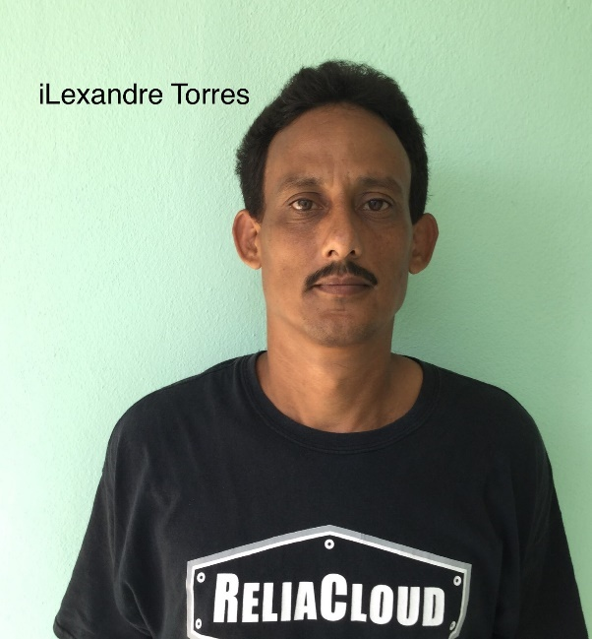
Full name: Ilexadre Torres Lobaina
Church and location: Baptist Church Bethel. Cruce de los Baños. III frente. Santiago de Cuba
Email address: ilexandre.torres@nauta.cu
Telephone number: mobile: +53 55634769
Average attendance of the church: 45 Adults: 27 Children: 18
Average monthly offering: 1,300.00 $52.00 USD
What are the five major needs of your church?
- Building a facility for meeting, building the parsonage
- Bathrooms for the facility
- Support for the missionary work
- Bible materials for the work with the children
- Power generator for the blackout we are facing

What are the five major needs of your family?
How many in your family? 5
- Furniture for the living room
- Two mattresses for my children’s beds
- An air conditioner
- A freezer
- A means of transportation ( a motor scooter) to visit the missionary circuit

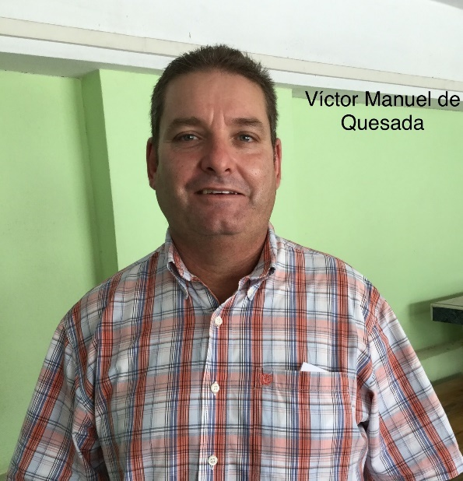
Full name: Victor Manuel de Quesada Perez
Church and location: Baptist Church in Baire, Santiago de Cuba
Email address: victor702mq@yahoo.es
Telephone number: mobile: +53 52713427
Average attendance of the church: 300 Adults: 230 Children: 70
Average monthly offering: 10,000.00 $400.00 USD
What are the five major needs of your church?
- Prayer
What are the five major needs of your family?
How many in your family? 4
- Prayer

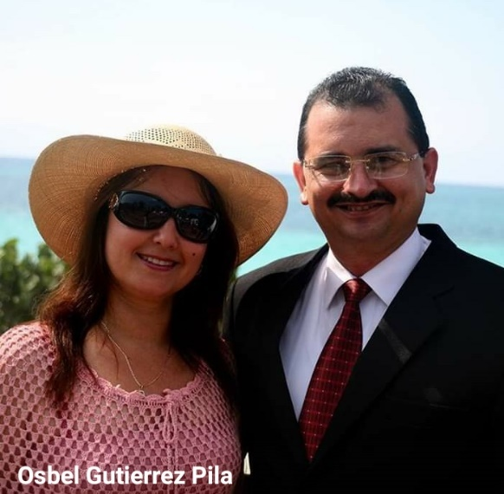
Full name: Osbel Gutierrez Pila
Church and location: 4th Baptist Church “Bethel” in Santiago de Cuba
Email address: osbelgutierrez@yahoo.es
Telephone number: mobile: +53 52948997 / church: +53 22624028
Average attendance of the church: 1,200 Adults: 1050 Children: 150
Average monthly offering: 55,000.00 $2,200.00 USD
What are the five major needs of your church?
- To extend the meeting room
- Improve the condition of the classrooms for Sunday School
- To increase and complete the dining room utensils (glasses,
dishes, etc..)
- Musical instruments (piano, trumpet, electric guitar)
- To have funds for the evangelism and missionary work

What are the five major needs of your family?
How many in your family? 5
- Two double bed mattresses
- A means of transportation (bicycle or motor scooter)
- A telephone for my wife
- Shoes for my children. Jonathan (34); jabnia (30) and jenny (28) these are European sizes
- A washing machine

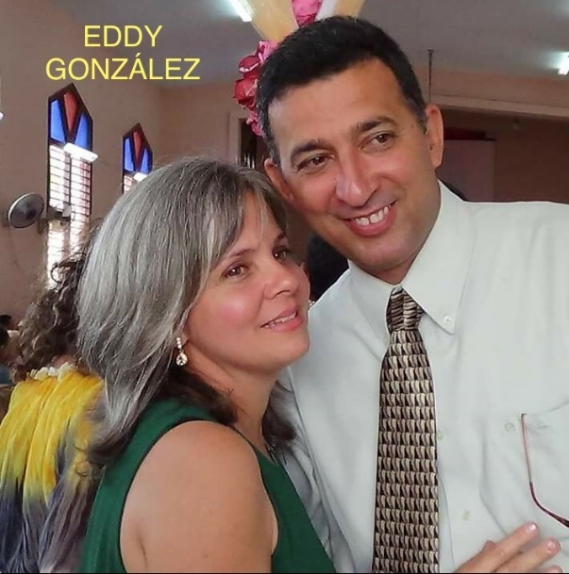
Full name: Eddy Gonzalez del Rio
Church and location: 3rd Baptist Church in Santiago de Cuba and Baptist Seminary
Email address: eddygr1970@gmail.com
Telephone number: mobile: +53 53388377
Average attendance of the church: 450 Adults: 370 Children: 80
Average monthly offering: 1,200.00 $48.00 USD
What are the five major needs of your church?
- To extend the main facility (construction and add benches
and electric fans)
- Bathrooms and two classrooms for the educational building
- Support for the senior adults ministry and disable people
- Musical instruments for the music school
- To have a budget to buy houses for planting of new churches
What are the five major needs of your family?
How many in your family? 5
- Finances to buy fuel for the transportation of the family
- Finances for the communication (top up the phones and internet)
- Payment of the electric bill
- A freezer
- A computer

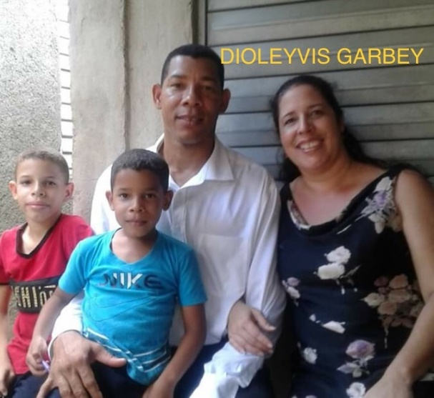
Full name: Dioleyvis Garbey Gonzalez
Church and location: Baptist church in dos Palmas Santiago de Cuba
Email address: ‘
Telephone number: mobile: +53 54202619 / home: +53 22534154
Average attendance of the church: 70 Adults: 55 Children: 15
Average monthly offering: 1,350.00 $54.00 USD
What are the five major needs of your church?
- Rebuilding of the parsonage, it leaks & the walls get wet
- Building of classrooms for the children. We don’t have any.
- To have a laptop and a printer to make tracts, programs, etc.
- A projector.
- A music equipment, sound board and microphones

What are the five major needs of your family?
How many in your family? 4
- Clothes and shoes
- Kitchen appliances
- A computer
- A toaster
- A house of my own

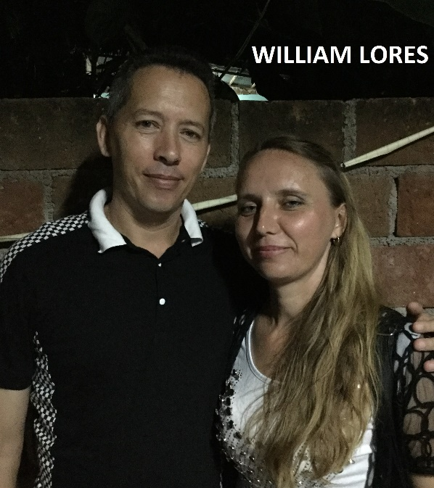
Full name: William Lores Perez
Church and location: Baptist Church in “Las Flores”. El Caney. Santiago de Cuba
Email address: willianlores@nauta.cu
Telephone number: mobile: +53 54525185
Average attendance of the church: 132 Adults: 95 Children: 37
Average monthly offering: 2,500.00 $100.00 USD
What are the five major needs of your church?
- Acquire a property for the temple. (1000.00)
- Building two bathrooms. (parsonage and temple)
- Bibles and New Testaments
- Benches and chairs
- Classrooms for Sunday School, etc.

What are the five major needs of your family?
How many in your family? 3
- A mattress (for a double sized bed)
- A bicycle
- An electric fan
- Shoes
- Kitchen appliances

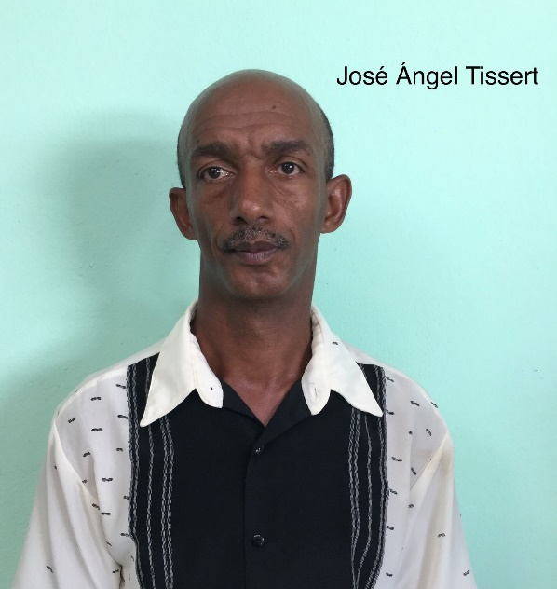
Full name: Jose Angel Tissert Tissert
Church and location: Baptist Church in La Cecilia. Ramon de las Yaguas. Santiago de Cuba.
Email address: -
Telephone number: mobile: +53 54810848
Average attendance to the church: 47 Adults: 35 Children: 12
Average monthly offering: 520.00 $20.00 USD
What are the five major needs of your church?
- A house to establish a new mission
- Bicycles for the missionaries
- A saddle for the horse
- Repairing of the parsonage
- Curtains, paint and mattresses

What are the five major needs of your family?
How many in your family? 4
- A washing machine
- A computer
- Clothes and shoes for the family
- A blender
- An electric fan. A closet (20.00 CUC)

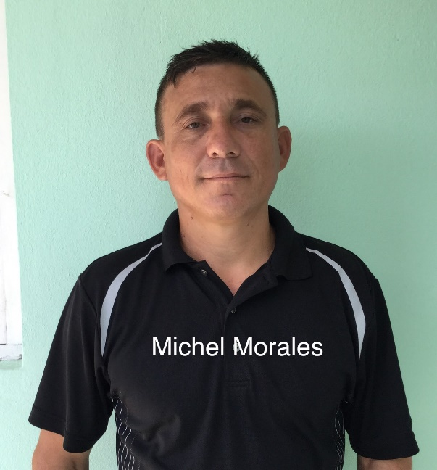
Full name: Michel Morales Avila
Church and location: 2nd Baptist Church in Palma Soriano. Santiago de Cuba.
Email address: michelmorales1980@gmail.com michel.morales@nauta.cu
Telephone number: mobile: +53 54074591
Average attendance to the church: 130 Adults: 105 Children: 25
Average monthly offering: 4,000.00 $100.00 USD
What are the five major needs of your church?
- Musical instruments (set of drums)
- Speakers
- Microphones with its lines
- Electric fans
- A computer

What are the five major needs of your family?
How many in your family? 5
- Two fans
- A dining room set
- Repair our living room set
- Bicycles tires
- A telephone

