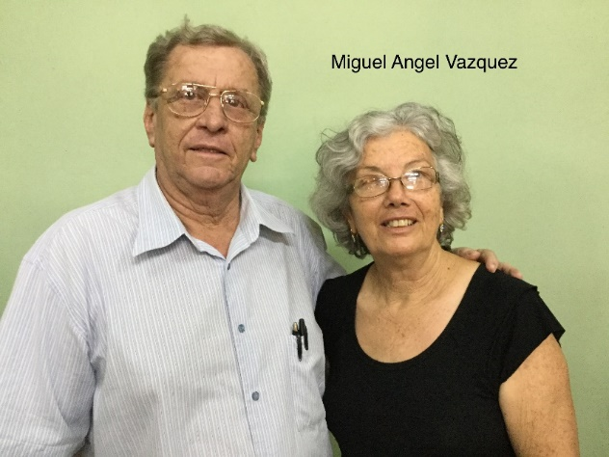
Full Name: Miguel Angel Vazquez Rodriguez
Church and location: 2nd Baptist Church in Baracoa
Email address: ministerioarmonia@nauta.cu
Average attendance to the church: 370 adults: 250 children: 120
Average monthly offering: $1,000.00 US Dollars

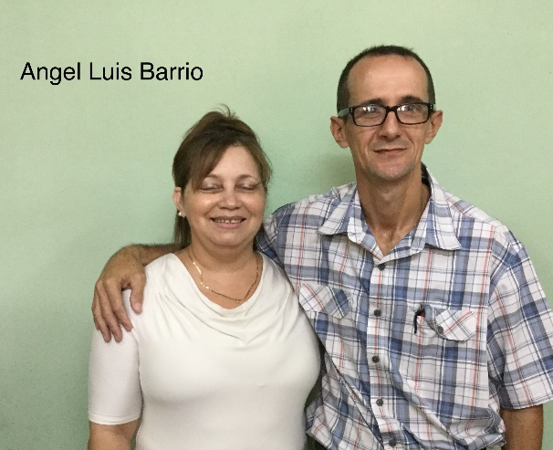
Full Name: Angel Luis Barrio Oliveros
Church and location: Third Baptist Church in Baracoa. Turey
Email address: angelluis71@nauta.cu
Average attendance to the church: 150 adults: 100 children: 50
Average monthly offering: $187.50 US Dollars

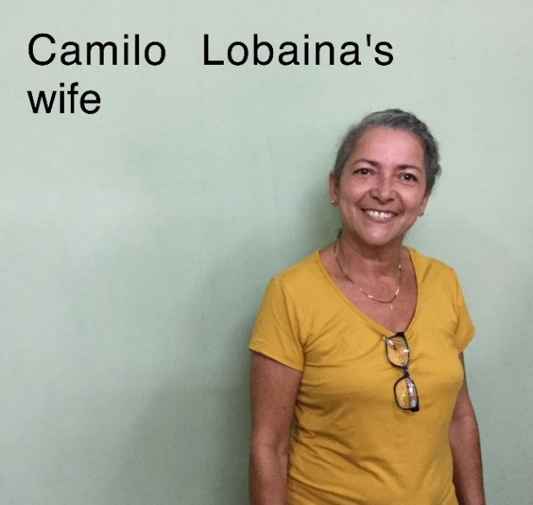
Full Name: Camilo Lobaina Matos (SUPPORTED)
Church and location: Bahia de Mata
Email address: camilorev@nauta.cu
Average attendance to the church: 150 adults: 100 children: 50
Average monthly offering: $125.00 US Dollars

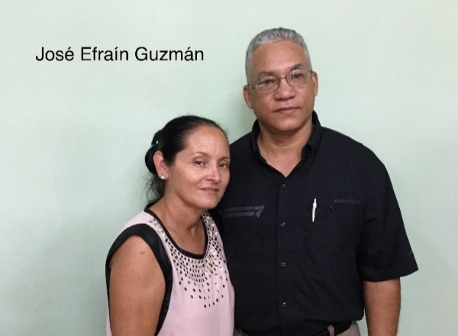
Full Name: José Efraín Guzmán Martinez
Church and location: 5th Baptist Church. Baracoa city.
Email address:
Average attendance to the church: 70 adults: 50 children: 20
Average monthly offering: $145.85 US Dollars

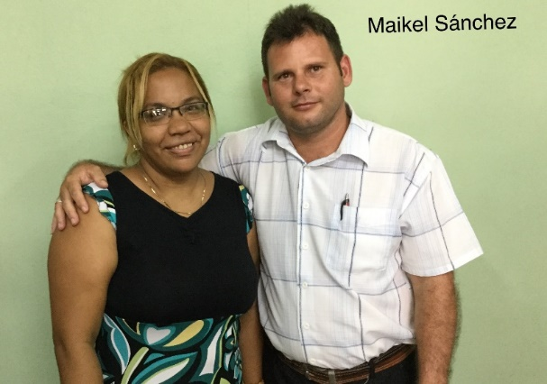
Full Name: Maikel Sanchez Portillo
Church and location: II iglesia Bautista Baracoa. (I am an associate pastor)
Email address: maikel82sanchez@nauta.cu
Average attendance to the church: 370 adults: 250 children: 12
Average monthly offering: $1,000 US Dollars

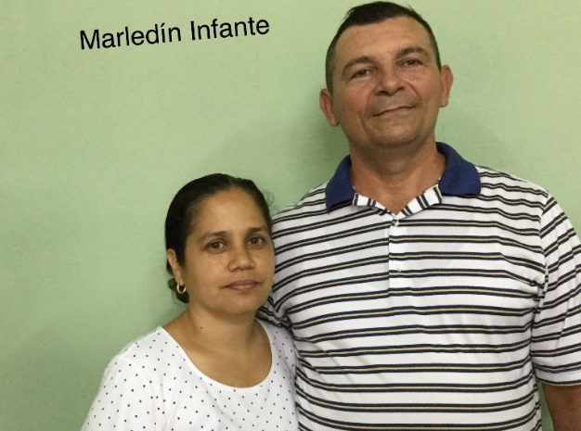
Full Name: Merledin Infante Matos
Church and location: Iglesia Bautista Betel. Hoyos de Sabanilla #46, Baracoa
Email address: mermada@nauta.cu
Average attendance to the church: 140 adults: 105 children: 35
Average monthly offering: $229.20 US Dollars
What are the five major needs in your church?

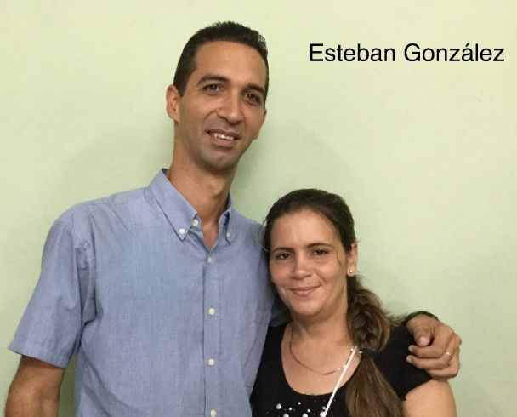
Full Name: Esteban Gonzalez Toirac (SUPPORTED)
Church and location: Iglesia Bautista Paso de Cuba, sabanilla. Baracoa
Email address: estebangt@nauta.cu
Average attendance to the church: 200 adults: 150 children: 50
Average monthly offering: $25.00 US Dollars

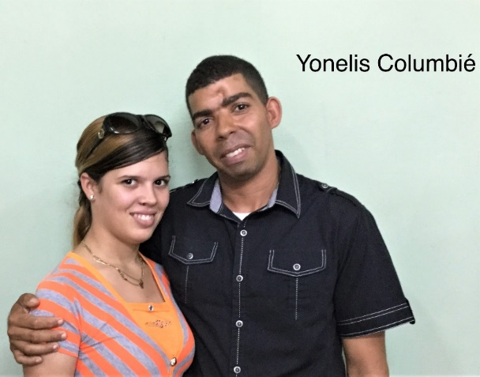
Full Name: Yonelis Columbie Campos
Church and location: Puerta de esperanza. Manglito, Baracoa
Email address: -
Average attendance to the church: 69 adults: 55 children: 14
Average monthly offering: $16.70 US Dollars

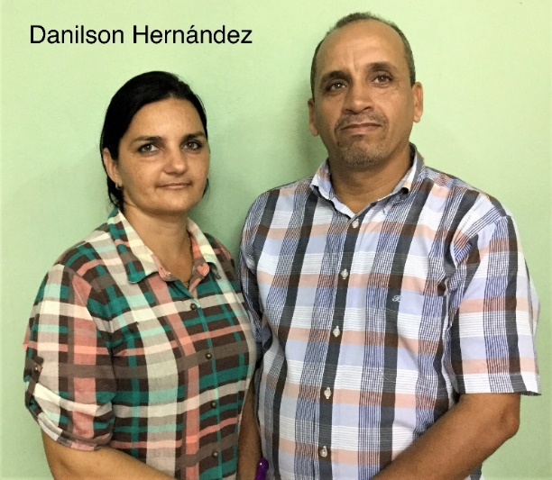
Full Name: Danilson Hernadez Jimenez
Church and location: La Hermosa de Mariana. Baracoa
Email address: danilson@nauta.cu
Average attendance to the church: 65 adults: 40 children: 25
Average monthly offering: $20.85 US Dollars

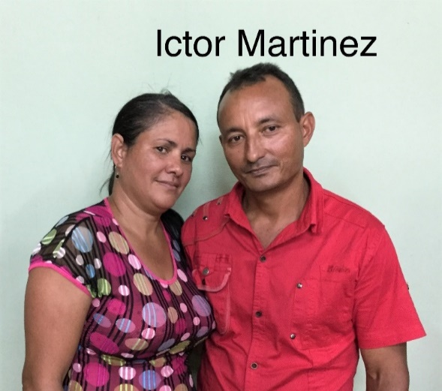
Full Name: Ictor Martinez Romero
Church and location: Getsemani. Arroyon de Capiro. Baracoa
Email address: -
Average attendance to the church: 105 adults: 80 children: 25
Average monthly offering: $41.65 US Dollars

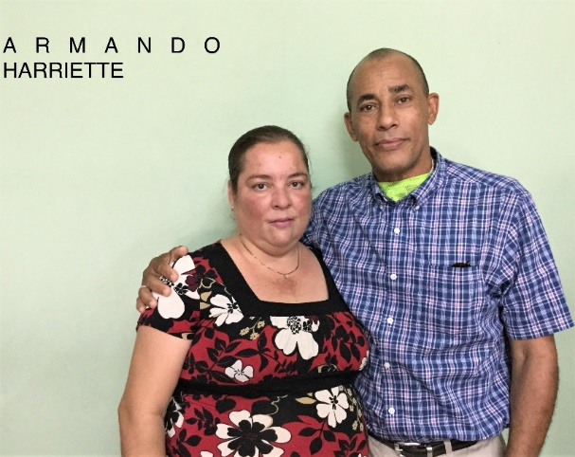
Full Name: Armando Harriette Barcelay
Church and location: fourth Baptist Church Baracoa “principe de paz”. La Granjita #19
Email address: armando7207@nauta.cu
Average attendance to the church: 78 adults: 56 children: 19
Average monthly offering: $50.00 US Dollars

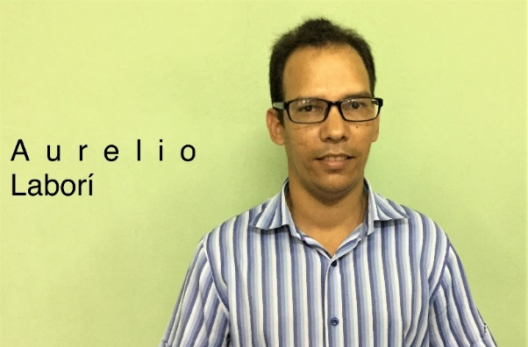
Full Name: Aurelio Labori Matos
Church and location: 1st Baptist Church in Baracoa
Email address: pastoraurelio@nauta.cu
Average attendance to the church: 385 adults: 305 children: 80
Average monthly offering: $62.50 US Dollars

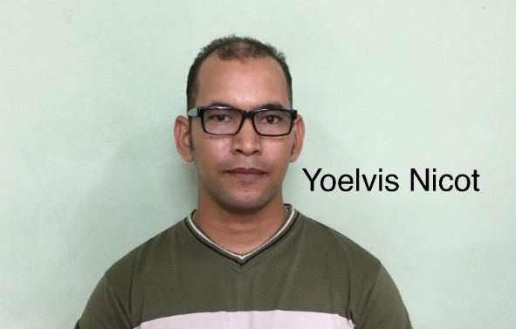
Full Name: Yoelvis Nicot Rodriguez
Church and location: 6th Bptist Church in Baracoa
Email address: ynicot86@nauta.cu
Average attendance to the church: 70 adults: 50 children: 20
Average monthly offering: $14.60 US Dollars

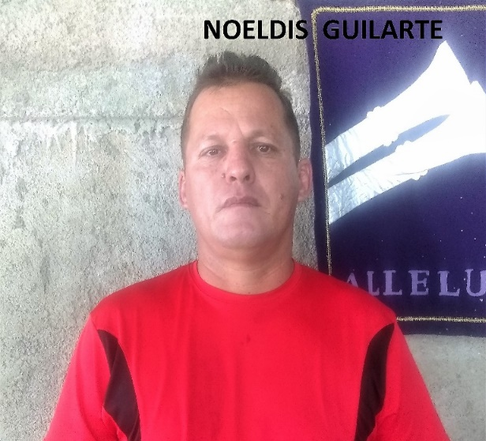
Full name: Noeldis Guilarte Barthelemy
Church and location: Iglesia Bautista. Maranatha. Nibujon. Baracoa
Email address: noeldis.guilarte@nauta.cu
Average attendance to the church: 166 adults: 111 children: 55
Average monthly offering: $32.81 US dollars
What are the five major needs in your church?

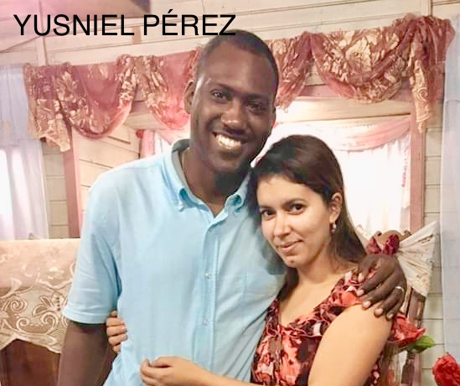
Full name: Yusniel Perez Montejo
Church and location: Baptist Church Antioquia de Capiro. Capiro. Baracoa
Email address: yusnielpm@nauta.cu
Telephone number: Mobile: +53 53917738 / home: +53-
Average attendance to the church: 100 adults: 80 children: 20
Average monthly offering: 900.00 - $36.00 USD

