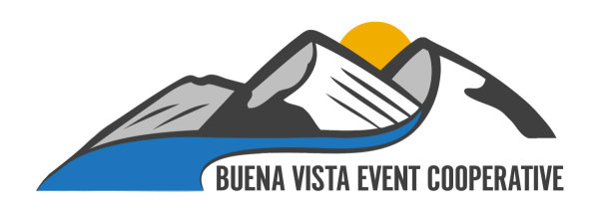

Hello Friend,

The 35th Annual *Mountain Mania Car Show* –*Powered by BVEC*, invites you to share in a wonderful event that showcases some of the finest vehicles in all of Colorado. This year’s show is **SATURDAY, JUNE 30** downtown on Main Street in beautiful Buena Vista, Colorado.

The show goes from 9 a.m. to 3 p.m., with parking beginning at 7 a.m.

The awards will be judged by owners, spectators, and event staff:

Car Owners Spectators Staff

* 20s / older * People’s Choice * Judge’s Favorite

* 30s * Most Unique * Rock n’ Roll

* 40s * Finest Engine * Best Off Road

* 50s * Finest Interior

* 60s * Best Truck

* 70s / newer

* GRAND CHAMPION

This year, the band will play on the street during the show! The popular Rock and Nostalgia band “**Blue Rooster**” will entertain the fans and car buffs alike in the center of the show at noon.

To pre-register, simply fill out the registration sheet and mail it back to:

Bea Harnish

P.O. Box 5273

Buena Vista, CO 81211

Include a check for $35, made out to **BVEC**. This entitles you to a free T-Shirt and plaque, so be sure to include your shirt size! You can register the up until the day of the show for $35, but participants may not get a T-Shirt if supplies are depleted. Please mail your check and registration back to Bea by **MAY 1.**

Any questions, call **TOM** at **719-966-9143**. We are really looking forward to seeing you June 30!

*Thank you!*