
DEPARTMENT OF THE ARMY
OFFICE OF THE DEPUTY CHIEF OF STAFF G-1
300 ARMY PENTAGON
WASHINGTON DC 20310-0300

DAPE-AR 27 August 15

MEMORANDUM FOR Senior Army Commanders and Senior Commanders of Army Elements (SCAE) on Joint Bases

SUBJECT: Teen Resilience and Performance Curriculum – Army Wide Release of V2.0- Memorandum of Instruction (MOI)

1. References:

a. Army Regulation (AR) 350-53, Comprehensive Soldier and Family Fitness (CSF2), dated 19 June 2014.

b. Army Directive 2014-23 (Conduct of Screening and Background Checks for Individuals Who Have Regular Contact with Children in Army Programs), dated 10 September 2014.

c. G-1, DAPE-AR (CSF2): Resilience and Performance Training for Teens, Version 1.1 (Controlled Release), Aug 2014.

d. G9, IMCOM, OPORD 15-103: Implementation of Teen Resilience and Performance Curriculum through Child, Youth, and School (CYS) Services (U)

e. Local guidance as applicable.

2. One of the Army Resiliency Directorate (ARD) Comprehensive Soldier & Family Fitness (CSF2) program goals is to create voluntary opportunities for resilience training for Army Family members. In answer to requests from the field, ARD CSF2 developed and piloted Teen Curriculum for two consecutive academic school years (2013-2014 and 2014-2015), training over 4000+ Army Teens. Program evaluation support from Walter Reed Army Institute of Research has confirmed the efficacy of this curriculum, which is now ready for Army wide voluntary delivery.

3. The goal of the Teen Curriculum is to translate the skills that are currently trained to Soldiers and Spouses into an adolescent appropriate topics for Army teens. The intent is to provide Army Families with a common language around resilience and performance skills. Army demands on family life can be difficult yet rewarding. This curriculum provides valuable skills to Army Families in managing adversity, challenges and change.

4. Senior Commanders (Active Duty Installation, Reserve, and Guard) will establish priority and coordinate delivery of the Teen Curriculum. The Community Health Promotion Council (CHPC) provides an ideal coordinating function for this initiative and the CSF2 Training Centers. Key voluntary stakeholders may include Child Youth & School Services (CYSS), Installation School Liaison Officers (SLOs), CSF2 Program Managers, National Guard and Army Reserve Family Programs, and local DODEA schools.

a. Youth Safety is the most critical aspect of this curriculum. Mandatory guidance is provided to ensure youth safety regulatory requirements are implemented. Per reference 1.b., instructors must have background checks (in addition to existing requirements that may exist for security clearances related to their normal duty positions) prior to implementing instruction of the Teen Curriculum. Enclosure 4 (Instructor Rules) provides a mandatory checklist to assist instructors in meeting these requirements. Other mandatory legal stipulations may be unique to individual locations. Please consult with your servicing Judge Advocate General (JAG) office for additional local mandates.

b. Instructor selection requires special engagement by the program manager to ensure the most qualified, skilled Master Resilience Trainers (MRTs) are selected for participation. It is recommended that MRTs with expertise in adolescent education and development are selected as instructors. Enclosure 3 (Instructor Selection Guidance) details key attributes of successful instructors and will assist in instructor selection. Within the Army Reserve/National Guard, all Teen Curriculum deliveries will be managed through their respective Child, Youth and School Services Program personnel.

(1) All instructors will be Master Resilience Trainer (MRT)-Level 1 or higher. It is recommended that MRTs have experience in adolescent education and development. Not all MRTs are good candidates for training teenagers and the best adult MRT may not be the best MRT to instruct teens. Choosing the right individuals to be your MRTs is important, but choosing the right MRTs to instruct the Teen Curriculum is essential.

(2) CSF2 Training Center (CSF2 TC) Managers and Installation Program Managers will assist in coordinating training with you and your local stakeholders to facilitate accomplishment of local teen training goals. Organizations without a CSF2 TC or an Installation Program Manager can coordinate directly with CSF2 to address questions, comments, and concerns.

c. Legal review and approval is required prior to implementation. Senior Commanders are advised to consult their local JAG office to ensure compliance.

5. The point of contact for the CSF2 Teen Curriculum is usarmy.pentagon.hqda-dcs-g-1.list.resilience-training@mail.mil.

5 Encls: KEVIN A. BIGELMAN
1. Overview COL, FA
2. Teen Curriculum Skills Description Chief, Operations and
3. Instructor Selection Guidance Training Division
4. Instructor Rules
5. Parental Consent

Encl. 1 – Overview
- Overview Teen Curriculum Description, Instructor Selections, and Applicability. The Teen Curriculum Version 2.0 is an Army wide release. A continual lifecycle management process will be used on the Teen Curriculum to ensure that After Action Reviews (AARs) from Teen Curriculum deliveries will inform future Teen Curriculum releases. For active duty installations, access to the curriculum is granted through CSF2 TCs. For the National Guard and Army Reserve, access to the curriculum is granted through HQ CYPCs, Ms. Dana Ivory (dana.c.ivory.civ@mail.mil), Ms. Patricia Sowell (patricia.l.sowell.civ@mail.mil) and Mr. James Moore (james.p.moore12.civ@mail.mil) for the National Guard, and Ms. Renee Podolec (renee.l.podolec.civ@mail.mil) for the Army Reserve. Access to the Teen Curriculum will be provided on a case-by-case basis and only upon confirming that youth safety requirements have been met (IAW Army Directive 2014-23). The DoD Central Adjudication Facility (CAF) is responsible for making favorable suitability determinations in accordance with guidance form the Deputy Assistant Secretary of Defense (Civilian Personnel and Policy). The DoD CAF will receive and review results from the Child Care National Agency Check and Inquiries (CNACI) to determine favorability suitability. All Teen Curriculum deliveries must include either an MRT instructor with a CNACI clearance, or an MRT instructor partnered with a CNACI approved individual (such as from CYSS or CYPC in the NG and AR).

a. Curriculum Description. The Teen Curriculum has been developed by ARD CSF2 for application Army wide, including the Army Reserve, and Army National Guard. Enclosure 2 (Teen Curriculum Skills Description) provides a detailed description of the skills presented within the Teen Curriculum.

b. Delivery.

(1) The Teen Curriculum offers two delivery options: 1) a 2 Hour Teen Workshop, which will provide teens with an introduction to resilience and teach the foundational skills of Hunt the Good Stuff, Goal Setting, and Activating Events/Thoughts/Consequences (ATC) and 2) the full Teen Curriculum, which will teach the skills of Goal Setting, Hunt the Good Stuff, Activating Thoughts and Consequences (ATC), Energy Management, Avoid Thinking Traps, Detect Icebergs, Problem Solving, Put It In Perspective, Mental Games, Real-Time Resilience, Identifying Character Strengths in Self and Others, Character Strengths / Challenges in Leadership, Assertive Communication, and Effective Praise and Active Constructive Responding (modules average 45-50 minute each, with 15 modules totaling 11.25 hours total course time). The full Teen Curriculum provides the entire 14 skills that are taught in the Master Resilience Trainer Course (MRT-C), and mirrors the MRT-C provided to adult learners in an age appropriate format.

(2) Order of Skills. Instructors are required to teach the Teen Curriculum Skills in the order they are presented within the accompanying Instructor and Participant Guides, specifically: 1) Goal Setting, 2) ATC, 3) Hunt the Good Stuff, 4) Energy Management, 5) Avoid Thinking Traps, 6) Detect Icebergs, 7) Problem Solving, 8) Put It In Perspective, 9) Mental Games, 10) Real-Time Resilience, 11) Identifying Character Strengths in Self and Others, 12) Character Strengths / Challenges in Leadership, 13) Assertive Communications, and 14) Effective Praise and Active Constructive Responding.

c. Instructor Selections. It is recommended that selected voluntary MRTs have expertise in adolescent education and development. Enclosure 3 (Instructor Selection Guidance) provides guidelines on successfully identifying instructors. Within the Army Reserve/National Guard, all Teen Curriculum deliveries will be managed through Child Youth Program Coordinators (CYPC).

(1) Senior Commander Selected MRTs. MRTs will be selected on a case by case basis by their Senior Commanders. As a result, not every CSF2 certified MRT will have access to the Teen Curriculum. Instructors must be trained on MRT Version 3.0 to be able to train the performance skills of Goal Setting and Energy Management that are included in the Teen Curriculum; MRTs who are trained on MRT Version 2.0 or earlier, and selected for instruction, should contact their local CSF2-TC to receive this additional training. MRTs who are selected for the Teen Curriculum delivery will not distribute the Teen Curriculum to other MRTs or any other person not approved by the command.

(2) CSF2 -TCs. CSF2-TCs own and deliver additional skills related to Performance Enhancement (Mental Skills Foundation, Building Confidence, Attention Control, and Integrating Imagery), and Learning Enhancement (Your Learning Mindset, Plan and Prioritize Your Time, Make Study Effort Count, Remember What You Study, Take Effective Notes, Attack Your Reading, Learn With Your Peers, Combat Your Tests). These skills can only be delivered by CSF2-TC approved MRT-Performance Experts (MRT-PEs). MRTs are not qualified or approved to conduct training of these additional Teen Curriculum skills.

d. Applicability. The Teen Curriculum is designed to provide maximum venue flexibility to curriculum instructors. Based upon successes in Teen Curriculum pilots, a multitude of settings are appropriate for Teen Curriculum delivery, to include: 1) local DoD high and middle schools, 2) afterschool programs, 3) Installation Teen Centers, 4) teen events, such as organized “teen nights,” 5) Army Reserve and National Guard (AR/NG) events, through Family Program Child, Youth & School Services, to include AR/NG Teen Councils, Teen Panel Trainings, Family Days, Yellow Ribbon events, Battle Training Assembly, and Youth Volunteer Training, 6) JROTC cadet training, 7) local high school sport teams/clubs, and 8) summer camps conducted for Army dependents, such as Child Youth School Services (CYSS) summer camp programs. Teen Curriculum instructors will be empowered to expand these venues as appropriate at each installation. The Teen Curriculum has been designed to support these multiple training platforms, providing high tech and low tech guidelines to instructors.

(1) Target Participants. The target participants for this Teen Curriculum are military-dependent youth in 7th-12th grades. Installations may also use this Teen Curriculum for teens that are transitioning from 12th grade to college. The Teen Curriculum Instructor Guides provide detailed notes on how the Teen Curriculum can be adjusted for age appropriate activities for 7th-8th graders, and 9th-12 graders. MRTs chosen for Teen Curriculum delivery must carefully review this guidance, and prepare for skill delivery accordingly.

(2) Instructor to Student Ratio. CSF2 recommends that for each Teen Curriculum Delivery, a minimum instructor to participant ratio of 1 instructor per 15 teen participants. Youth Safety requires a minimum of 2 adults within line-of-sight for every training situation (IAW Army Directive 2014-23).

2. Program Execution:

- Strategic Planning. Senior Commanders (or their delegates) directly engage voluntary key stakeholders in developing their Teen Curriculum Strategy: Child Youth & School Services (CYSS) for active duty, including School Liaison Officers (SLOs), Family Program Child, Youth & School Services within the AR/NG, Department of Defense Education Activity (DODEA) administrators where applicable, Army Community Services (ACS), Army afterschool program leaders, CSF2-Program Managers (CSF2-PMs), and CSF2-TC Managers. CYSS, and Family Program Child, Youth & School Services within the AR/NG, will also provide valuable insight into existing curricula that are being offered to teens, ensuring that the CSF2 Teen Curriculum does not duplicate existing efforts; a primary goal is to provide Soldiers and their Families with a common language around resilience, so in this regard recommendation is made that the CSF2 Teen Curriculum is used to provide a disciplined, consistent delivery of resilience skills training. This effort is completely voluntary, and at the discretion of each of these named organizations.

b. Quality Assurance/Quality Enhancement (QA/QE): Senior Commanders may request their nearest CSF2-TC to conduct a QA/QE review of Teen Curriculum deliveries to ensure that selected MRTs are delivering the Teen Curriculum to CSF2 standard. CSF2 has a standardized QA/QE process to evaluate all Teen Curriculum deliveries, ensuring that instruction is delivered to recommended best practices, and CSF2 standards.

c. Senior Commanders are advised to consult the local servicing Judge Advocate General office for a legal review determination.

3. Mandatory Youth Safety. Background investigations and security precautions are required to be completed and documented to ensure that the teens engaged in this delivery are protected from the threat of predation (IAW Army Directive 2014-23). American society and our national system of law enforcement and jurisprudence does not tolerate violations of any child and youth safety requirements. There is a zero tolerance policy on Teen Curriculum instructors not adhering to background investigation requirements (IAW Army Directive 2014-23).

- Instructor Rules. Enclosure 4 (Instructor Rules) provides specific guidance to Teen Curriculum instructors. These include:
- Instructors will never work one on one with teens, but will always be within line-of-sight of another adult trainer.
- Physical contact with teens will not occur at any time.
- Instructors will not communicate with individual teens through social media or texting.
- Instructors will not provide transportation to and from Teen Curriculum delivery.
- Engagement with teens will be limited to the Teen Curriculum delivery setting.

b. Teachers and Afterschool Facilitator Support. CSF2 recommends that where possible, existing classroom teachers, as well as afterschool facilitators, stay engaged with MRTs during Teen Curriculum delivery. Through pilot experience of the Teen Curriculum, existing teacher/facilitator support can provide a valuable contribution by maintaining discipline of the classroom, while MRT instructors focus on skills delivery and group activities.

c. Behavioral Health Support. The Teen Curriculum is not intended as therapy or counseling for any mental health issues, nor is it intended to replace therapy or counseling. This is clearly marked on the Teen Curriculum, and the MRTs who are selected for training are provided with instruction to identify behavioral health support for each venue where the Teen Curriculum is delivered. Teen Curriculum MRT instructors must have a plan in place addressing the location(s) where additional behavioral health support can be obtained in the event that a student discloses sensitive information that requires professional support. For example, during the resilience training, participants may present personal information regarding sensitive issues (e.g., depression, suicidal thoughts, eating disorders, or violence at home) and the training team must be prepared to respond appropriately by reporting this incident to a behavioral health support that can provide specialized support to the teen participant. Behavioral Health Support must be identified in advance of the Teen Curriculum delivery through installation services, Military One Source, community based mental health services, or school administrators.

d. Administrative Requirements.

- Instructors will provide the following to HQ, usarmy.pentagon.hqda-dcs-g-1.list.resilience-training@mail.mil.

(a) Summary of training plan, including the age range and approximate number of participants, where the training will occur, and who is responsible for delivery.

(b) Instructors will provide Enclosure 4 (Instructor Rules) on each member of the Teen Curriculum training team. There are NO EXCEPTIONS to this requirement. Access to the Teen Curriculum will not be provided until this requirement is met.

(c) After Action Reviews (AARs). This requirement enables the CSF2 Directorate of Curriculum (DoC) to incorporate valuable lessons learned and best practices found useful within the controlled release, thereby refining, validating, and improving the Teen Curriculum.

(2) Training teams will keep on file parental consent forms (Enclosure 5) for every student being trained. A signed parental consent form is a mandatory pre-requisite to training.

Encl. 2 – Teen Curriculum Skills Description
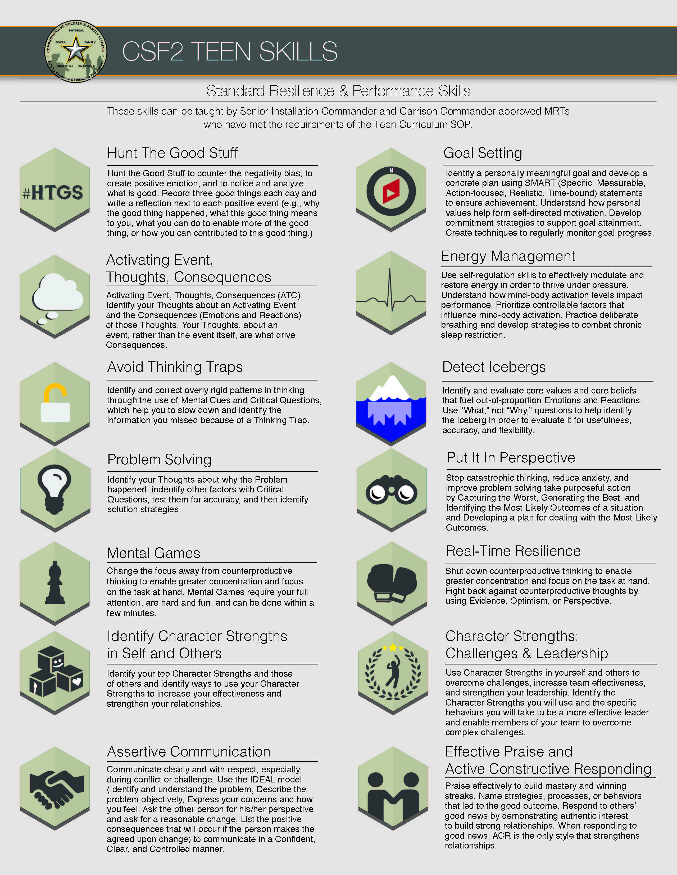

Encl. 2 – Teen Curriculum Skills Description

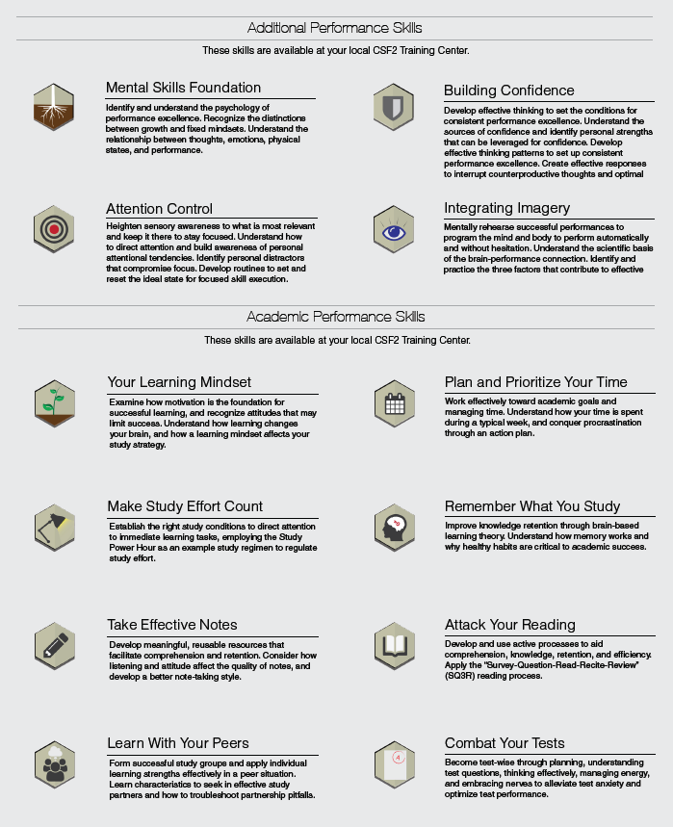
Encl. 3 –Instructor Selection Guidance
The following attributes are provided to assist installations in identifying a teen instructor (MRTs with expertise in adolescent education and development, or CSF2-TC MRT-PEs where available) for Teen Curriculum delivery. These attributes are being provided to increase the success for course delivery.

- Completion of MRT-Level 1 Course (Mandatory)
- Skills updated to MRT-C V3 (to include training on Goal Setting and Energy
Management)
- Experience in curriculum delivery to Soldiers and spouses for CSF2 skills-
based training (resilience and performance enhancement).
- Awareness of differences in training adult versus teen learners:
  - Increased energy in teen students
  - Increased need for interactive exercises to manage this energy (less
talking from the instructor, and more team exercises/hands on dialogue)
  - Increased need for individual student praise, acknowledgement, and
attention during curriculum delivery
  - Increased identification of individual strengths, and the ability to direct
students to apply individual strengths to the learning process
  - The ability to structure a classroom in a fashion to facilitate the
learning process and focus teen attention
  - Ability to identify and direct sensitive topics that may be emotional in a
teen population, and ability to direct adolescents in need of further support to identified behavioral health experts
  - Understanding that Teens learn more from concrete examples
than abstract examples, and the ability the make this adjustment for adolescent learners
- Previous work experience and education on adolescent learning and
development
- Background Investigations completed for child and youth safety (IAW
Army Directive 2014-23) providing CNACI background clearance or line of sight coverage.

Senior Commanders (or designated representative) are encouraged to use this checklist as instructor selections are identified for the Teen Curriculum delivery.

Note: All training teams must include at least one individual who has been trained to “identify and refer” youth exhibiting emotional distress.

Encl. 4 –Instructor Rules

Instructions: MRTs who have been nominated by their Senior Commanders to instruct the Teen Curriculum are required to complete the letter below. Please use the blue highlighted areas to provide your specific feedback, and sign and date. Completion of this form is required prior to obtaining access to the Controlled Release.

<INSERT DATE>

TO: Army G-1, Army Resiliency Directorate- Teen Curriculum
ATTN: usarmy.pentagon.hqda-dcs-g-1.list.resilience-training@mail.mil
RE: Resilience and Performance Training for Teens- Completion of Instructor Requirements

This letter confirms that the following steps have been completed in preparation of delivery of the Resilience and Performance Training for Teens Curriculum at <INSERT LOCATION>, where I will be engaged with training <INSERT NUMBER> of Teens during <TIMEFRAME>:

- I completed the MRT-C on <INSERT DATE> at <INSERT LOCATION>
- I am updated on MRT-C V3, to include formal training on Goal Setting and
Energy Management
- I completed my background investigation and met all volunteer process
requirements through <INSERT SCHOOL NAME, CYSS CENTER, AFTERSCHOOL PROGRAM NAME, AND DATE COMPLETED> (Army Directive 2014-23). This requires that all MRTs either possess or are partnered with personnel carrying a CNACI for line of support oversight.
- I understand who my contacts are within behavioral health, and agree to
share any knowledge from teens that is shared with me during the course of this training that represents a risk to the teen’s mental and physical health, or to the well-being of others.
- I have been in communication with my local or regional CSF2-TC to coordinate this
training delivery, and the CSF2-TC is fully aware of my training delivery.
- I have reviewed the Resilience and Performance Training for Teens
Curriculum, and addressed my questions and concerns on delivery through Teen Curriculum subject matter experts. I am prepared to lead the Teen Curriculum.
- I have previous experience teaching resilience skills, or previous experience
working with teens. This experience has been conducted at:

<INSERT DESCRIPTION OF PREVIOUS EXPERIENCE>

- I understand Instructor Rules with Teens in my course (please initial your understanding below) (IAW Army Directive 2014-23):
____ I agree that student engagement will be limited to the classroom setting, and that physical contact will not be made at any time.
____I agree that I will not interact with students outside of Teen Curriculum delivery (including social media sites).
____I confirm that I either possess a CNACI or am partnered with Army personnel (such as CYSS, CYPC) who do have a CNACI to provide mandatory line of sight supervision.
____I agree that I will not provide students with rides to or from this training.
____I agree that I will not engage with any student on a one on one basis; at all times during training, I will maintain line-of-sight with another adult trainer or teacher.
____I have read the Resilience and Performance Training for Teens Memorandum of Instruction, and understand that I must submit this letter prior to curriculum delivery to usarmy.pentagon.hqda-dcs-g-1.list.resilience-training@mail.mil. I understand CSF2’s zero tolerance for any violation, or appearance of violation, around the Instructor Rules with Teen participants, and agree that I will adhere to this guidance.
Regards,

_________________________________ __________________________
Signature Date

____________________________________
Printed Name

Encl. 5 - Parental Consent

Instructions: MRTs who are responsible for delivering the Teen Curriculum are required to provide parental consent forms prior to the commencement of the Teen Curriculum delivery. CSF2 recommends that this is distributed a minimum of 2 weeks prior to the course start date.

<INSERT DATE>
Dear Parents,
Throughout the course of the <INSERT TIMEFRAME>, your child will have the opportunity to participate in a program of skills based training to increase their individual resilience and performance, called Resilience and Performance Training for Teens. This program is targeted for adolescents, and is based upon a state of the art adult program delivered to U.S. Army Soldiers and their spouses.
When faced with stress and/or adversity, resilience is the key factor in mental, emotional, and behavioral ability to cope with and recover from the experience, achieve positive outcomes, adapt to change, stay healthy, and grow from the experience. Performance enhancement engages the mental, emotional, physical skills, learning skills and health that generate optimal human performance, empowering individuals to perform at their best when it matters most.
The Army’s Comprehensive Soldier & Family Fitness (CSF2) team has been delivering performance enhancement, and resilience skills based training to Soldiers and spouses since 2010, with significant positive results in improving the lives of countless individuals. Technical reports on the outcomes of this adult training can be found at http://csf2.army.mil/metrics-evaluation.html. Highlights from the outcomes of these technical reports include the following data points:
- Individuals who are trained on resilience skills demonstrate higher levels of
resilience post training than their counterparts who do not participate in resilience training.
- Resilience and psychological health are linked to important behavioral outcomes, such as individual self-assessments of emotional and social health, and reductions in depression, anxiety related illnesses, and substance abuse.

Based upon these outcomes, Soldiers and their spouses have requested that the CSF2 team translate the training delivered to adults for adolescents, providing families with a common language and approach to resilience (increasing self-awareness, self-regulation, optimism, mental agility, identifying strengths of character, and connection), and performance enhancement (energy management and goal setting). During this training, students will be encouraged to “bring home” what they have learned and to discuss and practice skills with their family; we ask parents to participate in these conversations so that your entire family can share in this learning experience.

The CSF2 Teen curriculum will be delivered to your child over the course of <INSERT TIME PERIOD>. Your parental permission is required in order for your teen to participate in this training. Please contact <INSERT CONTACT> for additional information about this program. Your signature below, granting your consent, must be received by <INSERT DATE>.

PARENTAL CONSENT OF CSF2 TEEN DELIVERY AT <INSERT PROGRAM NAME>

I, ____________________________________, grant my parental consent for ______________________ to participate in the CSF2 Resilience and Performance Training for Teens Curriculum.
___________________________________ ________________________________
Signature of Parent Date

