Saint Matthew, Apostle and Evangelist
September 21st, 2025

Divine Service 9am

St. James Lutheran Church
1213 US Hwy 22
Phillipsburg, NJ

908.454.2864 www.strawchurch.org strawchurch@gmail.com

Welcome to St. James!
Founded in 1750, the year 2025 marks our 275th anniversary of being God’s church. We’re so glad you’re here! We pray you feel warmly welcomed as we gather to celebrate God’s unconditional love in Jesus Christ. He who is the same, yesterday, today, and forever!

St. Matthew, Apostle and Evangelist: Introduction to the Day
Tax collectors were agents of the oppressive empire, and they also had a reputation for extorting more than they had to collect. Jesus’ calling Matthew to follow him showed that Jesus not only associated with “bad guys,” he welcomed them into his inner circle. His sharing a meal with Matthew and other tax collectors and “sinners” was an enacted parable of the mercy of God. The meal we share at Jesus’ table continues to be Jesus choice to love real, not pretend, sinners.

If you are visiting today: Thank you for joining us today! If you have any questions, please ask! Pastor Levi and the members of our church-community would be glad to help you out. Please sign the guest book or complete a hospitality card located in the pew racks.

Following along in the bulletin: *indicates the congregation stands. In our liturgical worship, bold words are spoken by the congregation. LBW refers to content found in the green hymnbook Lutheran Book of Worship. WOV refers to content found in the blue hymnbook With One Voice.

Presiding Minister The Rev. Levi Q. Powers
Assisting Minister Dan Gulick
Musician Dave Miller

- GATHERING

*CONFESSION AND ABSOLUTION
Th sign of the cross ☩ may be made by all in remembrance of their Baptism.
In the name of the Father and of the ☩ Son and of the Holy Spirit.
Amen.

Almighty God, to whom all hearts are open, all desires are known, and from whom no secrets are hid: cleanse the thoughts of our hearts by the inspiration of your Holy Spirit, that we may perfectly love you and worthily magnify your holy name, through Jesus Christ our Lord.
Amen.
Let us confess our sin in the presence of God and of one another.
Silence for reflection and self-examination.
Almighty and most Holy God,
we confess that we have sinned in thought, word, and deed, through our own fault, our own most grievous fault. We acknowledge our lack of faithfulness in holy service, our lack of discipline and obedience, and our lack of love. And so, we pray to you, O God, have mercy upon us, for the sake of Jesus Christ, your dear Son, our Lord. Amen.
God, who is rich in mercy, loved us even when we were dead in sin, and made us alive together with Christ. By grace you have been saved. In the name of ☩Jesus Christ, I forgive you all your sins. Almighty God strengthen you with power through the Holy Spirit, that Christ may live in your hearts through faith.
Amen.

*GATHERING HYMN: ELW 421 – By All Your Saints, Matthew {insert}

*GREETING
The grace of our Lord Jesus Christ, the love of God,
and the fellowship of the Holy Spirit be with you all.
And also with you.

*CANTICLE OF PRAISE- This is the Feast

*PRAYER OF THE DAY
Prayer concludes: Amen.

- WORD

FIRST READING: Ezekiel 2:8-3:11
A reading from Ezekiel.
⁸ “But you, mortal, hear what I say to you; do not be rebellious like that rebellious house; open your mouth and eat what I give you.” ⁹ I looked, and a hand was stretched out to me, and a written scroll was in it. ¹⁰ He spread it before me; it had writing on the front and on the back, and written on it were words of lamentation and mourning and woe.
¹ He said to me, “O mortal, eat what is offered to you; eat this scroll, and go, speak to the house of Israel.” ² So I opened my mouth, and he gave me the scroll to eat. ³ He said to me, “Mortal, eat this scroll that I give you and fill your stomach with it.” Then I ate it, and in my mouth it was as sweet as honey.
⁴ He said to me, “Mortal, go to the house of Israel and speak my very words to them. ⁵ For you are not sent to a people of obscure speech and difficult language but to the house of Israel, ⁶ not to many peoples of obscure speech and difficult language whose words you cannot understand. Surely, if I sent you to them, they would listen to you. ⁷ But the house of Israel will not be willing to listen to you, for they are not willing to listen to me, because all the house of Israel have a hard forehead and a stubborn heart. ⁸ See, I have made your face hard against their faces and your forehead hard against their foreheads. ⁹ Like the hardest stone, harder than flint, I have made your forehead; do not fear them or be dismayed at their looks, for they are a rebellious house.” ¹⁰ He said to me, “Mortal, all my words that I shall speak to you receive in your heart and hear with your ears; ¹¹ then go to the exiles, to your people, and speak to them. Say to them, ‘Thus says the Lord God,’ whether they hear or refuse to hear.”
The word of the Lord.
Thanks be to God.

PSALM 119:33-40
The Psalm is read responsively.
³³ Teach me, O Lord, the way of your statutes,
and I will observe it to the end.
³⁴ Give me understanding, that I may keep your law
and observe it with my whole heart.
³⁵ Lead me in the path of your commandments,
for I delight in it.
³⁶ Turn my heart to your decrees
and not to selfish gain.
³⁷ Turn my eyes from looking at vanities;
be gracious to me according to your word.
³⁸ Confirm to your servant your promise,
which is for those who fear you.
³⁹ Turn away the disgrace that I dread,
for your ordinances are good.
⁴⁰ See, I have longed for your precepts;
in your righteousness be gracious to me.

SECOND READING: Ephesians 2:4-10
A reading from Ephesians.
⁴ but God, who is rich in mercy, out of the great love with which he loved us ⁵ even when we were dead through our trespasses, made us alive together with Christ—by grace you have been saved ⁶ and raised us up with him and seated us with him in the heavenly places in Christ Jesus, ⁷ so that in the ages to come he might show the immeasurable riches of his grace in kindness toward us in Christ Jesus. ⁸ For by grace you have been saved through faith, and this is not your own doing; it is the gift of God ⁹ not the result of works, so that no one may boast. ¹⁰ For we are what he has made us, created in Christ Jesus for good works, which God prepared beforehand so that we may walk in them.
The word of the Lord.
Thanks be to God.

*GOSPEL ACCLAMATION: ELW 172 – Halle, Halle, Hallelujah
[sung before and after the Gospel reading]

GOSPEL READING: Matthew 9:9-13
The holy gospel according to St. Matthew.
Glory to you, O Lord.
⁹ As Jesus was walking along, he saw a man called Matthew sitting at the tax-collection station, and he said to him, “Follow me.” And he got up and followed him.
¹⁰ And as he sat at dinner in the house, many tax collectors and sinners came and were sitting with Jesus and his disciples. ¹¹ When the Pharisees saw this, they said to his disciples, “Why does your teacher eat with tax collectors and sinners?” ¹² But when he heard this, he said, “Those who are well have no need of a physician, but those who are sick. ¹³ Go and learn what this means, ‘I desire mercy, not sacrifice.’ For I have not come to call the righteous but sinners.”
The gospel of the Lord.
Praise to you, O Christ.

SERMON

*HYMN OF THE DAY: LBW 296 – Just As I Am without One Plea

*NICENE CREED
We believe in one God,
the Father, the Almighty,
maker of heaven and earth,
of all that is, seen and unseen.
We believe in one Lord, Jesus Christ,
the only Son of God,
eternally begotten of the Father,
God from God, Light from Light,
true God from true God,
begotten, not made,
of one Being with the Father;
through him all things were made.
For us and for our salvation
he came down from heaven,
was incarnate of the Holy Spirit and the virgin Mary
and became truly human.
For our sake he was crucified under Pontius Pilate;
he suffered death and was buried.
On the third day he rose again
in accordance with the scriptures;
he ascended into heaven
and is seated at the right hand of the Father.
He will come again in glory to judge the living and the dead,
and his kingdom will have no end.
We believe in the Holy Spirit, the Lord, the giver of life,
who proceeds from the Father and the Son,
who with the Father and the Son is worshiped and glorified,
who has spoken through the prophets.
We believe in one holy catholic and apostolic church.
We acknowledge one baptism for the forgiveness of sins.
We look for the resurrection of the dead,
and the life of the world to come. Amen.

*PRAYERS OF INTERCESSION
Each petition ends: “…God of grace. Hear our prayer.”
Prayers conclude: “Into your hands, gracious God, we commend all for whom we pray, trusting in your mercy; through Jesus Christ, our Savior.” Amen.
*Peace
The peace of Christ be with you always.
And also with you.
The people may greet one another with a sign of Christ’s peace, and may say, “Peace be with you,” or similar words.
The assembly is seated.

- THE LORD’S SUPPER
OFFERTORY

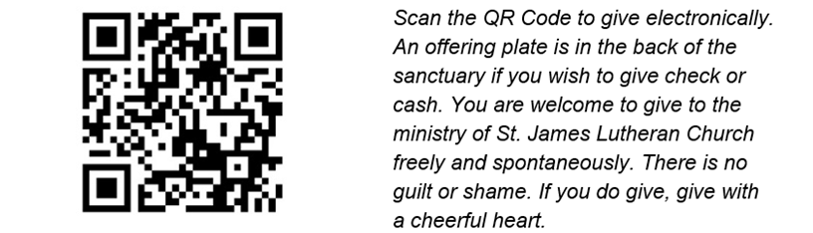

*OFFERING VERSE: TFF 216 – Give Me a Clean Heart

*OFFERING PRAYER
Prayer concludes: Amen.

*THE GREAT THANKSGIVING
Together with the bread and the cup we receive the body and the blood of Christ. We invite all baptized Christians to this sacrament. Children and adults who do not yet receive Holy Communion are invited to come forward with arms folded for a blessing. If you need communion brought to you, please let an usher know. We commune in tables of 10-15 people. The pastor will give you the bread, an assistant will give you a cup. Then two will come to pour into your cup-the first with grape juice, the second with wine. Whoever partakes receives orally the body and blood of Jesus Christ.
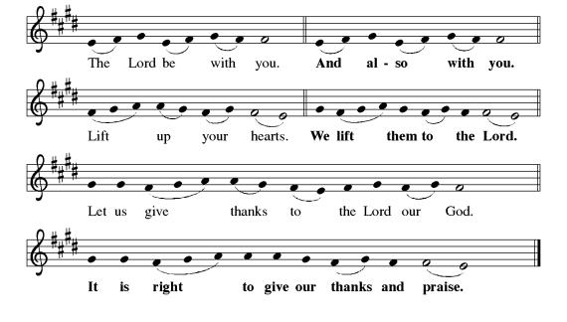
It is indeed right, our duty and our joy, that we should at all times and in all places give thanks and praise…Here the minister continues with the preface for the day, concluding: …we praise your name and join their unending hymn:
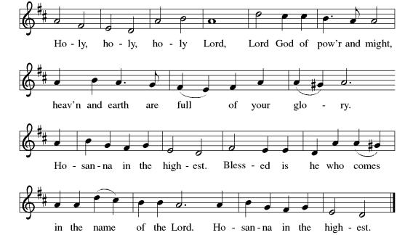

*THE WORDS OF INSTITUTION
In the night in which he was betrayed,
our Lord Jesus took bread, and gave thanks;
broke it, and gave it to his disciples, saying:
Take and eat; this is my body, given for you.
Do this for the remembrance of me.

Again, after supper, he took the cup, gave thanks,
and gave it for all to drink, saying:
This cup is the new covenant in my blood,
shed for you and for all people for the forgiveness of sin.
Do this for the remembrance of me.

*THE LORD’S PRAYER
Our Father, who art in heaven,
hallowed be thy name,
thy kingdom come,
thy will be done,
on earth as it is in heaven.
Give us this day our daily bread;
and forgive us our trespasses,
as we forgive those
who trespass against us;
and lead us not into temptation,
but deliver us from evil.
For thine is the kingdom,
and the power, and the glory,
forever and ever. Amen.

*INVITATION TO COMMUNION

COMMUNION
When giving the bread and cup, the communion ministers say
The body of Christ, given for you.
The blood of Christ, shed for you.
and each person may respond
Amen.

LAMB OF GOD
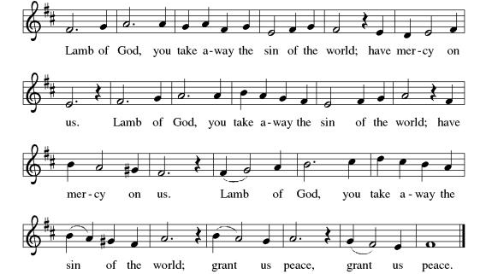

*POST COMMUNION SONG: ELW 206 – Thankful Hearts and Voices Raise
*POST COMMUNION PRAYER
Prayer concludes: Amen.

- SENDING
*BLESSING
Blessing concludes: Amen.

*SENDING SONG: ELW 536 – God Be with You Till We Meet Again

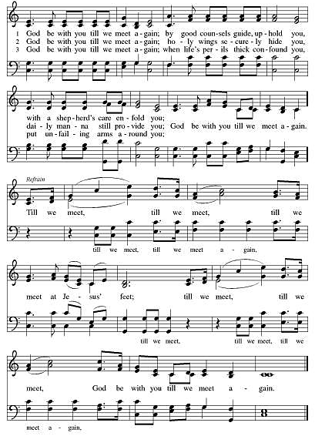
*DISMISSAL
Go in peace. Share the good news.
Thanks be to God.

ANNOUNCEMENTS

Social Ministry: Pullover Hoodie collection will begin September 14 thru October 12 for Phillipsburg School District middle and HS students. Adult sizes S-XXL.

- Wednesday 9/17: Fellowship at Sharky’s 4pm-6pm
- Thursday 9/18: Reading the Bible with Pastor Levi – 10am at the church

UPCOMING

September 14th after church, Worship Helpers' Training: Please attend if you are interested in any of these volunteer positions: greeter/usher, assisting minister, lector (reader), communion assistant, altar guild, technology assistant, and teller.

- Sunday, 9/21 after church: Coffee Fellowship begins. There is a sign up sheet on the bulletin board outside Frey Hall for coffee and refreshments.
- Monday, 9/22: Christian Ed meeting 10am at the church
- Tuesday, 10/9: Social Ministry Meeting at Panera 9:30am. All are welcome!
- Sunday, 10/12: Rally Day!

There is a sign up sheet on bulletin board outside Frey Hall for coffee and refreshment donations for Coffee Fellowship on Sundays.

- Sunday, 9/21 after church: Coffee Fellowship begins!
- Monday, 9/22: Christian Ed meeting 10am at the church
- Wednesday 9/24: Fellowship at Sharky’s 4pm-6pm
- Thursday 9/25: Reading the Bible with Pastor Levi – 10am at the church

UPCOMING

- Saturday, 10/4: Church Breakfast 7am-10am
- Sunday, 10/12: Rally Day!

Let us remember in prayer: The Family & Friends of Judy Imhof, The Family & Friends of Pam Sheehan, The Family & Friends of Lou Cicale, The Family & Friends of Audra, Ryan, Kevin, Beth, Stephanie, Max, Keith, Sara, Bob, Patrick, John, Gary, Sharon and those unable to attend church service; Janet, Janice, Greg, Helen, Alayne and Elsie

