***The Holy Trinity***

June 15th, 2025



**Divine Service 9am**

**St. James Lutheran Church**

1213 US Hwy 22

Phillipsburg, NJ

908.454.2864 www.strawchurch.org strawchurch@gmail.com

**Welcome to St. James!**

Founded in 1750, the year 2025 marks our 275th anniversary of being God’s church. We’re so glad you’re here! We pray you feel warmly welcomed as we gather to celebrate God’s unconditional love in Jesus Christ. He who is the same, yesterday, today, and forever!

**If you are visiting today:** Thank you for joining us today! If you have any questions, please ask! Pastor Levi and the members of our church-community would be glad to help you out. Please sign the guest book or complete a hospitality card located in the pew racks.

**Following along in the bulletin:** *indicates the congregation stands. In our liturgical worship, **bold words** are spoken by the congregation. LBW refers to content found in the green hymnbook *Lutheran Book of Worship*. WOV refers to content found in the blue hymnbook *With One Voice*.

Presiding Minister The Rev. Levi Q. Powers

Assisting Minister Dan Gulick

Musician Dave Miller

1. **GATHERING**

**\*CONFESSION AND ABSOLUTION**

In the name of the Father and of the ☩ Son and of the Holy Spirit.  
**Amen.**

The Sun of righteousness shall rise with shining beams of healing. Let us gather under the wings of God’s mercy.

*Silence for reflection and self-examination.*

Gracious God,  
**we acknowledge that we are sinners and we confess our sins—those known to us that burden our hearts, and those unknown to us but seen by you. We know that before you nothing remains hidden, and in you everything is revealed. Free us from the slavery of sin; liberate us from the bondage of guilt; work in us that which is pleasing in your sight; for the sake of Jesus Christ our Lord. Amen.**

From the house of David, God raised up a mighty Savior.

**Blessed be the Lord God of Israel, who comes to set us free.**

Remembering the covenant, God delivered us from our enemies.

**Blessed be the Lord God of Israel, who comes to set us free.**

Before God we are holy and righteous, free to worship without fear.

**Blessed be the Lord God of Israel, who comes to set us free.**

With a heart full of mercy and compassion, God saves you and forgives you all our sins. Christ, the dawn from on high, shines upon you, and by the light of the Holy Spirit guides your feet into the way of peace.  
**Amen.**

**\*GATHERING HYMN: LBW 165 – Holy, Holy, Holy**

**\*GREETING**

The grace of our Lord Jesus Christ, the love of God,

And the fellowship of the Holy Spirit be with you all.

**And also with you.**

**\*KYRIE**





**\*THIS IS THE FEAST**





**\*PRAYER OF THE DAY**

Prayer concludes: **Amen.**

1. **WORD**

**FIRST READING: Proverbs 8:1-4, 22-31**

*A reading from Proverbs.*

**1**Doesn’t wisdom call out?  
    Doesn’t understanding raise her voice?  
**2**At the highest point along the way,  
    she takes her place where the paths meet.  
**3**Beside the gate leading into the city,  
    she cries out at the entrance. She says,  
**4**“People, I call out to you.  
    I raise my voice to all human beings.  
**22**“The Lord created me as the first of his works,  
    before his acts of long ago.  
**23**I was formed a long, long time ago.  
    I was formed at the very beginning, when the world was created.  
**24**Before there were any oceans, I was born.  
    It was before there were springs flowing with water.  
**25**Before the mountains were settled in place, I was born.  
    Before there were any hills, I was born.  
**26**It happened before the Lord made the world and its fields.  
    It was before he made the dust of the earth.  
**27**I was there when he set the heavens in place.  
    When he marked out the place where the sky meets the sea, I was there.  
**28**That was when he put the clouds above.  
    It was when he fixed the ocean springs in place.  
**29**It was when he set limits for the sea  
    so that the waters had to obey his command.  
When the Lord marked out the foundations of the earth, I was there.  
**30**    I was constantly at his side.  
I was filled with delight day after day.  
    I was always happy to be with him.  
**31**His whole world filled me with joy.  
    I took delight in all human beings.

*The word of the Lord.***Thanks be to God.**

**PSALM 8**

*The Psalm is read responsively.*

 1 O **|** Lord our Lord,  
  how majestic is your name in **|** all the earth!—  
 2 **you whose glory is chanted above the heavens out of the mouths of in- | fants and children;**  
  **you have set up a fortress against your enemies, to silence the foe | and avenger. R**  
 3 When I consider your heavens, the work **|** of your fingers,  
  the moon and the stars you have set **|** in their courses,  
 4 **what are mere mortals that you should be mind- | ful of them,**  
  **human beings that you should | care for them? R**  
 5 Yet you have made them little less **|** than divine;  
  with glory and hon- **|** or you crown them.  
 6 **You have made them rule over the works | of your hands;**  
  **you have put all things un- | der their feet:**

 7 all **|** flocks and cattle,  
  even the wild beasts **|** of the field,  
 8 **the birds of the air, the fish | of the sea,**  
  **and whatever passes along the paths | of the sea.**  
 9 O **|** Lord our Lord,  
  how majestic is your name in **|** all the earth!**R**

**SECOND READING: Romans 5:1-5**

*A reading from Romans*.

**1**We have been made right with God because of our faith. Now we have peace with him because of our Lord Jesus Christ. **2**Through faith in Jesus we have received God’s grace. In that grace we stand. We are full of joy because we expect to share in God’s glory. **3**And that’s not all. We are full of joy even when we suffer. We know that our suffering gives us the strength to go on. **4**The strength to go on produces character. Character produces hope. **5**And hope will never bring us shame. That’s because God’s love has been poured into our hearts. This happened through the Holy Spirit, who has been given to us.

*The word of the Lord.*

**Thanks be to God.**

**\*Gospel Acclamation**



**GOSPEL READING: John 16:12-15**

*The holy gospel according to St. John*.

**Glory to you, O Lord.**

**12**“I have much more to say to you. It is more than you can handle right now. **13**But when the Spirit of truth comes, he will guide you into all the truth. He will not speak on his own. He will speak only what he hears. And he will tell you what is still going to happen. **14**He will bring me glory. That’s because what he receives from me he will show to you. **15**Everything that belongs to the Father is mine. That is why I said what the Holy Spirit receives from me he will show to you.”

*The gospel of the Lord.*

**Praise to you, O Christ.**

**SERMON**

**\*HYMN OF THE DAY: LBW 169 – Father Most Holy**

**\*NICENE CREED**

**We believe in one God,**

**the Father, the Almighty,**

**maker of heaven and earth,**

**of all that is, seen and unseen.**

**We believe in one Lord, Jesus Christ,**

**the only Son of God,**

**eternally begotten of the Father,**

**God from God, Light from Light,**

**true God from true God,**

**begotten, not made,**

**of one Being with the Father;**

**through him all things were made.**

**For us and for our salvation**

**he came down from heaven,**

**was incarnate of the Holy Spirit and the virgin Mary**

**and became truly human.**

**For our sake he was crucified under Pontius Pilate;**

**he suffered death and was buried.**

**On the third day he rose again**

**in accordance with the scriptures;**

**he ascended into heaven**

**and is seated at the right hand of the Father.**

**He will come again in glory to judge the living and the dead,**

**and his kingdom will have no end.**

**We believe in the Holy Spirit, the Lord, the giver of life,**

**who proceeds from the Father and the Son,**

**who with the Father and the Son is worshiped and glorified,**

**who has spoken through the prophets.**

**We believe in one holy catholic and apostolic church.**

**We acknowledge one baptism for the forgiveness of sins.**

**We look for the resurrection of the dead,**

**and the life of the world to come. Amen.**

**\*PRAYERS OF INTERCESSION**

Each petition ends: “…God of grace. **Hear our prayer.”**

Prayers conclude: “Into your hands, gracious God, we commend all for whom we pray, trusting in your mercy; through Jesus Christ, our Savior.” **Amen.**

**\*Peace**

The peace of Christ be with you always.

**And also with you.**

*The people may greet one another with a sign of Christ’s peace, and may say, “Peace be with you,” or similar words.*

*The assembly is seated.*

1. **THE LORD’S SUPPER**

**OFFERTORY**

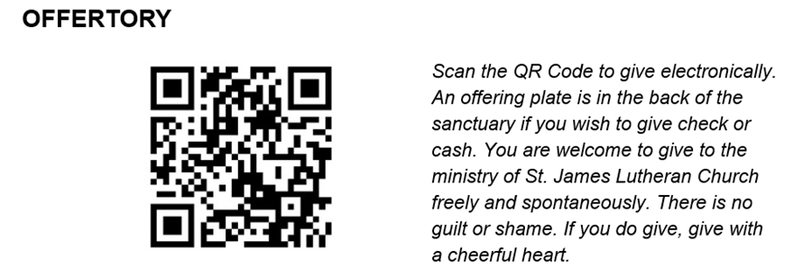

**\*OFFERING VERSE: ELW 184 – Let the Vineyards Be Fruitful**

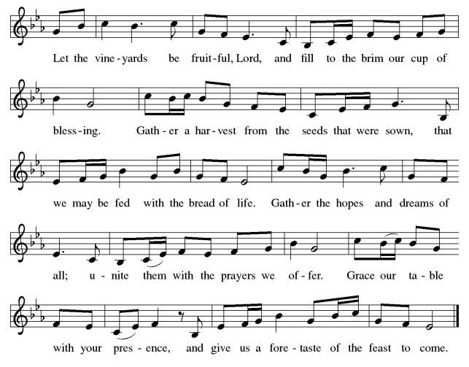

**\*OFFERING PRAYER**

Prayer concludes: **Amen.**

**\*THE GREAT THANKSGIVING**

*Together with the bread and the cup we receive the body and the blood of Christ. We invite all baptized Christians to this sacrament. Children and adults who do not yet receive Holy Communion are invited to come forward with arms folded for a blessing. If you need communion brought to you, please let an usher know. We commune in tables of 10-15 people. The pastor will give you the bread, an assistant will give you a cup. Then two will come to pour into your cup-the first with grape juice, the second with wine. Whoever partakes receives orally the body and blood of Jesus Christ.*

**C:\Users\roelc\Downloads\ELW Setting Three Dialogue (Melody).tif**

It is indeed right, our duty and our joy, that we should at all times and in all places give thanks and praise…Here the minister continues with the preface for the day, concluding: …we praise your name and join their unending hymn:

**C:\Users\roelc\Downloads\ELW Setting Three Holy (Melody).tif**

**\*THE WORDS OF INSTITUTION**

In the night in which he was betrayed,

our Lord Jesus took bread, and gave thanks;

broke it, and gave it to his disciples, saying:

Take and eat; this is my body, given for you.

Do this for the remembrance of me.

Again, after supper, he took the cup, gave thanks,

and gave it for all to drink, saying:

This cup is the new covenant in my blood,

shed for you and for all people for the forgiveness of sin.

Do this for the remembrance of me.

**\*THE LORD’S PRAYER**

**Our Father, who art in heaven,**

**hallowed be thy name,**

**thy kingdom come,**

**thy will be done,**

**on earth as it is in heaven.**

**Give us this day our daily bread;**

**and forgive us our trespasses,**

**as we forgive those**

**who trespass against us;**

**and lead us not into temptation,**

**but deliver us from evil.**

**For thine is the kingdom,**

**and the power, and the glory,**

**forever and ever. Amen.**

**\*INVITATION TO COMMUNION**

**COMMUNION**

*When giving the bread and cup, the communion ministers say*

The body of Christ, given for you.

The blood of Christ, shed for you.

*and each person may respond*

Amen.

**LAMB OF GOD**

**C:\Users\roelc\Downloads\ELW Setting Three Lamb (Melody).tif**

**\*POST COMMUNION SONG: ELW 205 – Thankful Hearts and Voices Raise**



**\*POST COMMUNION PRAYER**

Prayer concludes: **Amen.**

1. **SENDING**

**\*BLESSING**

Blessing concludes: **Amen.**

**\*SENDING SONG: LBW 535 – Holy God, We Praise Your Name**

**\*DISMISSAL**

Go in peace. Christ is with you.

**Thanks be to God.**

**ANNOUNCEMENTS**

All are invited to the Gulick’s for burgers and hot dogs with Pastor John Van Haneghan on Saturday, June 21st at 5pm. Please RSVP to Barbara 908-421-1199

Social Ministry is collecting food for the local food pantry-please leave donations in lobby.

* **Monday 6/16:** Bible Study – 4pm at the church
* **Tuesday 6/17:** Church Council meeting at church 7pm
* **Wednesday 6/18:** Fellowship at Sharky’s 4pm-6pm

Let us remember in prayer: The Friends & Family of Ron Vanderbilt, Brian, Pam, Sara, Bob, Patrick, John, Judy, Gary, Sharon and those unable to attend church service; Janice, Greg, Helen, Alayne and Elsie.

