22nd Sunday after Pentecost
November 9th, 2025

Divine Service 9am

St. James Lutheran Church
1213 US Hwy 22
Phillipsburg, NJ

908.454.2864 www.strawchurch.org strawchurch@gmail.com

Welcome to St. James!
Founded in 1750, the year 2025 marks our 275th anniversary of being God’s church. We’re so glad you’re here! We pray you feel warmly welcomed as we gather to celebrate God’s unconditional love in Jesus Christ. He who is the same, yesterday, today, and forever!

If you are visiting today: Thank you for joining us today! If you have any questions, please ask! Pastor Levi and the members of our church-community would be glad to help you out. Please sign the guest book or complete a hospitality card located in the pew racks.

Following along in the bulletin: *indicates the congregation stands. In our liturgical worship, bold words are spoken by the congregation. LBW refers to content found in the green hymnbook Lutheran Book of Worship. WOV refers to content found in the blue hymnbook With One Voice.

Presiding Minister The Rev. Dr. Timothy Wengert
Assisting Minister Polly Newbold
Musician Dave Miller

- GATHERING

*CONFESSION AND ABSOLUTION
Th sign of the cross ☩ may be made by all in remembrance of their Baptism.
In the name of the Father and of the ☩ Son and of the Holy Spirit.
Amen.
Almighty God, to whom all hearts are open, all desires are known, and from whom no secrets are hid: cleanse the thoughts of our hearts by the inspiration of your Holy Spirit, that we may perfectly love you and worthily magnify your holy name, through Jesus Christ our Lord.
Amen.
Let us confess our sin in the presence of God and of one another.
Silence for reflection and self-examination.

Almighty and most Holy God,
we confess that we have sinned in thought, word, and deed, through our own fault, our own most grievous fault. We acknowledge our lack of faithfulness in holy service, our lack of discipline and obedience, and our lack of love. And so, we pray to you, O God, have mercy upon us, for the sake of Jesus Christ, your dear Son, our Lord. Amen.
God, who is rich in mercy, loved us even when we were dead in sin, and made us alive together with Christ. By grace you have been saved. In the name of ☩Jesus Christ, I forgive you all your sins. Almighty God strengthen you with power through the Holy Spirit, that Christ may live in your hearts through faith.
Amen.

*GATHERING HYMN: WOV 742 - Come, We that Love the Lord

*GREETING
The grace of our Lord Jesus Christ, the love of God,
and the fellowship of the Holy Spirit be with you all.
And also with you.

*CANTICLE OF PRAISE: ELW 410 – All Glory Be to God on High
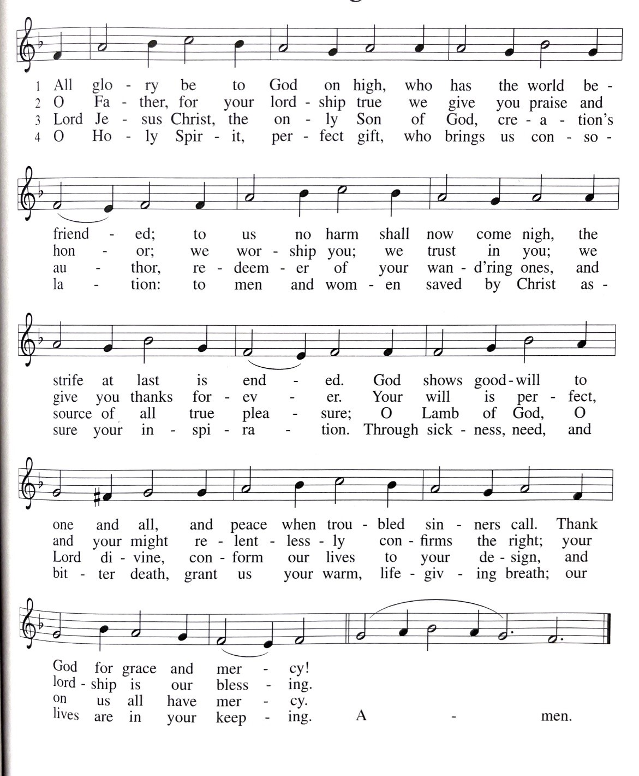

*PRAYER OF THE DAY
O God, who in Christ is our eternal redeemer, by the presence of your Spirit you renew and direct our hearts. Keep always in our mind the end of all things and the day of judgment. Inspire us for a holy life here, and bring us to the joy of the resurrection, through Jesus Christ, our Savior and Lord. Amen.

- WORD

FIRST READING: Job 19:23-27a
A reading from Job.
²³ “O that my words were written down!
O that they were inscribed in a book!
²⁴ O that with an iron pen and with lead
they were engraved on a rock forever!
²⁵ For I know that my vindicator lives
and that in the end he will stand upon the earth;
²⁶ and after my skin has been destroyed,
then in my flesh I shall see God,
^{27a} whom I shall see on my side,
and my eyes shall behold, and not another.”
The word of the Lord.
Thanks be to God.
PSALM 17:1-9
The Psalm is read responsively.
¹ Hear a just cause, O Lord; give heed to my cry;
listen to my prayer, which does not come from lying lips.
² Let my vindication come forth from your presence;
let your eyes be fixed on justice.
³ Examine my heart, visit me by night,
melt me down; you will find no impurity in me.
⁴ I have not regarded what others do;
at the word of your lips I have avoided the ways of the violent.
⁵ My footsteps hold fast to your well-worn path;
and my feet do not slip.
⁶ I call upon you, O God, for you will answer me;
incline your ear to me and hear my words.
⁷ Show me your marvelous loving kindness,
O Savior of those who take refuge at your right hand from those who rise against them.
⁸ Keep me as the apple of your eye;
hide me under the shadow of your wings,
⁹ from the wicked who assault me,
from my deadly enemies who surround me.

SECOND READING: 2 Thessalonians 2:1-5, 13-17
A reading from 2 Thessalonians.
¹ As to the coming of our Lord Jesus Christ and our being gathered together to him, we beg you, brothers and sisters, ² not to be quickly shaken in mind or alarmed, either by spirit or by word or by letter, as though from us, to the effect that the day of the Lord is already here. ³ Let no one deceive you in any way, for that day will not come unless the rebellion comes first and the lawless one is revealed, the one destined for destruction. ⁴ He opposes and exalts himself above every so-called god or object of worship, so that he takes his seat in the temple of God, declaring himself to be God. ⁵ Do you not remember that I told you these things when I was still with you?
¹³ But we must always give thanks to God for you, brothers and sisters beloved by the Lord, because God chose you as the first fruits for salvation through sanctification by the Spirit and through belief in the truth. ¹⁴ For this purpose he called you through our gospel, so that you may obtain the glory of our Lord Jesus Christ. ¹⁵ So then, brothers and sisters, stand firm and hold fast to the traditions that you were taught by us, either by word of mouth or by our letter.
¹⁶ Now may our Lord Jesus Christ himself and God our Father, who loved us and through grace gave us eternal comfort and good hope, ¹⁷ comfort your hearts and strengthen them in every good work and word.
The word of the Lord.
Thanks be to God.

*GOSPEL ACCLAMATION: ELW 172 – Halle, Halle, Hallelujah
{sung before and after gospel lesson}
GOSPEL READING: Luke 20:27-38
The holy gospel according to St. Luke.
Glory to you, O Lord.
²⁷ Some Sadducees, those who say there is no resurrection, came to [Jesus] ²⁸ and asked him a question: “Teacher, Moses wrote for us that if a man’s brother dies leaving a wife but no children, the man shall marry the widow and raise up children for his brother. ²⁹ Now there were seven brothers; the first married a woman and died childless; ³⁰ then the second ³¹ and the third married her, and so in the same way all seven died childless. ³² Finally the woman also died. ³³ In the resurrection, therefore, whose wife will the woman be? For the seven had married her.”
³⁴ Jesus said to them, “Those who belong to this age marry and are given in marriage, ³⁵ but those who are considered worthy of a place in that age and in the resurrection from the dead neither marry nor are given in marriage. ³⁶ Indeed, they cannot die anymore, because they are like angels and are children of God, being children of the resurrection. ³⁷ And the fact that the dead are raised Moses himself showed, in the story about the bush, where he speaks of the Lord as the God of Abraham, the God of Isaac, and the God of Jacob. ³⁸ Now he is God not of the dead but of the living, for to him all of them are alive.”
The gospel of the Lord.
Praise to you, O Christ.

SERMON

*HYMN OF THE DAY: WOV 710 - One Bread, One Body

*APOSTLES’ CREED
I believe in God, the Father almighty,
creator of heaven and earth.
I believe in Jesus Christ, God’s only Son, our Lord,
who was conceived by the Holy Spirit,
born of the virgin Mary,
suffered under Pontius Pilate,
was crucified, died, and was buried;
he descended into hell.
On the third day he rose again;
he ascended into heaven,
he is seated at the right hand of the Father,
and he will come to judge the living and the dead.
I believe in the Holy Spirit,
the holy catholic church,
the communion of saints,
the forgiveness of sins,
the resurrection of the body,
and the life everlasting. Amen.

*PRAYERS OF INTERCESSION
Each petition ends: “…God of grace, receive our prayer.”
Prayers conclude: “Into your hands, gracious God, we commend all for whom we pray, trusting in your mercy; through Jesus Christ, our Savior.” Amen.

*Peace
The peace of Christ be with you always.
And also with you.
The people may greet one another with a sign of Christ’s peace, and may say, “Peace be with you,” or similar words.
The assembly is seated.

- THE LORD’S SUPPER
OFFERTORY

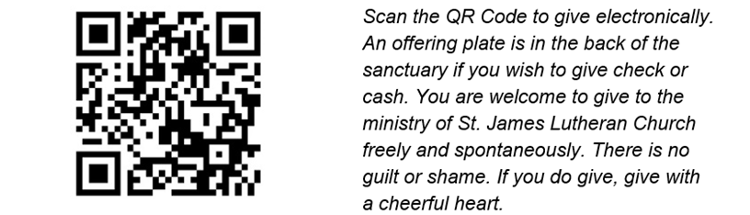

*OFFERING VERSE: ELW 184 – Let the Vineyards Be Fruitful
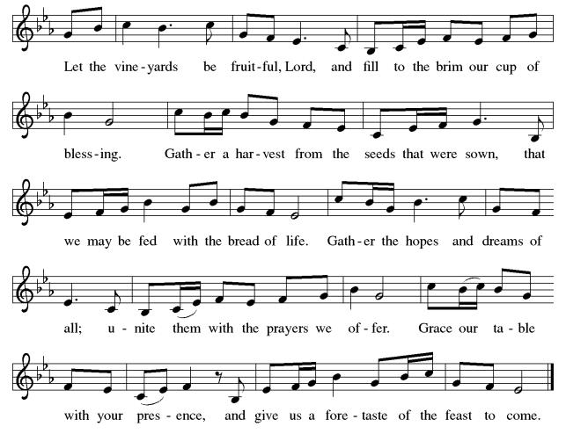

*OFFERING PRAYER
Prayer concludes: Amen.

*THE GREAT THANKSGIVING
Together with the bread and the cup we receive the body and the blood of Christ. We invite all baptized Christians to this sacrament. Children and adults who do not yet receive Holy Communion are invited to come forward with arms folded for a blessing. If you need communion brought to you, please let an usher know.
We commune in tables of 10-15 people. The pastor will give you the bread, an assistant will give you a cup. Then two will come to pour into your cup-the first with grape juice, the second with wine. Whoever partakes receives orally the body and blood of Jesus Christ.
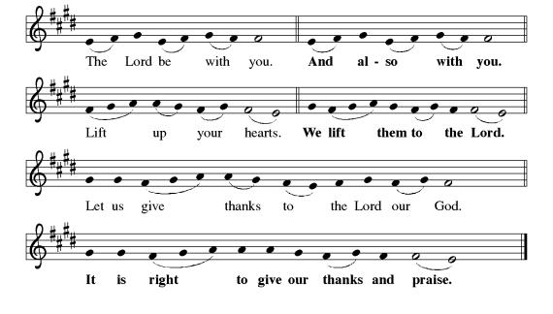
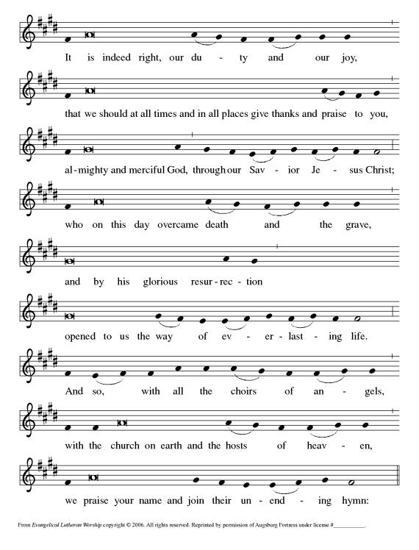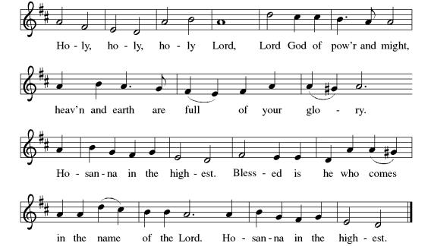
*THE WORDS OF INSTITUTION
In the night in which he was betrayed,
our Lord Jesus took bread, and gave thanks;
broke it, and gave it to his disciples, saying:
Take and eat; this is my body, given for you.
Do this for the remembrance of me.

Again, after supper, he took the cup, gave thanks,
and gave it for all to drink, saying:
This cup is the new covenant in my blood,
shed for you and for all people for the forgiveness of sin.
Do this for the remembrance of me.

*THE LORD’S PRAYER
Our Father, who art in heaven,
hallowed be thy name,
thy kingdom come,
thy will be done,
on earth as it is in heaven.

Give us this day our daily bread;
and forgive us our trespasses,
as we forgive those
who trespass against us;
and lead us not into temptation,
but deliver us from evil.
For thine is the kingdom,
and the power, and the glory,
forever and ever. Amen.

*INVITATION TO COMMUNION
Come to the banquet, for all is now ready.

COMMUNION
When giving the bread and cup, the communion ministers say
The body of Christ, given for you.
The blood of Christ, shed for you.
and each person may respond
Amen.

POST COMMUNION TABLE BLESSING
The body and blood of our risen Lord Jesus Christ strengthens you and keeps you in his grace. Amen.

LAMB OF GOD
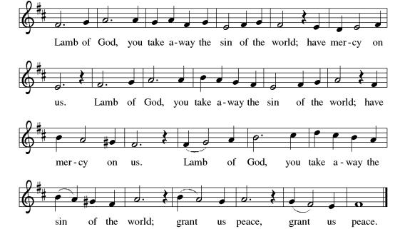

*POST COMMUNION SONG: ELW 206 – Thankful Hearts and Voices Raise

*POST COMMUNION PRAYER
Prayer concludes: Amen.

- SENDING
*BLESSING
The Lord blesses you and keeps you. The Lord's face shines on you with grace and mercy. The Lord looks upon you with favor and gives you peace. Amen.

*SENDING SONG: WOV 744 - Soon and Very Soon

*DISMISSAL
Go in peace. Remember the poor.
Thanks be to God.

Worship Helpers: Joanne Willauer will be coordinating the monthly schedule. Please contact her at 610-393-6317 or jdwillauer@rcn.com with your available dates!
Social Ministry Donation Collections:
- Veterans needs collection now thru November 9th. Items needed are posted on the Veterans barrel in Frey Hall Lobby.
- Food Drive collection: Social Ministry supports 175 Families thru River of Life & St. Luke’s Church in Phillipsburg.

ANNOUNCEMENTS

Pastor Levi was selected to attend the International Theological Seminar for Pastors by the Lutheran World Federation. This continuing education opportunity will take place November 8th through 22nd in Wittenberg, Germany. If you need the on-call pastor while he is away, please contact our church president Jon Slaton at 908-319-3992.
- Tuesday, 11/11: Social Ministry meeting 10am at the church. All are welcome!
- Tuesday 11/11: Property Committee 10am at the church.
- Wednesday 11/12: Fellowship at Sharky’s 4pm-6pm
- Thursday 11/13: NO Proverbs Bible Study with Pastor Levi – resumes 12/4

UPCOMING

- Sunday, 11/23: Thanksgiving Brunch after church. Sign up sheet on bulletin board in hallway.
- Tuesday, 11/25: Church Council meeting 7pm at the church.
- Sunday, 12/14: Live Nativity - Noon-2
Craft Fair – Noon-3

THIS WEEK’S WORSHIP HELPERS

Usher/Greeter: Doris Lauer
Lector: Harvey Walters
Altar Guild: Barbara and Jim Sikra
Tellers: Sandy Wismer/Don Willauer

NEXT SUNDAY’S WORSHIP HELPERS(11/16)

Usher/Greeter: Bob Agans
Lector: Joanne Willauer
Altar Guild: Steve Stocker
Tellers: Carol/Lois Steible

Let us remember in prayer: The Family & Friends of Brett Palmer, The Family & Friends of Max Williams, The Family & Friends of Brett Marino, Carol, Kelly, Justin, Stacey, Debbie, Carol, Ryan, Kevin, Keith, Sara, Bob, Patrick, John, Gary, Sharon and those unable to attend church service; Janet, Janice, Greg, Helen, Alayne and Elsie.

