Membership Application
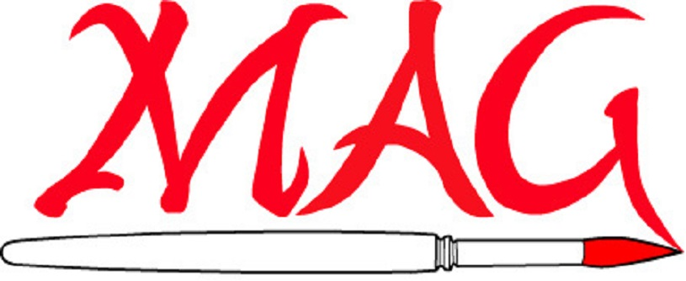
Matthews Artists Guild

Name: | Date:
Address:

City: | State: | Zip:
Cell Phone: | Home Phone:
Email:

I work in the following mediums:

How did you hear about MAG?

Dues:
$25 individual membership or $35 family membership
Due each year September 1st
Make checks payable to: Matthews Artists Guild

Mail to:
Matthews Artists Guild
100 E. McDowell Street
Matthews NC 28105

