Summer Fun 2018
Entry Form

Take-in: Saturday, July 7, 10-12
Take-down: Friday, August 3, anytime gallery is open and no later than 7 PM
Place: McDowell Arts Center, Matthews, NC
Entry fee: There is no cost to enter this show. You may bring up to 4 pieces. See attached Show Rules for details.
Eligibility: Current MAG members. You may pay your dues at take-in with $25 check to Matthews Artists Guild.
Show chair: Cynthia Howard: 803-242-4295, cynhow@bellsouth.net
Labels: In addition to labels on the back of your artwork, you will need to create your own title cards. Please use the attached templates.

Artist name:
Phone:
Email:

Title of Entry | Medium | Price
 |  | $
 |  | $
 |  | $
 |  | $

Release: The undersigned agrees to abide by the attached Show Rules. The artist agrees to hold harmless the Matthews Artists Guild, the Town of Matthews, and any of their staff, officers, volunteers and employees for damage to work that may arise while at the McDowell Arts Center. All work will be handled with the utmost care. Neither Matthews Artists Guild nor the Town of Matthews are responsible for works that are not picked up during the stated time of take-down.

Artist signature: ___________________________________________ Date: __________________________

Each entry must have a label on the back, bottom-left corner.

Matthews Artists Guild

Title
Artist
Medium
Phone

Price $
Matthews Artists Guild

Title
Artist
Medium
Phone

Price $

Matthews Artists Guild

Title
Artist
Medium
Phone

Price $
Matthews Artists Guild

Title
Artist
Medium
Phone

Price $

Title Cards

These will be displayed on the wall next to your painting. Use your computer to fill out if possible and print on card stock if you have it.

Matthews Artists Guild

Title:

Artist:

Medium:

Artist contact:

Price $

Matthews Artists Guild

Title:

Artist:

Medium:

Artist contact:

Price $

Matthews Artists Guild

Title:

Artist:

Medium:

Artist contact:

Price $

Matthews Artists Guild

Title:

Artist:

Medium:

Artist contact:

Price $

Show Rules
MAG Summer Fun 2018 at the McDowell Arts Center

- Members of MAG are eligible to enter up to 4 works of any of the following mediums: oil, watercolor, acrylic, pastel, charcoal, pencil, ink, encaustic, mixed media and photography. No 3-D works. No computer-generated work.
- Size is limited to 36” in width.
- Artwork must be original and may be of any age. Subject matter must be your own.
- Subject matter must be family-friendly. MAG, the McDowell Arts Center, and the Town of Matthews reserve the right to respectfully decline any piece.
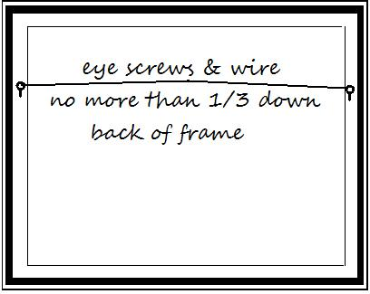
- Member shows are open only to members whose dues are current. You may join MAG at take-in with a separate $25 check to Matthews Artists Guild.
- All work must be properly framed and securely wired. Wires should be attached no more than 1/3 down the back of the frame. No clip mounting or saw-tooth hangers will be accepted. Damaged frames or artwork will not be accepted.
- The Town of Matthews requires a 15% commission on all work sold through this show.

Board of Directors
Matthews Artists Guild

