**MAG_logoMatthews Alive 2018**

Entry Form

Take-in: Saturday, August 25, 10-12

Take-down: Saturday, October 5, 10-12

Place: McDowell Arts Center, 123 E. McDowell Street, Matthews NC

Entry fee: $25 for up to 2 pieces. See attached Show Rules for requirements.

Eligibility: Artists 18 or older who abide by the Show Rules. There is a 15% commission to the Town of Matthews on any works sold during this show.

Show chair: Cynthia Howard: 803-242-4295, cynhow@bellsouth.net

Labels: Attach a label to the back of each entry.

Awards: First Place - $400. Second Place - $200. Third Place - $100. Eight Honorable Mentions plus a People’s Choice Award.

|  |
| --- |
| Artist name: |
| Phone # |
| Email: |

|  |  |  |
| --- | --- | --- |
| Title of Entry | Medium | Price |
|  |  | $ |
|  |  | $ |

**Release:** The undersigned agrees to abide by the attached Show Rules. The artist agrees to hold harmless the Matthews Artists Guild, the Town of Matthews, and any of their staff, officers, volunteers and employees for damage to work that may arise while at the McDowell Arts Center. All work will be handled with the utmost care. Neither Matthews Artists Guild nor the Town of Matthews are responsible for works that are not picked up during the stated time of take-down.

Artist signature: \_\_\_\_\_\_\_\_\_\_\_\_\_\_\_\_\_\_\_\_\_\_\_\_\_\_\_\_\_\_\_\_\_\_\_\_\_\_\_\_\_\_\_ Date: \_\_\_\_\_\_\_\_\_\_\_\_\_\_\_\_\_\_\_\_\_\_\_\_\_\_

|  |
| --- |
| Attach a label to the back of each entry |

Title:

Artist:

Medium:

Artist contact:

Price $

Title:

Artist:

Medium:

Artist contact:

Price $

Show Rules

2018 Matthews Alive Art Show

Sponsored by Matthews Artists Guild

* Artist may enter works of the following mediums: oil, watercolor, acrylic, pastel, charcoal, pencil, ink, encaustic, mixed media and photography. 3-D works must fit on a 12”x12” pedestal.
* Size is limited to 36” in width, including frame.
* Artwork must be original and not previously entered in a MAG judged show. Subject matter must be your own, or proper credit must be given to the original source. Artwork done within the framework of a workshop or class will not be accepted.
* Subject matter should be family-friendly. MAG and the Town of Matthews reserve the right to respectfully decline any piece.
* 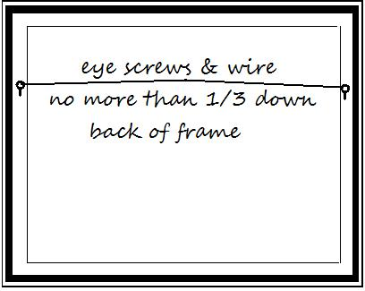All work must be securely wired and ready to hang. Wires should be attached no more than 1/3 down the back of the frame. No clip or saw-tooth hangers will be accepted. Damaged frames or artwork will not be accepted.
* No participant can be with the judge during the selection process.
* There is a 15% commission to the Town of Matthews on any works sold during the show.
* If any work is sold during the show, contact the Show Chair regarding removal and replacement.
* Awards: First Place - $400. Second Place - $200. Third Place - $100. Eight Honorable Mentions and a People’s Choice Award.

Board of Directors  
Matthews Artists Guild