**MAG_logoPre-Holiday Show and Sale**

Entry Form

Take-in: Saturday, November 3, 2018 from 10-12

Take-down: Friday, January 4, 2019, all day

Place: McDowell Arts Center, Matthews, NC

Entry fee: There is no cost to enter this show. You may bring up to 4 pieces. See attached Show Rules for details.

Eligibility: Current MAG members only. You may pay your dues at take-in with $25 check to Matthews Artists Guild.

Show chair: Terry Ruhs 704-941-0516, terrysue@carolina.rr.com

Labels: In addition to labels on the back of your artwork, you will need to create your own title cards. (See attached templates)

|  |
| --- |
| Artist name: |
| Phone: |
| Email: |

|  |  |  |
| --- | --- | --- |
| Title of Entry | Medium | Price |
|  |  | $ |
|  |  | $ |
|  |  | $ |
|  |  | $ |

**Release:** The undersigned agrees to abide by the attached Show Rules. The artist agrees to hold harmless the Matthews Artists Guild, the Town of Matthews, and any of their staff, officers, volunteers and employees for damage to work that may arise while at the McDowell Arts Center. All work will be handled with the utmost care. Neither Matthews Artists Guild nor the Town of Matthews are responsible for works that are not picked up during the stated time of take-down.

Artist signature: \_\_\_\_\_\_\_\_\_\_\_\_\_\_\_\_\_\_\_\_\_\_\_\_\_\_\_\_\_\_\_\_\_\_\_\_\_\_\_\_\_\_\_ Date: \_\_\_\_\_\_\_\_\_\_\_\_\_\_\_\_\_\_\_\_\_\_\_\_\_\_

Title Cards

These will be displayed on the wall next to your painting. If possible, use your computer to fill out and print on card stock

Matthews Artists Guild

Title:

Artist:

Medium:

Artist contact:

Price $

Matthews Artists Guild

Title:

Artist:

Medium:

Artist contact:

Price $

Matthews Artists Guild

Title:

Artist:

Medium:

Artist contact:

Price $

Matthews Artists Guild

Title:

Artist:

Medium:

Artist contact:

Price $

Artwork Labels

Each entry must have a label on the back

Matthews Artists Guild

Title:

Artist:

Medium:

Artist contact:

Price $

Matthews Artists Guild

Title:

Artist:

Medium:

Artist contact:

Price $

Matthews Artists Guild

Title:

Artist:

Medium:

Artist contact:

Price $

Matthews Artists Guild

Title:

Artist:

Medium:

Artist contact:

Price $

Show Rules

Pre-Holiday Show and Sale 2018 at the McDowell Arts Center

* Artist may enter works of the following mediums: oil, watercolor, acrylic, pastel, charcoal, pencil, ink, encaustic, mixed media and photography. 3-D works must fit on a 12”x12” pedestal.
* Size is limited to 36” in width, including frame.
* Artwork must be originaland may be of any age. Subject matter must be your own.
* Subject matter must be family-friendly. MAG and the Town of Matthews reserve the right to respectfully decline any piece.
* Member shows are open only to members whose dues are current. You may join MAG at take-in with a $25 check to Matthews Artists Guild.
* 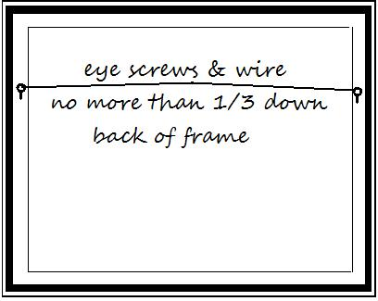All work must be securely wired and ready to hang. Wires should be attached no more than 1/3 down the back of the frame. No clip or saw-tooth hangers will be accepted.
* There is a 15% commission to the Town of Matthews on any work sold during the show.
* If any work is sold during the show, contact the Show Chair regarding removal and replacement.

Board of Directors  
Matthews Artists Guild