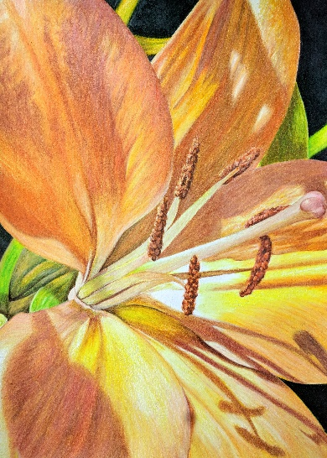
Colored Pencil Workshop

This fun workshop will be presented by Jan Schopen, colored pencil artist and instructor. She will present the many features of this beautiful medium and share her techniques used to create rich and vibrant images.

All materials will be provided, and each participant will leave with a finished or nearly finished work of art!

Saturday, March 14, 2020, 1:00-4:00 PM
McDowell Arts Center, Matthews NC
$50

To register, complete the form below and mail it with your check, made payable to Matthews Artists Guild. Registration must be received by March 7.
Questions? Contact Terry Ruhs at terrysue@carolina.rr.com.

Please register me for the Colored Pencil Workshop. I have enclosed my check for $50.

Name: | Phone:
Street Address:
City: | State: | Zip:
Email:

Mail to Matthews Artists Guild, 100 McDowell Street East, Matthews NC 28105.

