**MAG_logoMAG at Founders Hall 2020**

Entry Form

Take-in: Monday, February 3, 6-8 pm.

Take-down: Friday, February 14, 6-8 pm.

Place: Founders Hall, Bank of America, 100 North Tryon Street, Charlotte

Eligibility: MAG members may enter up to 3 pieces. See Show Rules for requirements.

Entry fee: There is no entry fee. (But be prepared to pay for parking).

Show chair: Terry Ruhs 704-941-0516, terrysue@carolina.rr.com

Pre-registration: **Pre-registration is required for this show**. Email Terry Ruhs by January 18 to reserve your spot.

Title cards: You will need to make your own title cards. Use attached templates or create your own. Please no handwritten title cards!

Labels: Make sure you also have labels on the back of your entries.

|  |
| --- |
| Artist name: |
| Phone: |
| Email: |

|  |  |  |
| --- | --- | --- |
| Title of Entry | Medium | Price |
|  |  | $ |
|  |  | $ |
|  |  | $ |

**Release:** The undersigned artist agrees to all Show Rules. The artist agrees to hold harmless Matthews Artists Guild, Founders Hall, Bank of America, and any of their staff, officers, volunteers and employees, for damage to work that may arise during the show. All work will be handled with the utmost care. Neither Matthews Artists Guild nor Founders Hall are responsible for works not picked up during the stated time of take-down.

Artist signature: \_\_\_\_\_\_\_\_\_\_\_\_\_\_\_\_\_\_\_\_\_\_\_\_\_\_\_\_\_\_\_\_\_\_\_\_\_\_\_\_\_\_\_ Date: \_\_\_\_\_\_\_\_\_\_\_\_\_\_\_\_\_\_\_\_\_\_\_\_\_\_

**Suggested parking for Founders Hall**

Use the Bank of America Center Parking Garage, located at 150 N. College Street.  
Cost to park after 5 pm is $10.

Park on the 6th level and use the walkway to cross over to Founders Hall

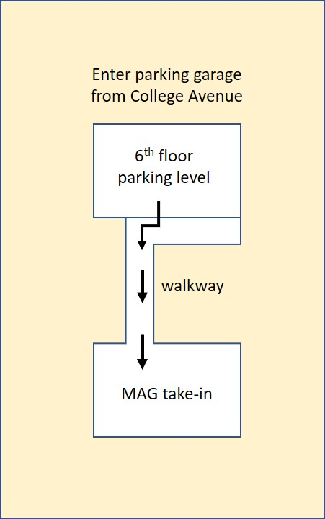

Show Rules

Matthews Artists Guild at Founders Hall

February 3-14, 2020

* MAG members may enter works of the following mediums: oil, watercolor, acrylic, pastel, charcoal, pencil, ink, encaustic, paper, mixed media and photography. No 3-D works. No computer-generated work.
* Size is limited to 32” in width and 32” in height, including frame.
* Artwork must be original.
* Subject matter should be family friendly. MAG and Founders Hall reserve the right to respectfully decline any piece.
* Member shows are open only to members whose dues are current. You may join MAG at take-in with a $25 check to Matthews Artists Guild.
* All work must be securely wired and ready to hang. Wires should be attached no more than 1/3 down the back of the frame. No clip or saw-tooth hangers will be accepted.

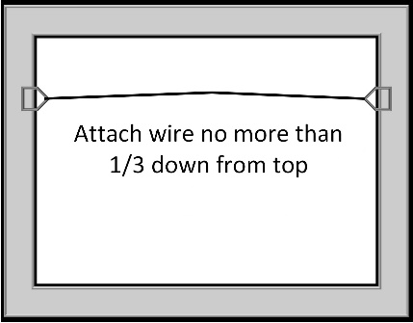

* Damaged frames or artwork will not be accepted.
* If you sell a piece during the show, you may replace it with another piece and let the Show Chairman know.

Board of Directors  
Matthews Artists Guild

**Title Cards**

You must create your own title cards for this show. Use the template below or create your own. Please no handwritten cards! These will be displayed next to your work.

Title:

Artist:

Medium:

Artist contact:

Price $

Title:

Artist:

Medium:

Artist contact:

Price $

Title:

Artist:

Medium:

Artist contact:

Price $

**Labels**

Attach a label to the back of each of your entries

Title:

Artist:

Medium:

Artist contact:

Price $

Title:

Artist:

Medium:

Artist contact:

Price $

Title:

Artist:

Medium:

Artist contact:

Price $