**MAG_logo**

**Member Show at McDowell – March 2020**

Entry Form

Take-in: Saturday, March 7, 2020, from 10-12

Take-down: Friday, April 3, all day

Place: McDowell Arts Center, Matthews, NC

Entry fee: There is no cost to enter this show. You may bring up to 3 pieces. See attached Show Rules for details.

Eligibility: Current MAG members only. You may pay your dues at take-in with $25 check to Matthews Artists Guild.

Show chair: Terry Ruhs 704-941-0516, [terrysue@carolina.rr.com](mailto:terrysue@carolina.rr.com)

Title cards and labels: In addition to the required labels on the back of your artwork, you will need to create your own title cards. Please use the attached templates.

|  |
| --- |
| Artist name: |
| Phone: |
| Email: |

|  |  |  |
| --- | --- | --- |
| Title of Entry | Medium | Price |
|  |  | $ |
|  |  | $ |
|  |  | $ |

**Release:** The undersigned agrees to abide by the attached Show Rules. The artist agrees to hold harmless the Matthews Artists Guild, the Town of Matthews, and any of their staff, officers, volunteers and employees for damage to work that may arise while at the McDowell Arts Center. All work will be handled with the utmost care. Neither Matthews Artists Guild nor the Town of Matthews are responsible for works that are not picked up during the stated time of take-down.

Artist signature: \_\_\_\_\_\_\_\_\_\_\_\_\_\_\_\_\_\_\_\_\_\_\_\_\_\_\_\_\_\_\_\_\_\_\_\_\_\_\_\_\_\_\_ Date: \_\_\_\_\_\_\_\_\_\_\_\_\_\_\_\_\_\_\_\_\_\_\_\_\_\_

**Title Cards**

You must create your own title cards for this show. Use the template below or create your own. Please no handwritten cards. These will be displayed next to your work.

Title:

Artist:

Medium:

Artist contact:

Price $

Title:

Artist:

Medium:

Artist contact:

Price $

Title:

Artist:

Medium:

Artist contact:

Price $

**Artwork Labels**

All entered work must be labeled on the back.

Title:

Artist:

Medium:

Artist contact:

Price $

Title:

Artist:

Medium:

Artist contact:

Price $

Title:

Artist:

Medium:

Artist contact:

Price $

Show Rules

Member Show at the McDowell Arts Center

March 2020

* MAG members may enter works of the following mediums: oil, watercolor, acrylic, pastel, charcoal, pencil, ink, encaustic, mixed media and photography. 3-D works must fit on a 12”x12” pedestal.
* Entries may be no larger than 36” in width, not including the frame.
* Subject matter must be family friendly. MAG and the Town of Matthews reserve the right to respectfully decline any piece.
* Member shows are open only to members whose dues are current. You may pay your dues at take-in with a $25 check to Matthews Artists Guild.
* All work must be securely wired and ready to hang. Wires should be attached no more than 1/3 down the back of the frame; make wire as tight as possible. No clip or saw-tooth hangers will be accepted.

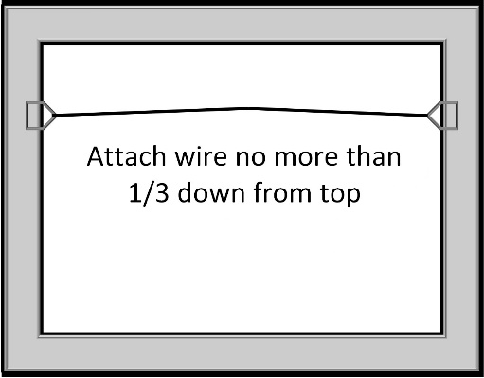

* If unframed, all sides of the canvas must be painted.
* Damaged frames or artwork will not be accepted.
* There is a 15% commission to the Town of Matthews on any work sold during the show.

Board of Directors  
Matthews Artists Guild