Membership Application
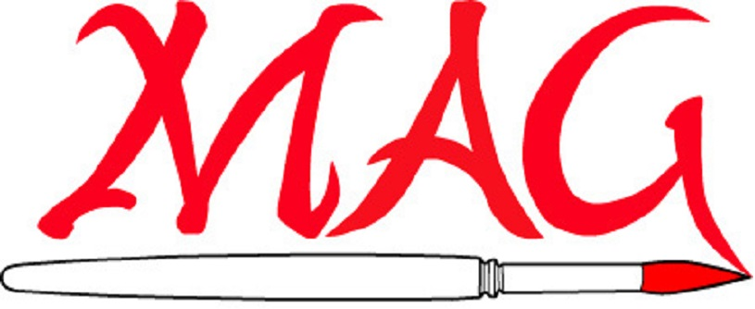

Matthews Artists Guild

Name: | Date:
Email:
Phone Number:
Address:

City: | State: | Zip:
I work in the following mediums:

How did you hear about MAG?

Dues: $25 per calendar year

Make checks payable to Matthews Artists Guild

Mail to:
Matthews Artist Guild
C/O Matthews Community Center
100 E. McDowell Street
Matthews NC 28105

