Luqoom: A Publishing Start-up with a Sweet Tooth for Kids’ Books

Beirut - May 2018

Luqoom, a new boutique publishing house in Beirut, just launched its first children’s book, ‘Swingers, Clingers and Other Amazing Animals in Motion’.

Luqoom founder and the book’s author, Racha Mourtada, recently moved back to her native Beirut to start the publishing house after a long stretch of corporate and government jobs in Dubai. Spurred by a love of children’s books–especially pretty print editions–she set up Luqoom to create beautiful books that young readers can hold, pore over, snuggle with and share. And she wanted to draw on Beirut’s–and the region’s– creative talents to make them.

“Books are treats to be savoured,” Mourtada said, a sentiment that inspired the name of her publishing house and its tagline, ‘we have a sweet tooth for books’. It is also evident in her first book, a colourful confection of animals that sprint, swim and fly across the page, brought to life by local illustrator, Elia Tawil. A self-confessed science geek who did her engineering thesis on motion–albeit that of humans–Mourtada felt that writing about how animals move was a natural fit for Luqoom’s first book.

“Animals can be awe-inspiring in their movements,” she said. “What better way for kids to learn about motion than from the graceful underwater acrobatics of a sea otter or the zig-zagging flight of a butterfly?”

So if you’ve ever wondered how a monkey swings through the trees, or how a gecko can cling upside down to a leaf, ‘Swingers, Clingers and Other Amazing Animals in Motion’ can answer all of that and more. From leaping lemurs to crawling crabs, the lush illustrations and simple explanations of animal locomotion will delight animal enthusiasts of all ages.

The book is the first in a line of engaging and visually-rich Arabic and English books that Luqoom aims to publish on wide-ranging topics, with a soft spot for science, silliness and good storytelling.

‘Swingers, Clingers and Other Amazing Animals in Motion’ will be available at Papercup from May 12th, and online at www.luqoom.com and in Antoine bookstores across Lebanon the following week.

Swingers, Clingers and Other Amazing Animals in Motion
Written by Racha Mourtada; Illustrated by Elia Tawil
Published by Luqoom
Release Date: May 12th, 2018
Hardcover/64 pp/ 24x24 cm/ $18.00
ISBN 978-9953-0-4394-4
www.luqoom.com

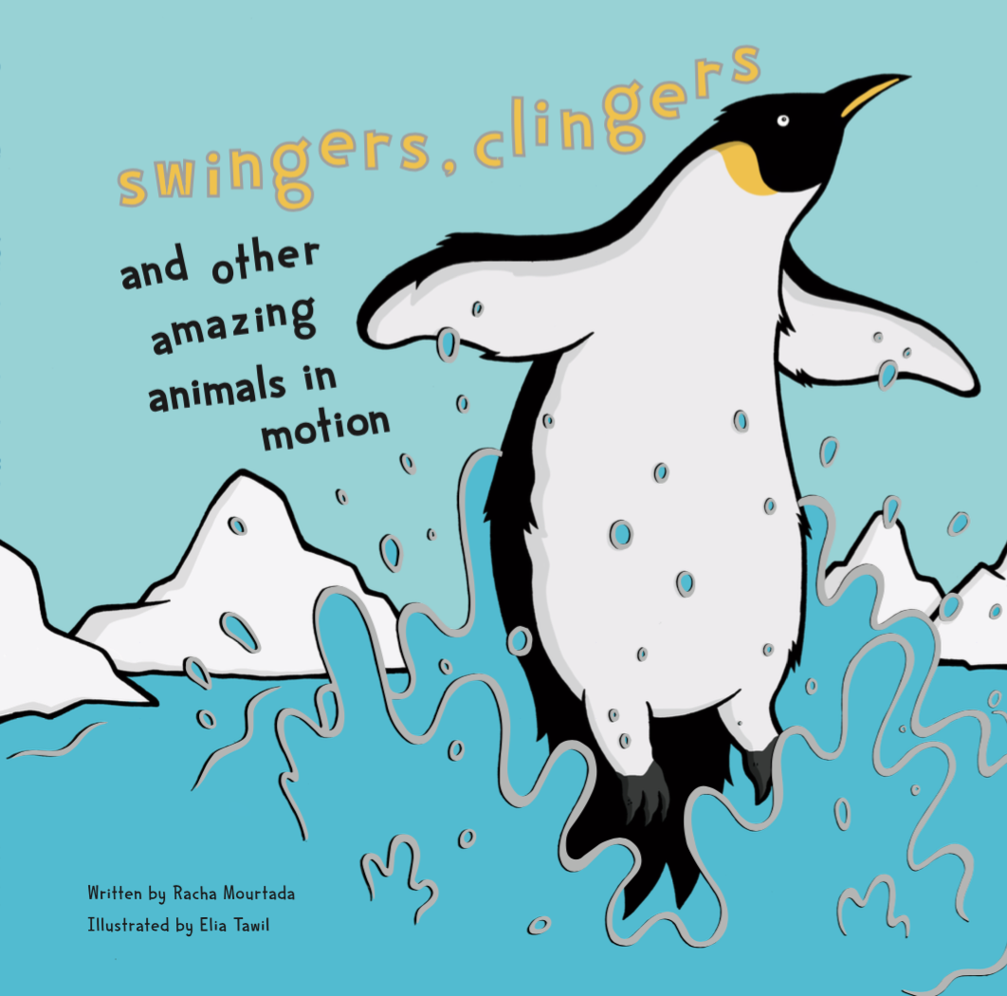

Book photos can be downloaded from: https://www.dropbox.com/sh/scvb717b4206e42/AABZv1hS6Kw0Z7OUHn9ymiDYa?dl=0

About Luqoom:
Luqoom is a new boutique publisher of children's books in Arabic and English, based in Beirut.

About the Author:
Racha Mourtada is the founder of Luqoom. She has had a varied career–working as a biomedical engineer, a UN researcher and a public policy analyst–throughout which the one constant has been her love of writing. An alumnus of Faber Academy’s ‘Novel Writing Course’ and the inaugural ‘Columbia Publishing Course’ at Oxford University, she recently decided to leave her corporate life in Dubai and move back to her native Beirut to set up a publishing house for children’s books.

Contact:

Racha Mourtada – Founder/Publisher
racha.mourtada@gmail.com
+9613-785745
www.luqoom.com

A hard copy or PDF of the book is available on request

