Luqoom Launches New Children’s Book, ‘I’ll Love You from Afar’
An Ode to Love in a Time of Coronavirus and Social Distancing

Beirut – November 2020

Luqoom–a boutique publishing house known for its pretty picture books–has launched a new children’s book, ‘I’ll Love You from Afar’, as an antidote to our frustration with the coronavirus and having to spend so much time apart from our loved ones.

Written by Racha Mourtada, the publishing house’s founder, ‘I’ll Love You from Afar’ started out in response to how much she missed hugging her nieces and nephew, and it turned into a warm and touching tale of all the ways we can still express our love and affection for each other, no matter where we are. These include singing whales, butterfly kisses and notes written in the stars!

Although initially inspired by the difficulty of social distancing, the book’s themes apply to any situation where we find ourselves unable to be with the ones we care about. With rhyming text and whimsical illustrations by Sasha Haddad, ‘I’ll Love You from Afar’ offers a comforting boost and a sweet reminder to both children and adults that love can transcend any distance.

“The idea for the book came about organically. I was actually working on a completely different project that I set aside because this line kept popping into my head about how love doesn’t fade no matter how far away you are, and I felt that people would find that reassuring,” Mourtada said. “And despite the difficulty of getting this book made in Lebanon right now and the struggle to source the paper and material needed, everyone involved was so enthusiastic and passionate about the project that there was no question about getting it done. In addition to the timeliness of the topic itself, I felt it was important that we keep creating and producing and expressing ourselves in these difficult times.”

The author has dedicated this book to Lebanon, specifically in the aftermath of the August 4 blast, which occurred about halfway through the writing and illustration process. She decided to change one of the spreads (below) as a tribute to the Lebanese people and the outpouring of love from around the world in response to the tragedy.
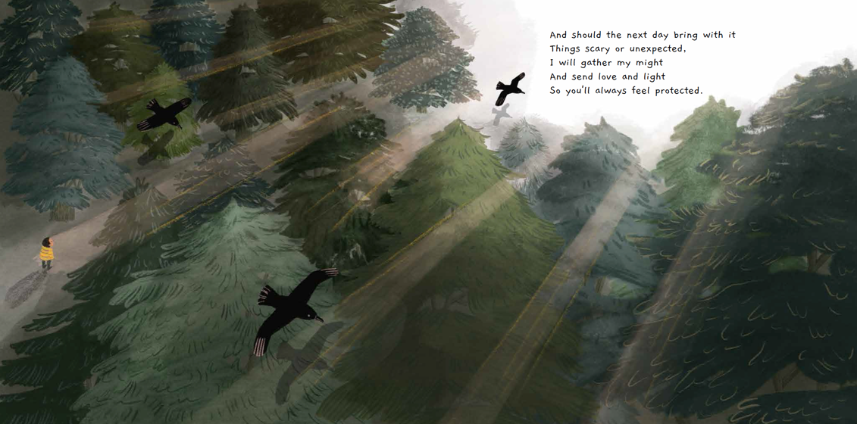
‘I’ll Love You from Afar’ is now available at Beirut bookstores and will be distributed in the UAE and Saudi Arabia in the following weeks. It is available to purchase online at www.luqoom.com.

Synopsis:

We all feel like we’ve missed out on our fair share of hugs and physical affection this year because of the coronavirus. “I’ll Love You from Afar” is an ode to all the wonderful and imaginative ways we can still love each other while we’re apart–like using singing whales and writing notes in the stars! With whimsical illustrations and rhyming text, this book is a sweet reminder for people of all ages that we can love each other no matter how near or far.

I'll Love You from Afar
Written by Racha Mourtada; Illustrated by Sasha Haddad
Published by Luqoom
Release Date: 15 October 2020
Hardcover with gold foil/32 pp/ 26 x 26 cm
Ages: 4+
ISBN 978-9953-9033-4-7
www.luqoom.com

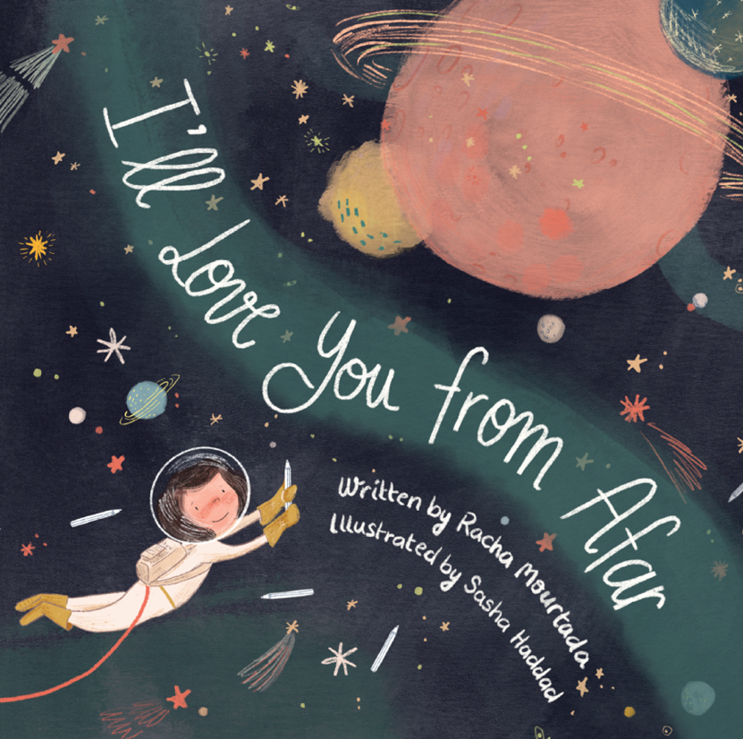

About Luqoom:
Luqoom is a boutique publisher of children's books in Arabic and English, established at the end of 2017 and based in Beirut. We believe books are treats to be savoured. They should be held, pored over, snuggled with and shared.

At Luqoom, we know that the combination of spare prose and beautiful imagery can create something magical. We strive to make luscious books that are captivating and visually rich, inviting kids (and the young at heart) into a world where they can let their curiosity and imagination run free.

We are particularly partial to science, silliness and good storytelling.
​

About the Author:
Racha Mourtada is the founder of Luqoom, a boutique publishing house she set up in Beirut after quitting her corporate life in Dubai. She has a soft spot for quirky tales and is an alumnus of Faber Academy's 'Novel Writing Course' and the 'Columbia Publishing Course' at Oxford University.
Prior to publishing, she had a varied career–working as a biomedical engineer, a UN researcher and a public policy analyst.

About the Illustrator:
Sasha Haddad is a Lebanese illustrator, and a Cambridge School of Arts MA graduate. She has illustrated over 15 children's books (among them two books for Sesame Street) and has illustrated magazine covers and articles for digital and printed magazines (Vice Arabia, Mira’a, Executive) and has worked with many international and local agencies creating mascots and illustrations for various brands.

Contact:

Racha Mourtada – Founder/Publisher
racha.mourtada@gmail.com
+9613-785745
www.luqoom.com
FB/Insta/Twitter: @LuqoomBooks

A hard copy of the book is available on request.

