Luqoom Launches its First Arabic Children’s Book
Encourages Kids to Explore What They Want to be When They Grow Up

Beirut - October 2018

Luqoom, a new boutique publishing house in Beirut, is launching its first children’s book in Arabic on October 27th. ‘When I Grow Up, I Want to Be…’ (translated title) is a fun, illustrated picture book about the diverse careers that kids can aspire to when they grow up. Written by Mona Karaoui and illustrated by Siwar Kraytem, the book combines traditional jobs with unconventional ones - like acrobats and wildlife photographers – and subtly subverts gender stereotypes by highlighting examples like female firefighters and male nurses. The eclectic mix of jobs teaches kids that the sky really is the limit when it comes to figuring out what you want to be when you grow up.

Racha Mourtada, Luqoom founder and publisher, said, “Kids are fascinated by what grownups do, and what they see around them informs what they believe they can or can’t be when they grow up. The more a young girl who loves space sees female astronauts in books and other media, the more encouraged she will be to pursue that career. The more a young boy sees video game design as a valid industry, the more likely he is to turn a hobby into an exciting career path. Our societies tend to prize a few professions above the rest, but it takes all kinds of jobs to build a thriving society. By highlighting this, we hope our book will show children that they can be anything they want to be when they grow up; their aspirations are only limited by their imagination.”

The book’s author, Mona Karaoui, said, “Writing ‘When I Grow Up, I want to Be…’, has been a truly rewarding experience for me. Being a new mom to a little girl, I am raising her to become her best, find her passion and make a positive contribution to her community and the world. This is the exact aim of the book, as it takes young girls and boys on an exciting exploration of a wide range of careers that ultimately help make the world a brighter place. I am very fond of the Arabic language and extremely delighted to have published my first work in Arabic with Luqoom. I hope our book will further connect our younger generations with this enchanting language and promote our Middle Eastern culture.”

Luqoom is launching ‘When I Grow Up, I want to Be…’ at Planet Discovery in Beirut Souks on Saturday, October 27th, between 10.30 and 13.30. The author will be signing books and doing readings throughout the morning. There will be drawing and colouring activities for the kids and free entry into the Planet Discovery exhibits for all attendees.

‘When I Grow Up, I Want to Be…’ is the first Arabic book in a line of high-quality, engaging and visually-rich Arabic and English children’s books that Luqoom aims to publish on wide-ranging topics - with a soft spot for science, silliness and good storytelling. It will be available at bookstores across Beirut from the beginning of November, and online at www.luqoom.com.

عندما أكبر، أريد أن أكون…
(When I Grow Up, I Want To Be…)
Written by Mona Karaoui; Illustrated by Siwar Kraytem
Published by Luqoom
Release Date: October 27th, 2018
Hardcover with gold foil/40 pp/22x28 cm
Ages: 7+
ISBN 978-9953-9033-0-9
www.luqoom.com

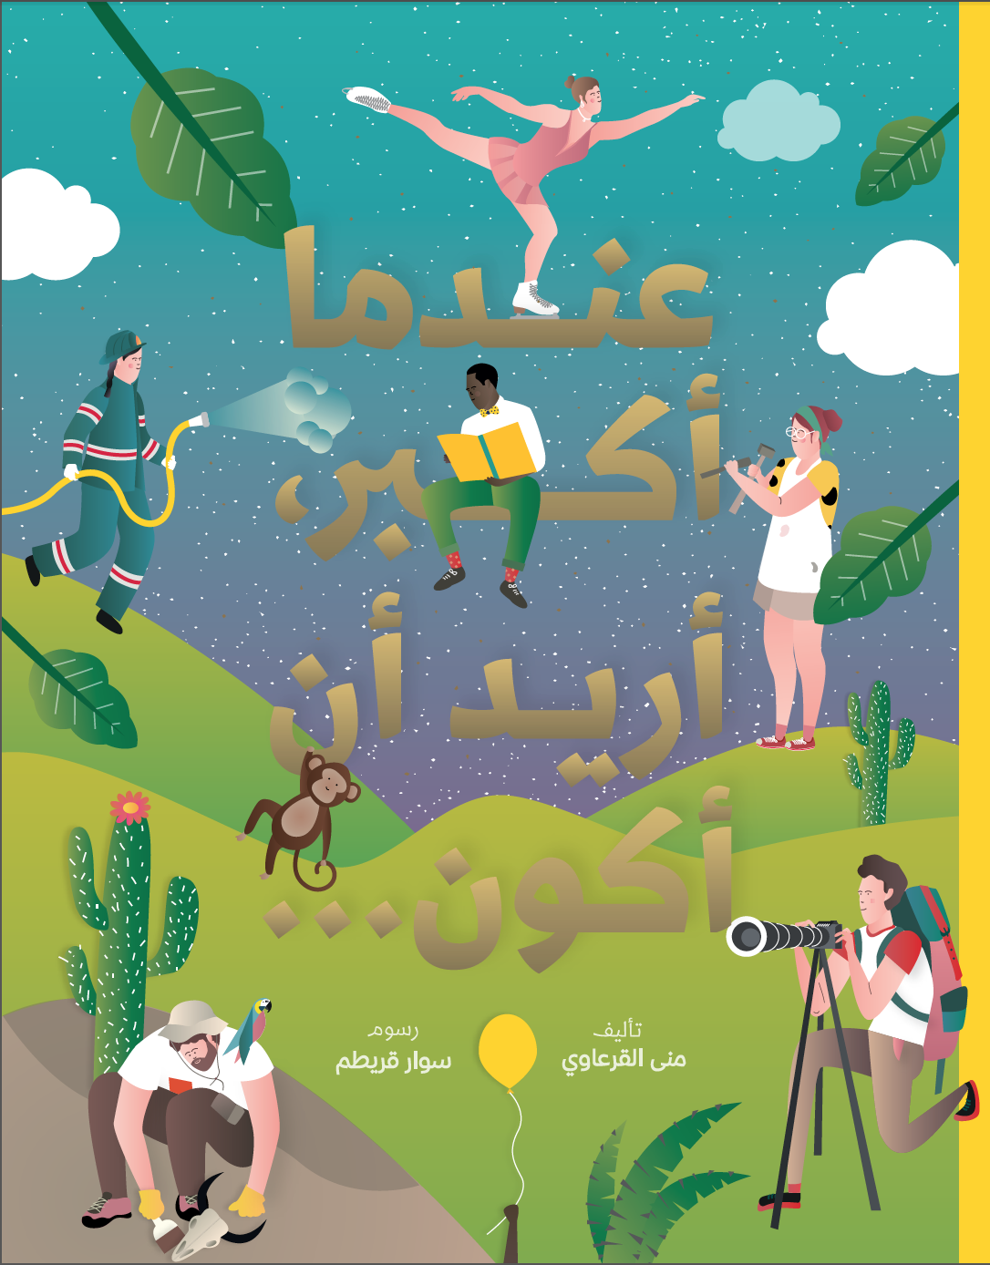

About Luqoom:
Luqoom is a boutique publisher of children's books in Arabic and English, based in Beirut. We strive to make books that are captivating and visually rich, inviting kids into a world where they can let their curiosity and imagination run free. We are particularly partial to science, silliness, and good storytelling.

About the Author:

Mona Karaoui is a Lebanese writer and editor, with extensive professional experience, based in Dubai. She graduated from the Lebanese American University with a Master’s in Business Administration and has worked both in Beirut and Dubai. Mona is also the founder of content and communications boutique consultancy Qalami Linguistic Services. She is deeply passionate about the Arabic language and Middle Eastern culture. ‘When I Grow Up, I Want to Be…’ is her first Arabic children’s book.

About the Illustrator:
Siwar Kraytem is graphic designer who is passionate about everything graphics and illustration. She is constantly seeking ways to get away from the computer by putting her hands to work (with illustration and screen-printing) and her legs to cycling around town. This is her first real venture into illustration and something she hopes to keep exploring.

Contact:

Racha Mourtada – Founder/Publisher
racha.mourtada@gmail.com
+9613-785745
www.luqoom.com
FB/Insta/Twitter: @LuqoomBooks

A PDF of the book is available on request.

