Luqoom Launches ‘55 Slightly Sinister Stories’
Deliciously Dark Bite-Size Tales for Grownups

Beirut – June 2019

Luqoom–a boutique publishing house known for its pretty children’s picture books–is announcing its first foray into books for grownups with ‘55 slightly sinister stories’, an illustrated collection of tiny tales with a twist coming out under its new imprint, Rose Luqoom.

Written by Racha Mourtada, the publishing house’s founder, ‘55 slightly sinister stories’ is the product of the author’s fascination with ‘microfiction’–a genre of extremely short stories ranging anywhere between six and one thousand words–a reverence for the creepy brilliance of Edward Gorey and Tim Burton, and a New Year’s resolution to write one story a day for a year. Specifically, she set out to write stories that are exactly fifty-five words long as an exercise in discipline, creativity and stripping a story to its bare bones.

This went on for 180 days, during which Mourtada scribbled and honed her stories before her daily commute, during lunch breaks, on the way to the gym and after dinner plans, posting each daily to a blog for posterity. Although difficult at times, it confirmed her sneaking suspicion that it is possible to find time to write, no matter how busy your life is. A few years later, she collected fifty-five of these stories–populated with narcoleptic drivers, bickering bakers, suspicious spouses and other quirky characters–polished and curated them into a book.

In keeping with Luqoom’s ethos of books as ‘treats to be savoured’, these bite-size tales are the equivalent of literary canapes, seasoned with a dash of dark humour and a modicum of absurdity. Each is accompanied by a delicate, hand-drawn, black and white illustration by Lebanese designer Lynn Atme, to complement the story’s cheeky undertones.

Ideal for busy book lovers who enjoy a good story but whose attention span has been reduced to the length of a social media post, ‘55 slightly sinister stories’ offers a reading experience that is slight but satisfying. The stories can be read in a few sips of your morning coffee, a literary pick-me-up to accompany your daily caffeine fix.

“There is something deeply gratifying–and challenging–about constructing an entire world out of fifty-five words. That might not seem like much to work with, but it forces you to consider each word and makes the story all the better for it,” Mourtada said, “What you leave out of a story is just as important as what you put in. Sometimes just a hint is all you need to ignite a reader’s imagination and you can trust them to fill in the blanks,” she added.

Luqoom is launching ‘55 slightly sinister stories’ at Aaliya’s Bookshop on Wednesday evening, June 19th, where the author will be signing copies. The book will be available post-launch in Beirut bookstores and online at www.luqoom.com.

55 slightly sinister stories
Written by Racha Mourtada
Illustrated by Lynn Atme
Release Date: June 19, 2019
Hardcover - 128 pp/16x20 cm
ISBN 978-9953-9033-1-6
www.luqoom.com

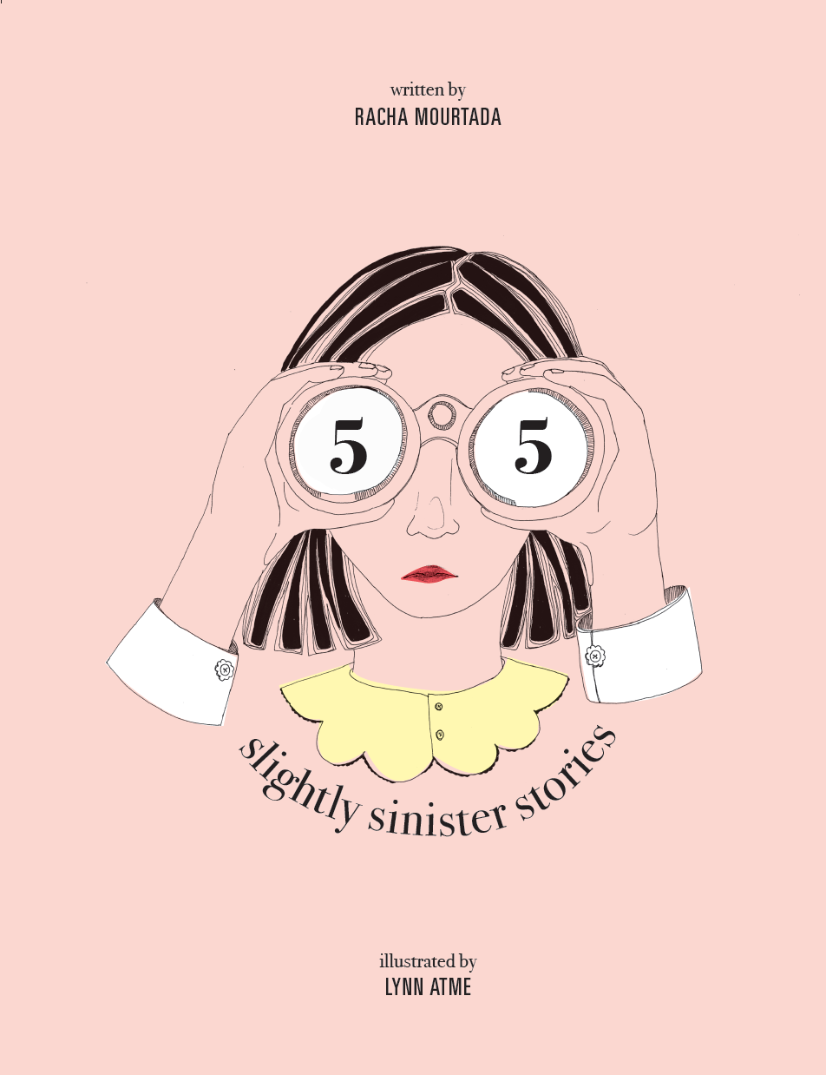

Link to PDF: https://bit.ly/2HCFt1E
Link to book trailer: https://www.youtube.com/watch?v=jIRGnOpQkdY

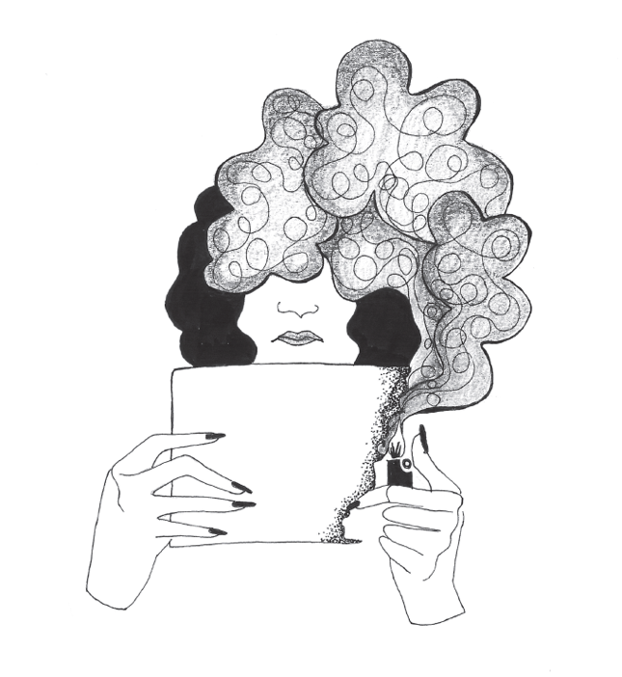
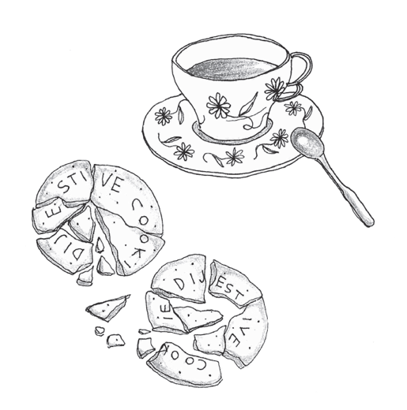
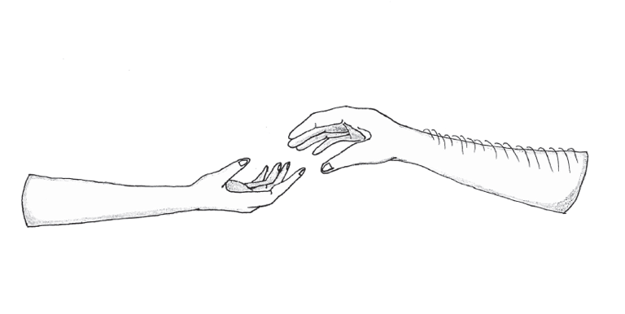
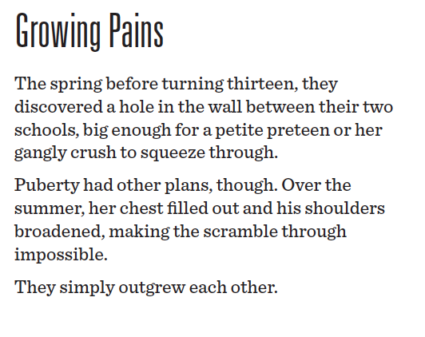
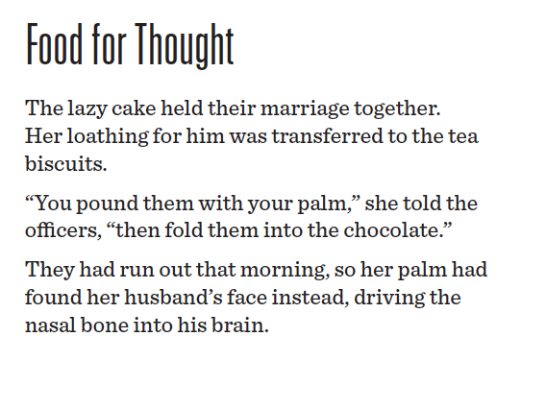
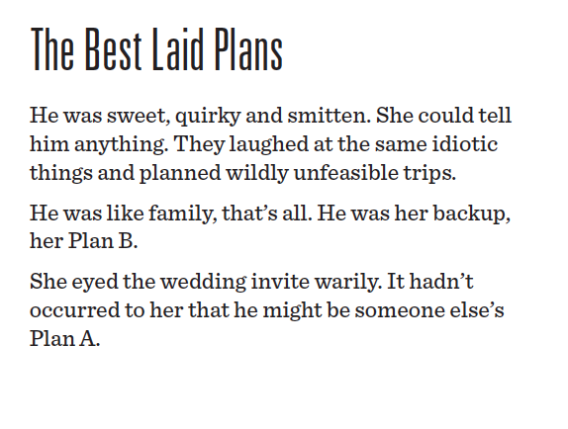

About Luqoom:
Luqoom is a boutique publisher of children's books in Arabic and English, established at the end of 2017 and based in Beirut. We believe books are treats to be savoured. They should be held, pored over, snuggled with and shared.

At Luqoom, we know that the combination of spare prose and beautiful imagery can create something magical. We strive to make luscious books that are captivating and visually rich, inviting kids (and the young at heart) into a world where they can let their curiosity and imagination run free.

We are particularly partial to science, silliness and good storytelling.
​

About the Author:
Racha Mourtada is the founder of Luqoom, a boutique publishing house she set up in Beirut after quitting her corporate life in Dubai. She has a soft spot for quirky tales and is an alumnus of Faber Academy's 'Novel Writing Course' and the 'Columbia Publishing Course' at Oxford University
Prior to publishing, she had a varied career–working as a biomedical engineer, a UN researcher and a public policy analyst.

About the Illustrator:
Lynn is an interior architect and self-taught illustrator. Using thin ink lines and textured details Lynn draws moments inspired by her curiosity for human stories. Along with her illustration, she works as an interior architect and lighting designer based in Beirut.

Contact:

Racha Mourtada – Founder/Publisher
racha.mourtada@gmail.com
+9613-785745
www.luqoom.com
FB/Insta/Twitter: @LuqoomBooks

A hard copy of the book is available on request.

