Photo consent release form
I ___________________, hereby grant Bels Dog Training LLC permission to use any photographs or videos taken of myself or my pet, in any all of its publications, including but not limited to website entries, without payment or any other consideration.
____(initial) I understand and agree that these materials will become your property and will not be returned.
____(initial) I hereby authorize to edit, alter, copy, exhibit, publish or distribute this photo or video for purposes of publicizing your programs or for any other lawful purpose.
In addition, I waive any right to royalites or other compensation arising or related to the use of the photograph.
____(initial) I hereby release rights to all claims, demands, and causes to action which I, my heirs, representatives, executors, administrators, or any other persons acting on my behalf of my estate have or may have by reason of this authorization. In signing this consent, I give authorization to use my name and my pet’s name and information as printed below.

(Print pets name)

(Printed owners name)

(Owners signature)

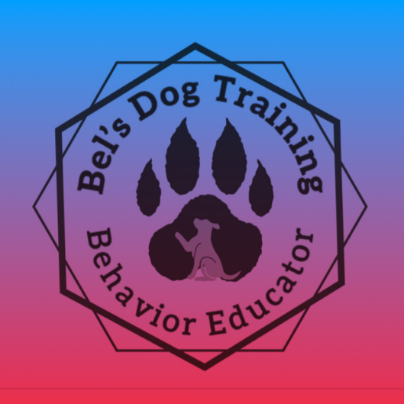
(Date)

