**Bel’s Dog Training LLC**

**Dog Training Liability Waiver**

I, ______________________________________________, owner of __________________________, agree that I am entering in to this dog training program in full knowledge that, although highly unlikely, that there are certain risks that may not be avoided when training my dog. I agree to release Bels Dog Training LLC and my dog’s trainer of any and all liabilities associated with this dog training program, including but not limited to loss, injury, sickness, and death of my dog. I agree to take on the full financial burden of any incident or damages that may happen to my dog, or to that of any other dog, person, other animal, or property directly or in directly associated with this dog training program. I agree to cover any and all costs associated with any damage or injuries caused to my dog’s trainer or their property while they are working with my dog. I agree to release Bels Dog Training LLC and the dog trainer(s) of any and all liabilities for any accident or incident that may happen to me, my dog, or anyone that is actively involved in training my dog in a group class setting, on a walk, field trip or other dog training related activities that results in the loss, injury, sickness or death of my dog or any of those actively involved in training my dog during these activities.

By signing this document, I, ________________________________________________, hereby waive Bels Dog Training LLC and any dog trainer associated with Bels Dog Training of any liabilities associated with me, my family and my dog being enrolled in this dog training program.

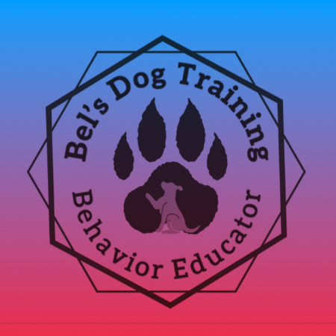Signature: ___________________________________________________ Date: ________________