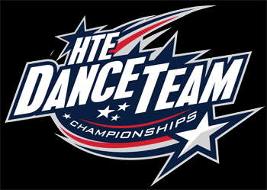
Frequently Asked Questions: 2018 Regional and National Contests

What will be offered in the Spirit Shop retail store during contest?
The Spirit Shop has a wide range of items including shirts, sweatshirts, dance attire, jewelry, purses, novelty items, flip flops, pins and patches. Be sure to bring plenty of spending money!
What will be available to eat at the concession stand?
Each host school will offer its own menu. The host will send a menu to you beforehand and may also ask for pre-orders on lunch and dinner. Please plan to take advantage of the concession stand at contest. This is a fundraiser for the host school. It is also one major way HTEDance is able to keep our contest fees to a minimum comparatively. ABSOLUTELY NO OUTSIDE FOOD or DRINK IS PERMITTED. No ice chests!

Do you take credit cards?
We accept credit cards, cash, checks and official school PO’s.

What is the cost of admission to the contest?
- $10 for spectators 6 and over.Children under 6 years old are free.
- Each team receives 4 chaperone passes.
- Managers and escorts MUST be in uniform to be admitted free of charge.
- Unless injured, team members must be performing to be admitted free with the team. New member groups not performing in the contest must pay admission fee of $10 each.

What is the performance area?
The performance area for all team performances will be a regulation-sized court with basic basketball markings. Performance area for officer, select, ensemble and solo performances will vary depending on contest size. We will make every effort to have a regulation-sized area, but be prepared for a smaller area if necessary.
What if I have other questions?
Please feel free to contact our contest coordinator via phone or email anytime day or night. We want to ensure that you are comfortable and confident with your contest experience with HTEDance.

