Greetings:
Welcome to the ultimate social officer camp experience! Are you and your team ready for an amazing year? You will be when we’re done. Welcome to the one and only…
HTEDance
Social Officers Activities Retreat

We are delighted that you are going to be a part of our family! Whether this is your first experience at an HTEDance event, or you are a seasoned veteran this program is designed to help turn your officer line into a well-oiled machine!
This year’s theme is “Live Your Story!” A curriculum designed to guide you through the journey of leadership!
- We will SEE our assets and talents and recognize each leader’s contribution.
- We will DREAM about what we could do with those talents. To maximize ALL our gifts.
- We will WRITE about our journey to record it and recall it later.
- We will learn to LIVE our story to its fullest and make the most of the journey!

This program is designed to help you and your fellow officers to maximize the resources around you. We will help to instill in you the drive and desire:
- To bring out the best in each other and to accept, love and respect each other.
- To live their life to the fullest and make a TRUE and HONEST commitment to SERVE!
- To find inner motivation and inspire them to take the road less traveled! EXCELLENCE
- To believe in yourself and the power of TEAM and maximize that potential!
- To turn your young students into mature LEADERS!!

Here are a few documents to help make your experience fun and successful. READ THEM ALL!
- What To Know Before You Go
- OTC Intensive Student Schedule – Find the most updated schedule at www.HTEDance.com
- What To Bring To Camp
- The NEW OTC Intensive “Social Servant Leader Challenge!”

With these documents in hand, we are excited to introduce the very first
HTEDance OTC Social Servant Leader Challenge!
There are five projects that we want for you to undertake during the two weeks prior to camp! These challenges are designed to help give us all a glimpse into the talents, assets and creativity that your officer line possess already!
As with all that you do as a leader, give us your VERY BEST! These projects are to be completed as an officer line. No help from parents, directors or others. This is YOUR time to shine! Now, Let’s ROLL!
Best of luck, put your best foot forward and LET’S LEAD!
Mr. Jeffrey

SOCIAL OFFICER ACTIVITIES RETREAT
Schedule Version 3

Day 1 - Reflect - Learning
8:30-10:30 Registration & Lunch on Your Own
10:30-11:00 OPENING RALLY!
11:00-11:45 Introduction to SOAR
11:45-12:15 SOAR WORKSHOP – What’s My Job?
11:45-1:30 DIRECTOR MEETING - VIEW PEP RALLY DANCES
12:15-1:15 PROJECT WORK TIME – Base Project #1
1:15-2:15 SOAR WORKSHOP – Project #1
2:15-4:00 PROJECT WORK TIME
4:00-4:15 Showoffs - Director’s may video
4:15-4:30 Buddy Introduction
4:30-5:00 GRAND PRIX LEAPS
5:00-6:00 DINNER- Included in your package.
6:00-7:00 SOAR WORKSHOP
7:00-9:15 TEAMLEADER SESSION 1 (Students must have packets and pens!)
9:15-10:00 Midnight Mail/Buddy Visits
9:30-12:00 PROJECT WORK TIME – Consider additional work on your presentation table.

Day 2 - Rebuild - Loving
7:00-8:00 Warm-Up/Review Camp Dance & Academy Audition Combos taught
8:00-10:00 SOAR WORKSHOP & PROJECT WORK TIME
10:00-12:00 TEAMLEADER SESSION #2 (Students must have packets and pens!)
12:00-12:30 GRAND PRIX EXTENSIONS
12:30-1:00 LUNCH – Included in your package! Get Academy Sign Up Sheets!!
1:00-3:15 SOAR WORKSHOP & PROJECT WORK TIME
1:30-3:00 DIRECTOR/SOCIAL OFFICER COLLABORATION
3:15-3:45 Showoffs - Directors may video
3:45-6:00 DINNER - Free Time for “Night on the Town” and/or practice
6:00-7:30 SOAR WORKSHOP & PROJECT WORK TIME
7:30-9:30 TEAMLEADER SESSION #3 (Students must have packets and pens!)
9:30-10:15 Midnight Mail/Buddy Visits
10:15-12:00 PROJECT WORK TIME – Continue work on your project and presentation table.

Day 3 - Renew - Leading
7:00-7:15 Warm-Up
7:15-7:45 Final Routine Review
7:45-8:15 Prep Campers for Show-Offs
8:15-8:30 Routine Demos
8:30-10:15 ROUTINE SESSION #4
8:30-10:15 SOAR Presentation Tables Set up in Foyer!
10:00-10:30 Showoffs/Meet & Greet - Directors may wish to film this routine
10:30-11:30 SPIRIT SHOP OPENS FOR PARENTS SHOPPING!
10:30-11:30 TEAMLEADER #4 – “Covenant” (Students must have packets and pens!)
(Please bring 1 taper candle for each person in your group & matches/lighter)
11:30 BALLROOM OPENS FOR PARENTS
11:30 Original Choreography Teams Check in with HTE Staff!
SOAR Project Check in with HTE Staff!
12:00 PARENT SHOW-OFFS
1:00 HTE Officer Training Camp Graduation & Goodbyes!

Dance & Social Officers Together

WHAT TO KNOW BEFORE YOU GO
Social Servant Leader Edition

The following list has been compiled to help you better prepare for your experience at HTEDance Officer Training Camp. It is our hope that you have the most productive and memorable experience possible, and we will do everything in our power to ensure that happens. Let us know if you have any questions.
CAMP SCHEDULE
In this packet and online, you will find a Tentative Social Servant Leader Schedule. This will give you a general idea of times and workshops. HTEDance expects you, as a Social Servant Leader be punctual to ALL classes!

WHAT TO BRING
This list will help you and your fellow Social Servant Leaders to pack for OTC Intensive.

MEDICAL AND LIABILITY RELEASE FORM
ALL ATENDEES MUST COMPLETE THIS FORM! You will not be admitted without it. Check often with your parents or guardians to make sure they have completed it. It is YOUR responsibility to have this done!
OTC Medical Liability Release

SPIRIT SHOP
HTEDance is proud to once again to present the Spirit Shop. The Spirit Shop is open every evening.

GOOD LUCK NOTES/GIFTS (Dallas 198 students) (Houston 128 Students)
HTEDance does not require you to do good luck notes/gifts for the other schools at camp. However, if you choose to do so out of the spirit of good sportsmanship, feel free. We do encourage a spirited environment at HTEDance, and Spirit Awards are given out daily based on such things as good sportsmanship, enthusiasm and camaraderie with other schools, etc.

CHOREOGRAPHY 101
HTEDance does not require you to bring a home routine to camp. Instead, our staff teaches the proper dos and don’ts of choreography through the Choreography 101 class & project. We will walk you through the basics of choreography, present the necessary skills and then you will create your own routine at camp. This routine will be shown off on the final day for all your fellow campers to see.

TEACHING 101:
The HTEDance staff will work with each of you on developing proper teaching skills. You will be given an extensive training class on the do’s and don'ts of proper teaching techniques to be used with your team.

The CONVENANT
This is an exclusive to HTEDance! This is THE most important time you will spend at an HTEDance Officer Training Camp Intensive. This highly emotional workshop is designed to prepare you for the year ahead. This is truly where it all starts. Here is the place where all the memories begin. You will need a long-tapered candle for this intimate, yet inspiring workshop.
Please note: You will need something to catch the dripping wax as well as matches!!

WHAT TO KNOW BEFORE YOU GO
Social Servant Leader Edition
Page 2

WORKSHOPS
For all workshops, you will need the following items: notebook with loose leaf paper, pens/pencils, colored markers, pens or pencils, stationary, fun stickers, and a copy of your Team’s Constitution. Please feel free to bring any other items you feel necessary to make yourselves comfortable without being distracted.

ROUTINES
At each routine session, you will be offered multiple styles and levels from which you may choose. You or your director need to divide up to learn as much material as possible or stick together—the choice is yours.

NIGHT ON THE TOWN
The second night at OTC, you will be given the evening off. What you choose to do with this time is up to you and your fellow leaders. You may spend the time practicing, go out to dinner, shopping, etc. HTEDance does encourage you to do something together so that you may continue with the See/Dream/Write/Live Your Story process that has been introduced at camp thus far.

EVALUATIONS
HTEDance does not promote competition at its training camps, but rather a spirit of unity and togetherness. You will be evaluated on the last day based on your performance and abilities to “follow the guidelines given.” You will NOT be scored against the other teams there, but against a standard. This is meant to be a means of critique to help get your year started on the right foot.

HTEDANCE SIGN LANGUAGE:
HTEDance’s “Sign” Language contest is BACK! This is a fun, spirited way to wish your fellow campers good luck for the week ahead, say hello and introduce yourselves, or simply motivate fellow campers. Make a poster/sign that can be hung in the main meeting area. The most important thing is to be creative, positive, motivating, and fun. Prizes will be given based on creativity, originality and motivational impact.

DIRECTOR GIFTS
HTEDance does not require you to give a gift to your director at camp. However, if you choose to do so, please feel free. There are instances that occur where a gift or note might be appropriate, but again, not mandatory.

OFFICIAL HTEDANCE OTC INTENSIVE TEE & VARSITY PATCH
The official camp Tee and Patch are ONLY available as a pre-order item. Please make sure that your director knows if you wish to have one so that she can place an order on your behalf. The officers usually wear their tee as a team during “Night On The Town!”

WHAT TO BRING LIST
Social Servant Leader Edition

- Theme Day outfit (GET CREATIVE & CRAZY, BUT DON’T FORGET A COVER UP)
- Sweatshirt/ jacket (it gets cold in the ballrooms. We have them in Spirit Shop)
- Other clothes (shorts, t-shirts, etc. to be worn in the evening during work time)
- Cosmetics as needed.
- Toiletries as needed.
- Hair Dryer as needed
- Curlers, curling iron, flat iron, etc. as needed.
- Pajamas
- Pillow for Pillow Pals each evening during TEAM TIME!
- Cell phone with charger
- Alarm Clock (Don’t be late! You are now a Social Servant Leader and are expected to maintenance your own schedule accordingly,)
- TEAM CONSTITUTION - You WILL be using your constitution this year! Make sure you have a copy!
- Proper footwear (Whatever you are comfortable with)
- You may wish to bring a nice outfit for “Night on the Town.” (Most teams wear and we encourage you to wear the Official OTC T-shirt with some kind of cute shorts, blue jean or cute pants.)
- Money for “Night on the Town,” Spirit Shop, SNACK SHAK and other goodies and necessities
- WATER BOTTLE!! STAY HYDRATED!! We expect each student to take care of themselves! Each student is responsible to fill a water bottle or YETI with ice and water for the day. There are not enough water fountains or water service to keep the students comfortable. Please make sure you are prepared.
- Each participant/director must bring an 8”-10” taper candle.
- Wax catcher” of some sort – matches or lighter.
- TEAM ROSTER and your FOOTBALL/ANNUAL TEAM CALENDAR
- DON’T FORGET: OTC SOCIAL SERVANT LEADER CHALLENGE

- Any other items that you may wish to bring with you to camp.

HTEDANCE SOAR 2021
TECHNOLOGY PACKING LIST

- Laptop
- USB or External Hard dive bring the following:
  - Team Roster
  - Team Birthdays
  - Yearly Team Calendar of Events
  - Football Game Schedule
  - Director & Assistant Director Photos
  - Social Officer Head Shots
  - Dance Officer Head Shots
  - 2021-2022 Team Photo
  - Constitution/ Team Guidelines
  - 2021-2022 School Calendar
  - School Song
  - Fight Song
  - Team Logo

HTEDANCE SOAR 2021
PROJECT PACKING LIST

- Laptop (Do not forget the cords!)
- Cricket/ Silhouette (Do not forget the cords!)
    - Cutting Mat
    - Vinyl in complementary color of chosen paint color.
    - Fresh Blade
    - Weeder
    - Transfer tape
- Toolbox of Supplies (Put in a tub to organize.)
    - Scissors/ Ruler
    - Makers/ Paint pens
    - Pens/ Pencils
    - Glitter
    - Glue Gun with extra Glue Sticks
    - Extension Cord(s) with multi-plug strip
    - Paper and Cardstock, different colors/ designs.
    - Vinyl in various colors to complete all projects.
    - Letters/ Sticker Letters of various sizes
    - Rolls of Ribbon of various sizes, check your projects for desired color/size.
    - Acrylic paint of various colors
    - Spray paint for hangers
    - Paint brushes of various sizes
    - Sandpaper- for Director Gift
    - Mod Podge
    - 1 Solo cup for each member of your team
    - 20 pictures of each officer, printed on white copy paper.

HTEDANCE SOAR 2021
PROJECT WORKSHEET – Team Hangers

Project #1: You will be asked to create a spirit hanger for each member of your team. HTE will proved the wooden hanger. Dream big and create a useable gift for your team to hanger their uniforms on for the upcoming year. I would stay away from glitter unless you plan to seal with acrylic to protect your uniforms.
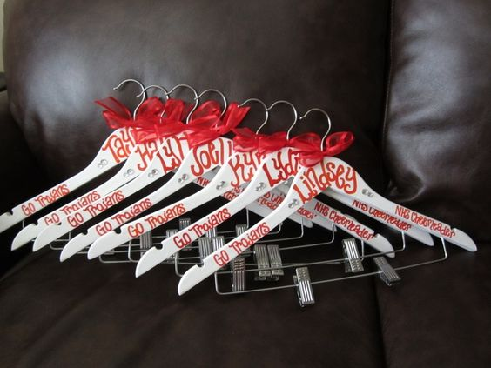
- Spray Paint/ Acrylic Paint
- Paint Brushes
- Letter Stickers/ Vinyl to cut Names & Rank at camp
- Ribbon
- Any extra accessory you want to include.

HTEDANCE SOAR 2021
PROJECT WORKSHEET – Director Gift

Project #2: You will be asked to create a director gift for each of your directors. You will be given 1- 12” long block, 1- 10” long block, 1- 8” long block for each director. You can decorate them any way you want!
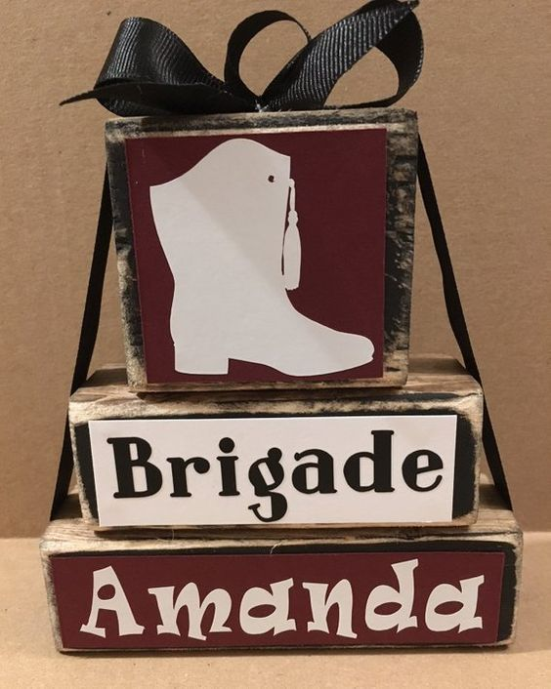
- Ribbon
- Paint
- Glitter
- Letters/ Vinyl to cut once you get to camp.
- Sandpaper
- Scrapbook paper
- Mod Podge
- Paint brushes

HTEDANCE SOAR 2021
PROJECT WORKSHEET – Team Ornament

Project #3: You will be asked to create an ornament for each member of you team. Be creative, you will be given a plastic 4” clear sphere ornament. If you plan to paint them on the inside, make sure you bring a way to rest them upside down to let the paint dry in a timely manner!
- Paint
- Vinyl to cut team logo, name, rank, team name, etc.
- Ribbon
- Stickers
- Glitter
- Solo Cups- To hold ornaments to dry.
- Crinkle cut paper shred filler.
- Team or Individual Pictures – 1 for each team member

HTEDANCE SOAR 2021
PROJECT WORKSHEET – Officer Gift

Project #4: You will be asked to decorate 13’ wooden letter that represents the rank your officers hold. Keep this a secret! We want to surprise them!

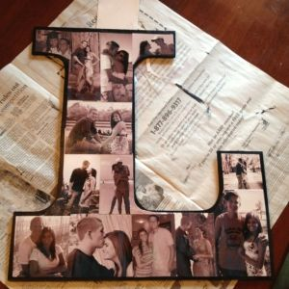
- Print 20 pictures of each officer on regular copy paper.
- Mod Podge
- Paint Brush
- Ribbon
- Hot Glue gun
- Extra Glue Sticks

HTEDANCE OTC SOCIAL SERVANT LEADER CHALLENGE
To be completed by the officers ONLY!

Read Challenges / Collaborate Ideas / Initiate Action Plan / Implement Results

SOAR Challenge 1 - We’re LIVING OUR STORY at HTE! Social Media Project
We want you to be as excited as we are about this summer’s Officer Intensive! So, we want you to SHOUT IT OUT to everyone on Instagram! Give us your most unique post. You can make it a dance, a chant a song or anything you can imagine! Make sure to follow and tag us at “htedance.” You must mention your team name and let social media know that you all are…SEEING, DREAMING, WRITING AND LIVING OUR STORY at HTE! YOU NEED TO DO THIS AS A SOCIAL OFFCIER SQUAD!
PRE-CAMP: Post this on your own time any time BEFORE June 1st! Post on your team social media AND your own

Challenge 2 - Theme Sign Language
Again this year, we celebrate each of our teams with a motivational sign to help motivate themselves and all others at SOAR! Make it fun, clever and to support the theme of See, Dream, Write, and LIVE YOUR STORY! Make it all about your Social Officer Journey to SOAR! You will need to plan everything from the materials, the design and them manner if which you display the sign. You may hang it up in the ballroom, but you will need to bring Command Strips to do so. Or it can be stand alone. You are only limited to your own imagination. This sign will be installed in your SOAR classroom!
AT CAMP: When you arrive, simply install your signage in the SOAR classroom as you wait for Opening Rally to begin!

Challenge 3 – Spirit Challenge
At HTEDance, we are all about fun. And part of that fun is creating, building and spreading team spirit. So put your best fashion foot forward and dress for success each day at SOAR!
Day 1 - Princess Power – Bring out the bling and show us your inner princess.
Day 2 - It’s A Jungle Out There – Dress your best safari fashion in your hunt for servanthood.
Day 3 - Spirit Day – Show us your own personal school pride by wearing & boasting your school colors.
AT CAMP: Wear the designated costume each day at SOAR. Prizes will be awarded daily!

Challenge 4 - Officer Line Pass Down Notebook
It takes a lot to make a team! Even more to make a team that treasures traditions and standards. We want to help you create a notebook to pass down to your future peers. You bring THE notebook, dividers, pens, pencils, markers, stickers and any other fun resources to make it your own. We will give you all that you need to create a notebook to celebrate and pass down the traditions that make your team…YOURS! Invest time in this project as it will be YOUR legacy as well!
AT CAMP: We will begin working on our Notebooks at Team Time on the first night.

Challenge 5 - Director Interview
One of the keys to being a successful Social Officer is knowing the FIVE W’s - Who, What, When Where and Why of things. And to do that, you need to check in with the one person that knows all there is to know about your team and its past! Because YOU are their future. You will need to conduct an interview with your director to attain information, documentation and timing of the following:
- Your team calendars
- Your Football Schedule
- Big Sis Lil Sis
- Squad Details
- Individual Team Pics
- Team Roster
- Social Officer Expectations
- Budget for Social Officers
- Director Ditties – Yes, you will need to know a little something about your fearless leader.
What is her favorite color, food, candy, movie, song…the things that make her….HER!

AT CAMP: The 1st Annual HTEDance Lip Sync Battle will take place on the last evening of your camp.

