HTEDANCE SOAR 2023
PROJECT PACKING LIST

- Laptop (Do not forget the cords!)
- Cricket/ Silhouette (Do not forget the cords!)
    - Cutting Mat
    - Vinyl in complementary color of chosen paint color.
    - Fresh Blade
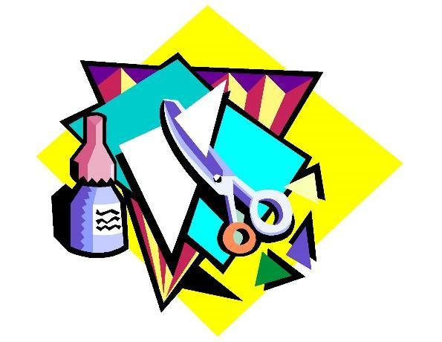
    - Weeder
    - Transfer tape
- Toolbox of Supplies (Put in a tub to organize.)
    - Scissors/ Ruler
    - Makers/ Paint pens
    - Pens/ Pencils
    - Glitter
    - Glue Gun with extra Glue Sticks
    - Clear Packing Tape
    - Extension Cord(s) with multi-plug strip
    - Paper and Cardstock, different colors/ designs.
    - Vinyl in various colors to complete all projects.
    - Letters/ Sticker Letters of various sizes
    - Rolls of Ribbon of various sizes, check your projects for desired color/size.
    - Acrylic paint of various colors
    - Mod Podge
    - Paint brushes of various sizes

TIPS:
- Pre design anything your plan to cut on your personal cricut or silhouette.
- If you or your Social Officers do not know how to use the cricut or silhouette, have all needed stickers precut prior to camp.
- Bring more than you need or anything.

