Explorer Post 9774 uniform order sheet

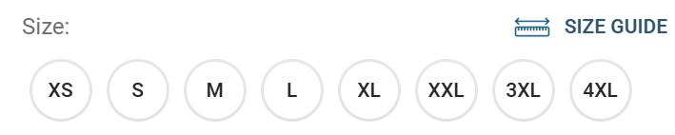

Item: uniform polo | Price: $25.00 | Quantity: | 1 required

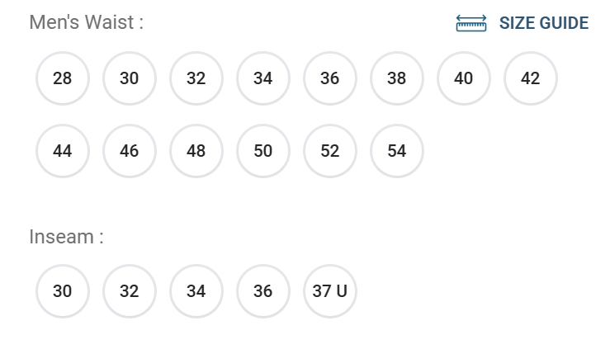
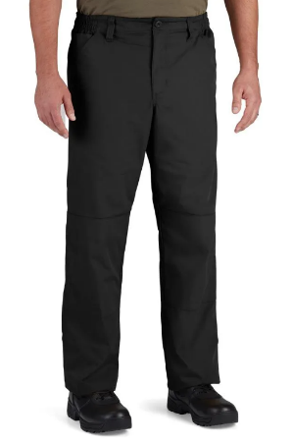

Item: uniform pant | Price: $30.00 | Quantity: | 1 required

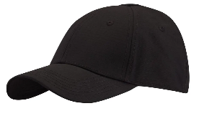
Item: uniform hat | Price: $15.00 | Quantity: | 1 required

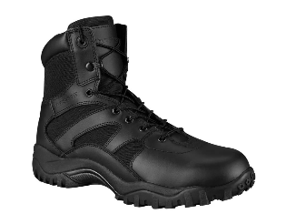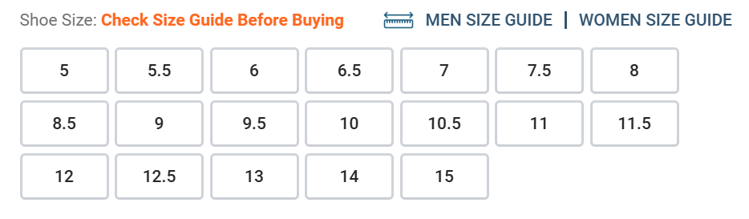
Item: 6” Tac Boot | Price: $70.00 | Quantity: | 1 pair required

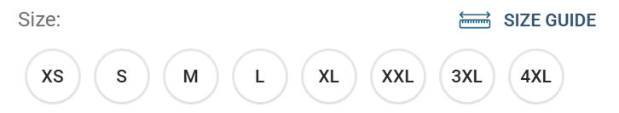
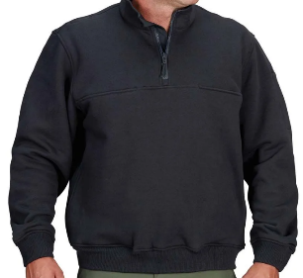
Item: quarter zip pullover | Price: $60.00 | Quantity: | Optional purchase item

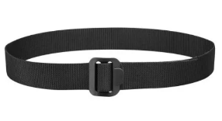belt size based on pant size order
Item: tactical web belt | Price: $10.00 | Quantity: | 1 required

All items marked with * are considered standard uniform apparel therefore required for enrollment in the Saint Louis County Police Explorer program. Payment for items ordered is required upon acceptance into the Police Explorer program. These items are non-refundable once order is submitted. All Explorer purchased items are yours to keep upon completion or dismissal from the program. Soom items may be sold back to the Explorer Post depending on the condition of the uniform.

