16 |  | Little Stoke  Garden Society www.littlestokegardenandallotmentsociety2018.co.uk  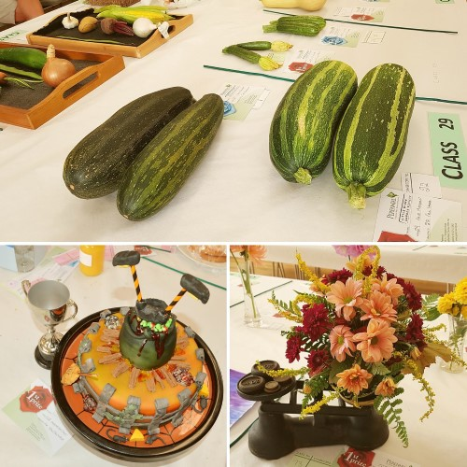  44th Annual Show  Saturday 31st August 2019 2.30pm  Awards to be presented at 3.45 pm  Little Stoke Community Hall  Little Stoke Lane  Little Stoke  BS34 6HR
Little Stoke Garden Society  44th Annual Show  Saturday 31st August 2019  To be held at The Community Hall, Little Stoke Lane  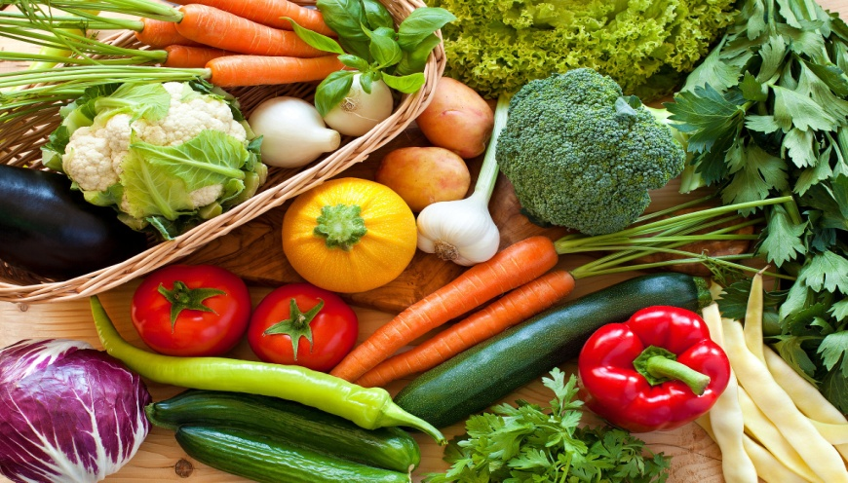  2 |  | Special Cup Awards (To be held for one year)  MEL WILLIAMS CUP For most points in show  GADD CUP Best exhibit in show  WINNER MOST POINTS: VEGETABLES For most points in Vegetable section  WINNER MOST POINTS: FLOWERS For most points in flower section  WINNER OF HANDICRAFT For most points in Handicraft section  WINNER OF HOMECRAFT For most points in Homecraft section  WINNER OF MOST POINTS IN FRUIT For Most Points in Fruit section  WINNER OF PHOTOGRAPHY For most points in the Photography section  WINNER OF FLOWER For the most points in  ARRANGEMENT Flower Arranging section  JUNIOR WINNER UNDER 7 For most points aged under 7  JUNIOR WINNER 7-10 For most points aged 7-10  JUNIOR WINNER 10-16 For most points aged 10-16
RULES  PLEASE READ CAREFULLY BEFORE ENTERING EXHIBITS  Entry forms must be completed and handed, with the entry fees, to one of the persons named on page 5 by WEDNESDAY NIGHT 28th August 2019. NO ENTRIES WILL BE ACCEPTED ON THE DAY OF THE SHOW.  Points will be awarded as follows :-  1st.= 4 : 2nd. = 3 : 3rd. = 2. HC = 1  Exhibitors must bring exhibits to the exhibition hall on the day of the show between the hours of 8.45 and 10.45 am. No exhibits will be collected by the committee. Judging will commence at 11.00 am. Please allow ample time for arranging your exhibits. Staging MUST be completed by 10.45 am.  ALL EXHIBITS MUST CONFORM STRICTLY TO THE SCHEDULE.  Exhibits cannot be removed from the show before 4.15 pm. Prizes will be presented at 3.45 pm.  Exhibitors are asked to ensure that all their exhibits and prize cards are collected and taken away at the end of the show.  Exhibitors are not allowed to enter more than one exhibit in any one class.  All exhibits must be grown by the exhibitors, or be their own unaided work. Tomatoes will be classed as a vegetable. Rhubarb will be classed as a vegetable.  All junior exhibits must be their own unaided work. Exhibits to show age only, not name.  Please name exhibits as this gives added interest to the show.  All preserve labels must state variety and date.  The committee will take every possible care of exhibits, but cannot hold themselves responsible for any breakage or damage done.  Exhibitors in the flower section must provide their own containers.  Flower arrangement section - an exhibit is natural plant material with or without accessories.  If less than four entries in any one class, the committee reserve the right to amend the number of prizes awarded.  All matters not provided for in these rules shall be left to the committee whose decision will be final  4 |  | 3  PLEASE RETURN COMPLETED ENTRY FORMS WITH CASH TO ANY  MEMBER LISTED BELOW BY 8.00 pm WEDNESDAY 28th August 2019  L.Davis 54 Wrington Close, Little Stoke  K Evans 142 Pursey Drive, Bradley Stoke South  D.Hutton 80 Farley Close, Little Stoke  P Ballinger 3 Osborne Close, Stoke Gifford  J Szczelkun 16 Tyrrel Way, Stoke Gifford  M Harris 53 Bush Avenue, Little Stoke  G Alderson 30 Belmont Drive, Stoke Gifford  L Howe 8 Gloucester Close, Stoke Gifford  5

Schedule of Classes  Vegetable Section  Class  1 Vegetable Marrow (Longest)  2 Pumpkin (Heaviest)  3 Onion (Heaviest As Lifted)  4 Potato (Heaviest)  5 Runner Bean (Longest)  6 Sweet Corn (Best Golden Cob)  7 Collection of Six Vegetables (One of each kind for quality, tomato may be included. Trim root vegetables. Maximum tray size 2ft x 1ft)  8 Three Onions From Sets (Trimmed)  9 Three Onions Sown From Seed (Trimmed Not Exceeding 12oz)  10 Three Onions Sown From Seed (Trimmed 12oz and Over)  11 Four Potatoes (White)  12 Four Potatoes (Coloured)  13 Two Cabbages (One Variety, with 3" Stalk)  14 Nine Shallots (Large over 32mm (1.25”) diameter)  15 Nine Shallots (For Pickling under 32mm (1.25”) diameter)  17 Four Carrots (Intermediate and Large)  18 Four Carrots (Stump Rooted) *  19 Three Beetroot (One variety) *  * Classes 17 - 21 Trimmed 3" to 4”  20 Three Parsnips (One variety) *  21 Three Turnips  22 Three Leeks (Untrimmed )  23 Six Runner Beans (One variety)  24 Six Dwarf Beans (One variety)  25 Four Tomatoes (With Calyces)  26 Nine Small Tomatoes (With Calyces)  * Classes 17 - 21 Trimmed 3" to 4”  27 One Squash  28 Two Courgettes (size to be between 100 mm - 200mm (4” - 8”)  29 One Pair of Vegetable Marrows (Length Not to Exceed 18")  30 Six Sticks of Rhubarb (Trimmed)  31 Any Other Vegetable Not Classified Above  32 Novelty Vegetable (Most Unusual Shaped Vegetable)  33 A Vase of Mixed Herbs  6 |  | Little Stoke Garden Society  Adult Show Entry Forms  Please put an 'O' around the numbers you wish to enter.  Please note that a separate entry form is required for each member of the family wishing to exhibit in the show. Please check that your entries conform strictly to the Schedule to avoid disqualification and subsequent disappointment.  Veg: 1 2 3 4 5 6 7 8 9 10 11 12 13 14 15 16 17 18 19 20 21 22 23 24 25 26 27 28 29 30 31 32 33  Fruit: 40 41 42 43 44 45 46  Flower: 50 51 52 53 54 55 56 57 58 59 60 61 62 63  64 65  Flr. Argt: 70 71 72 73  Handicraft: 80 81 82 83 84 85 86 87 88 89 90  Homecraft: 100 101 102 103 104 105 106 107 108 109  110 111 112 113 114 115 116 117 118 119  120 121 122 123 124  Photography: 130 131 132 133 134 135 136 137 138  Name .........................................................................  Address .........................................................................  .........................................................................  Email: .........................................................................  Tel: .........................................................................  Entry Fee 25p per entry,  I enclose the sum of: p  7
Little Stoke Garden Society  Adult Show Entry Forms  Please put an 'O' around the numbers you wish to enter.  Please note that a separate entry form is required for each member of the family wishing to exhibit in the show. Please check that your entries conform strictly to the Schedule to avoid disqualification and subsequent disappointment.  Veg: 1 2 3 4 5 6 7 8 9 10 11 12 13 14 15 16 17 18 19 20 21 22 23 24 25 26 27 28 29 30 31 32 33  Fruit: 40 41 42 43 44 45 46  Flower: 50 51 52 53 54 55 56 57 58 59 60 61 62 63  64 65  Flr. Argt: 70 71 72 73  Handicraft: 80 81 82 83 84 85 86 87 88 89 90  Homecraft: 100 101 102 103 104 105 106 107 108 109  110 111 112 113 114 115 116 117 118 119  120 121 122 123 124  Photography: 130 131 132 133 134 135 136 137 138  Name .........................................................................  Address .........................................................................  .........................................................................  Email: .........................................................................  Tel: .........................................................................  Entry Fee 25p per entry  I enclose the sum of: p  8 |  | Little Stoke Garden Society  Junior Entry Forms  Please put an 'O' around the numbers you wish to enter.  Please note that a separate entry form is required for each member of the family wishing to exhibit in the show. Please check that your entries conform strictly to the Schedule to avoid disqualification and subsequent disappointment.  Juniors are asked to attach a piece of paper to their exhibit stating Age Only  140 141 142 143 144 145 146 147 148 149 150 151 152 153 154 155 156 157 158 159 160 161 162 163 164 165 166 167 168 169 170  Name .......................................................................................  Address .......................................................................................  .......................................................................................  Date of Birth .......................................................................................  Entry Fee 15p per entry  I enclose the sum of __________ p  9
Little Stoke Garden Society  Junior Entry Forms  Please put an 'O' around the numbers you wish to enter.  Please note that a separate entry form is required for each member of the family wishing to exhibit in the show. Please check that your entries conform strictly to the Schedule to avoid disqualification and subsequent disappointment.  Juniors are asked to attach a piece of paper to their exhibit stating Age Only  140 141 142 143 144 145 146 147 148 149 150 151 152 153 154 155 156 157 158 159 160 161 162 163 164 165 166 167 168 169 170  Name .......................................................................................  Address .......................................................................................  .......................................................................................  Date of Birth .......................................................................................  Entry Fee 15p per entry  I enclose the sum of __________ p  10 |  | Flower Section  Class  50 Largest Sunflower Head (Points for 1st, 2nd and 3rd)  51 Three Blooms of Cacti Dahlia  52 Three Blooms of Decorative Dahlia  53 Five Blooms of Pom Pom Dahlia 2" and under  54 Five Blooms of Ball Dahlia over 2"  55 Three Spikes of Gladioli  56 Three Blooms of Roses (Hybrid Tea)  57 One Stem of Roses (Floribunda)  58 One Specimen Rose  59 Six Blooms of Pansies or Viola  60 Six Stems of Asters  61 Vase of Flowers Not Classified Above (One Kind no other foliage)  62 Pot Plant (For Foliage) *  63 Pot Plant In Bloom - Geranium *  64 Pot Plant In Bloom - Begonia (Fibrous) *  65 Pot Plant In Bloom - Impatiens *  * Classes 62 - 65 Not exceeding 9” pot, only one plant per pot  Flower Arrangement Section  70 Petite Arrangement Not to exceed 9” x 9”  71 An Autumnal Arrangement using a mixture of Flowers, Fruit and Veg.  72 A Buttonhole  73 Arrangement In An Unusual container  11
Handicraft Section  Class  80 A Painting or Drawing (unsigned)  81 A Soft Toy (Fabric)  82 A Soft Toy (Knitted)  83 A Hand Knitted Garment (unworn  84 A Piece of Crochet Work  85 A Piece Of Needlework  86 A Piece of Patchwork  87 A Piece of Tapestry Work (Framed)  88 Any Other Article of Handicraft Not Listed Above  89 Piece Of Wood / Metal Work  90 A Handmade Greeting Card  Homecraft Section  100 A Large Sponge Fruit Flan (Judged for decoration only)  101 A Victoria Sandwich (Baked in two 7" to 8" sandwich tins,filled with jam  102 A Decorated Cake (Judged for originality)  Classes 103 - 112  Jar not to exceed 1lb (454g) or less than 12oz (340g) 'Small Labels and no Fancy Tops'.  103 A Jar of Home Made Curd  104 A Jar of Home Made Marmalade (Any variety)  105 A Jar of Home Made Jelly (Any variety)  106 A Jar of Home Made Strawberry Jam  107 A Jar of Home Made Plum or Damson Jam  Classes 103 - 112  Jar not to exceed 1lb (454g) or less than 12oz (340g)  108 A Jar of Home Made Raspberry Jam  109 A Jar of Any Other Home-made Jam or Honey  110 A Jar of Home Made Chutney (Any variety)  111 A Jar of Pickled Beetroot  112 A Jar of Home Made Pickles (Any variety)  113 An Everyday Fruit Cake (Not to Exceed 8”)  114 Dundee Cake  115 Four Scones (Sultana)  Note:  In the interest of hygiene all cakes etc. should be covered with Clingfilm.  116 A Quiche (7” to 8” dia)  117 Four Sausage Rolls  118 Any Variety of Bread  119 4 Jam Tarts  120 A 6” Round Short Bread  121 3 Cup Cakes judged for decoration  122 An Assortment of 4 Small Cakes.  123 A Fruit Pie not to exceed 8".  124 A 50cl min. Bottle of Homebrew - Wine, Beer etc.  12 |  | Photography Section  Prints Only - Colour or Black and White  (Prints should be a maximum of7" x 5" and  mounts should be a maximum of 9" x 7")  This Section is for Adults only, Children should use the Junior Section  130 Print. Animal (or Bird, Insect etc)  131 Print. Horticultural Subject  132 Print. Landscape  133 Print. Seascape  134 Print. Inland Waterscape  135 Print Portrait  136 Print Local View ( 10 mile radius  137 Print Mechanical Subject  138 Print Any other subject not listed above  (Prints must NOT have been previously exhibited in this show)
Junior Section  14 |  | 13  Junior Section  Age Groups  Under 7 years on day of show = A  7 and over and under 10 on day of show = B  10 and over and under 16 on day of show = C  Class Age Group  140 Miniature Garden not exceeding 18" X 12" (45 x 30 cm) A  141 Miniature Garden not exceeding 18" X 12" (45 x 30 cm) B  142 Miniature Garden not exceeding 18" X 12" (45 x 30 cm) C  143 Model made from JUNK materials A  144 Model made from JUNK materials B  145 Model made from JUNK materials C  146 Draw and colour picture (any medium and any subject) A  147 Draw and colour picture (any medium and any subject) B  148 Draw and colour picture (any medium and any subject) C  149 Three Small Decorated Cakes A  150 Three Small Decorated Cakes B  151 Three Small Decorated Cakes C  152 A Bookmark (8” or 20cm Long) A  153 A Bookmark (8” or 20cm Long) B  154 A Bookmark (8” or 20cm Long) C  155 Animal made from Vegetables and/or Fruit A  156 Animal made from Vegetables and/or Fruit B  157 Animal made from Vegetables and/or Fruit C  158 A Homemade Birthday Card A  159 A Homemade Birthday Card B  160 A Homemade Birthday Card C  161 Design Next Year’s Poster A,B & C  162 Colour Photograph of an Animal Subject (or Bird, Insect etc) A,B & C  163 Colour Photograph of a Horticultural Subject A,B & C  164 Colour Photograph of a Landscape A,B & C  165 Colour Photograph of a Seascape A,B & C  166 Colour Photograph of a Inland Waterscape A,B & C  167 Colour Photograph of a Portrait A,B & C  168 Colour Photograph of a Local View (10 mile radius) A,B & C  169 Colour Photograph of a Mechanical Subject A,B & C  170 Colour Photograph of Any Subject Not Listed Above A,B & C  15

