
Grant Request Application
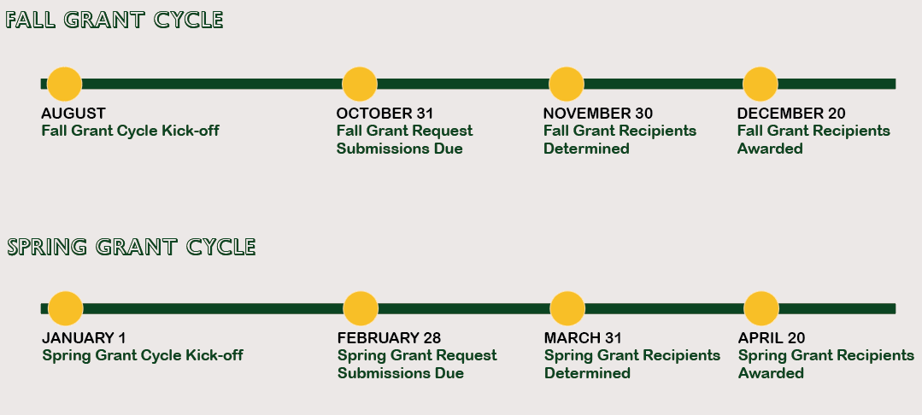

Application Completion Date:

Grant Cycle Consideration: Fall Spring

Applicant Name:

Main Contact Phone and Email:

School: Grade:

Subject Area:

Project Title:

Explain Project in Detail:

How many students will be involved in this project? Directly or indirectly? Please explain.

In what ways is this project creative and innovative?

Will this project supplement an existing program or introduce new ideas?

Does this project support teamwork and school goals?

How do you plan to evaluate this project and share the results with other staff?

Will parents or community resources be utilized for this project?

Budget Information

Please complete all of the information with sufficient detail:
Item Description | Quantity | Per Unit Cost | Total Cost

Please attach a copy of a brochure, catalog page, or website page printout for each item you would like to purchase.

Will funds in addition to this grant be used in the project? If so, please describe

Source(s) of additional funding: | Amount

Total Cost of Project: $

Total Amount Requested from Mokena School District 159 Educational Foundation: $

I have reviewed this project application with my principal (required signature of principal & super).

Signature of Principal Date

Signature of Superintendent____ Date

I certify that if approved, the funds I am requesting will be used only for the purpose indicated in this application. I understand that all awarded grants become the property of Mokena School District 159. I also understand that receipts for all purchases must be submitted by the grantee(s) or the school district to the Foundation’s treasurer.

Signature of All Applicants:

Date

Date

Date

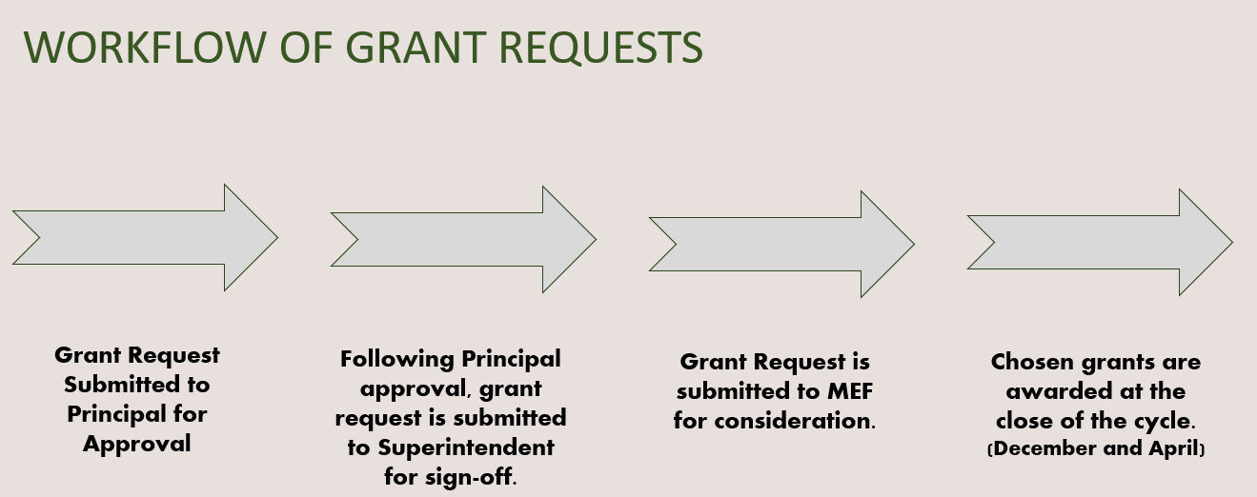

(Please send completed application to: mokenaedfoundation@yahoo.com)

==================================================================================
For Foundation Use Only

Application Approved Application Denied

Foundation Board Signature Date

