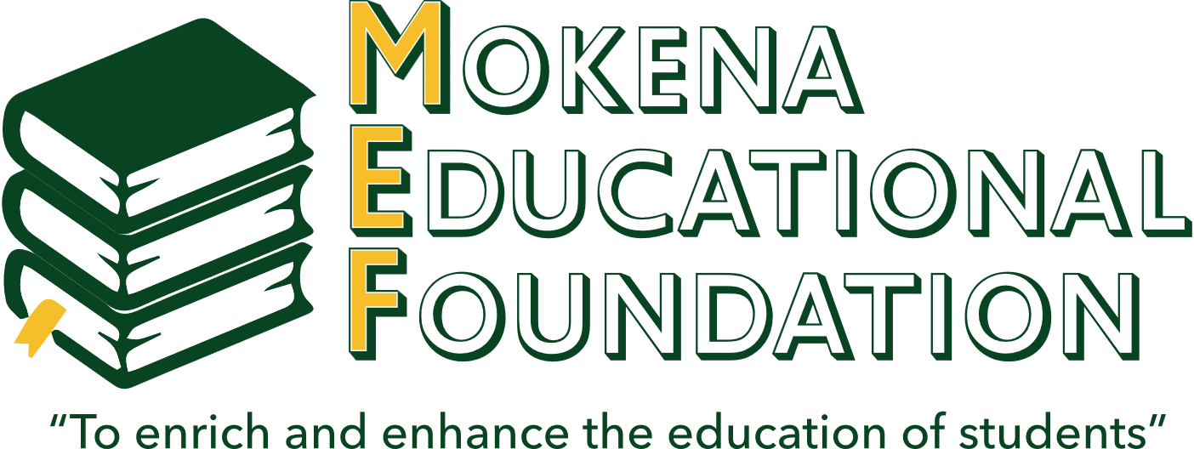

**MOKENA EDUCATIONAL FOUNDATION**

**2025 Springfield, Illinois Scholarship Application**

The Mokena Educational Foundation is pleased to award five (5) $75

scholarships for the 7th grade Springfield, Illinois field trip.

Name: _______________________________________________________________________

Address: _____________________________________________________________________

Number of siblings: ______________________ Siblings’ ages: ________________________

List your interests, hobbies and other activities you participate in (both in and out of school):

____________________________________________________________________________

____________________________________________________________________________

____________________________________________________________________________

To be considered for this scholarship, please submit the following:

* Completed application
* Two (2) letters of recommendation (one from a current teacher)
* Essay explaining why you are participating in this trip and why it is important for you to attend

This award is not based on financial need or grades. However, applicants may choose to mention need, scholastic achievement and/or other important information in their essay.

**All completed applications (including letters of recommendation)**

**must be returned to the MJHS office by**

**Friday, February 28, 2025**