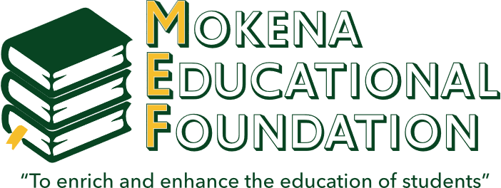
MOKENA EDUCATIONAL FOUNDATION
Springfield, Illinois Scholarship Application
The Mokena Educational Foundation is pleased to award five (5) $75
scholarships for the 7th grade Springfield, Illinois field trip.

Name: ________________________________________ Date: _____________________________________
Address: __________________________________________________________________________________
Number of siblings: _____________________________ Siblings’ ages: ______________________________
List your interests, hobbies and other activities you participate in (both in and out of school):
____________________________________________________________________________
____________________________________________________________________________
____________________________________________________________________________
To be considered for this scholarship, please submit the following:
- Completed application
- Two (2) letters of recommendation (one from a current teacher)
- Essay explaining why you are participating in this trip and why it is important for you to attend

This award is not based on financial need or grades. However, applicants may choose to mention need, scholastic achievement and/or other important information in their essay.

All completed applications (including letters of recommendation)
must be returned to the MJHS office

