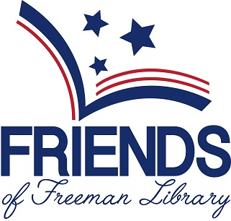
FRIENDS OF THE FREEMAN
Be a Friend!
Friends of the Freeman, a volunteer organization, supports all aspects of the Clear Lake City-County Freeman Branch Library. The library is one of 30 branches of the Harris County Public Library System.
Shop the Bookstore!
Located immediately inside and to the right of the main entrance to the library, our bookstore offers a great selection of books, CD’s, DVD’s and vinyl records. Friendly and knowledgeable volunteers restock shelves and 2 freestanding carts with great bargains daily.
No time to browse? Shop online at amazon.com/shops/freemanfriends
Donate!
We welcome gently used books, audiobooks, DVD’s, CD’s, LP’s and VHS tapes. Donations are accepted at the bookstore during regular hours. Please contact us if you need assistance with a large or special donation. (281) 488-1906
The Friends are a 501(c)(3) organization so membership fees and all donations are tax deductible.
Membership is open to everyone!

FriendsofFreeman.org
JOIN THE FRIENDS
All information is confidential and will not be shared or sold.
Join online at FriendsofFreeman.org or at
Freeman Library
16616 Diana Lane, Houston, TX 77062

Level Bonus
$500 …….Champion A Premium Book
$250 …….Guardian Commemorative Poster
$100 …….Benefactor Innovation Lab Gift
$50 ………Patron Book Bag
$25 ………Family Friends Window Decal
$15 ………Single Friends Magnet
$10 ………Teacher/Student Friends Magnet
Each level receives bonus gifts of all levels below it. For more information about bonus gifts and levels, visit our website.
NAME _____________________________________________________
ADDRESS _________________________________________________
____________________________________________________________
CITY and ZIP _______________________________________________
PHONE _____________________________________________________
EMAIL ______________________________________________________
New membership Renewal
I’m interested in volunteering I have books to donate

