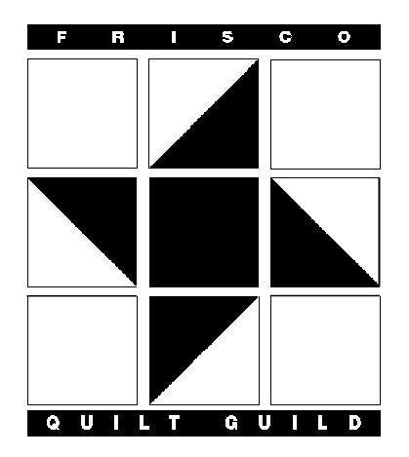
The Frisco Quilt Guild
Membership Form 2022-2023

Please print clearly

Date Completed:

Name:

Mailing address:

City: | State: |  | Zip:
Home Phone: | Cell: |  | Work:
E-mail: |  |  | Birthday: (month & day)
Are you related to anyone else in the FQG (mother, daughter, sister, etc.). If so, who:

Favorite Color(s):

Quilting Interest(s):

Guild Opportunities:  □ I would like to help with a guild committee.  □ I would like information about a small group.  □ I would like to help with guild projects. |  | Newsletter:  Newsletters are sent to your e-mail address and are visible on Facebook. Members are welcome to join our closed Facebook group!
Dues
□ New Membership
Full year (June through May) $25.00
Half year (January through May) $20.00
□ Renewal Membership $25.00
Regular (June through May*) *Must be received by August 1st
□ Check here if any of above information has changed from the previous year, including e-mail.
Amount Enclosed: Check #:

Make checks payable to: The Frisco Quilt Guild

Mail completed form and check to: Susan Mareburger
7118 Highland Heather Ln
Dallas, TX 75248

