May 2019 – Dancing Umbrellas

I have had this pattern for years, and finally decided it needed to be made! Whatever happened to the old adage “April flowers bring May flowers”, our weather lately sure has gotten it wrong lately. Your kit this month includes the ‘yellow’ for the umbrella accent, the grey for the handle, *and* the templates for the applique, *and* a piece of fusible web. *You will be providing a colorful umbrella and a white (or white-on-white) for the background.* This block will be trimmed out at 9.5”, for a 9” finished block. The suggested layout I’ve provided finishes out at 57” x 67”.

**From the yellow (provided in the kit):**

Copy the template (in reverse) on the paper side of the fusible web. Trim to within ¼” of the outline. Fuse to the wrong side of the yellow provided. Cut out on the line.

**From the grey (provided in the kit):**

Copy the template (in reverse) on the paper side of the fusible web. Trim to within ¼” of the outline. Fuse to the wrong side of the grey provided. Cut out on the line.

**From your umbrella fabric:**

Copy the template (in reverse) on the paper side of the fusible web. Trim to within ¼” of the outline. Fuse to the wrong side of your umbrella fabric. Cut out on the line.

**From white fabric, cut:**

1 – 10 ½” square

***Making the block:***

1. Optionally, lightly press a line diagonally from corner to corner on the back

of the 10 ½ white square.

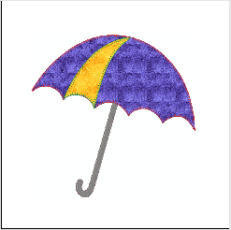

1. Centering your umbrella, fuse the umbrella parts on to the white background,

starting with the handle, then the main umbrella fabric, and finally the yellow

accent piece. Applique in place with the method of your choice. Trim your

block down to 9 ½”

*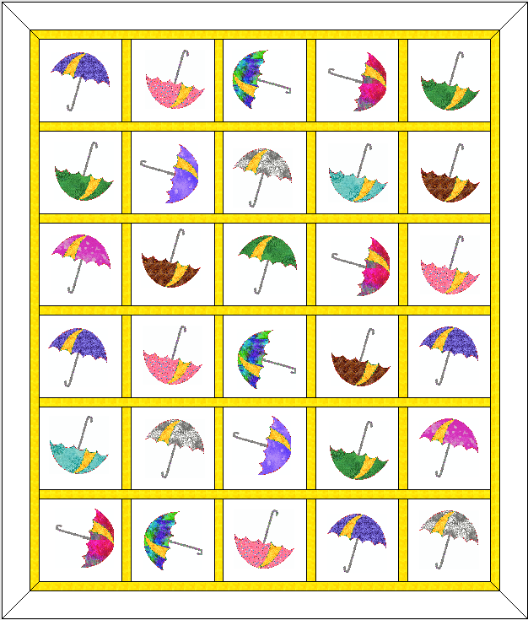****Assembling the quilt:***

1. Make the rows as shown here, and press each row in the direction of the arrows shown
2. Stitch 6 rows of 5 blocks each together, rotating umbrellas randomly. Add borders and sashing. The sample has 1 ½” sashing and inner border, followed by a 3.5” outer border.