Rail Fence and Solid #2
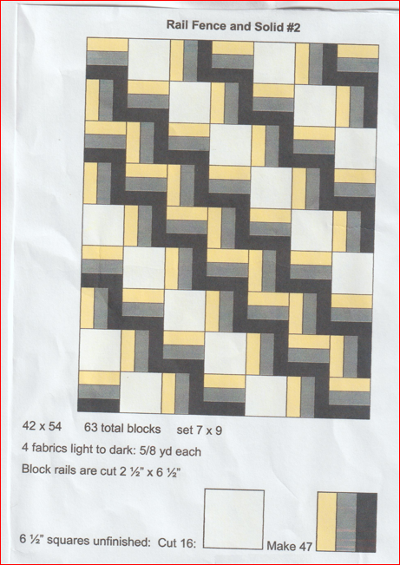
42 x 54 63 total blocks Set 7 blocks across & 9 blocks down
4 fabrics light to dark: 5/8 yard each
Block rails are cut 2 ½” x 6 ½”

