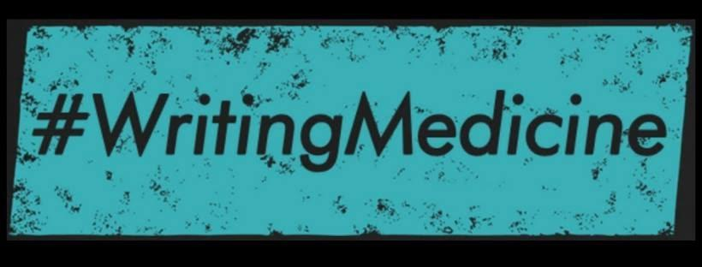

The Writing Midwife: #Brujarituals and
Writing from the Womb
by Alicia Anabel Santos
Panelist, AWP19 Conference, Portland, OR
Friday, March 29, 2019

My journey and process:
- I “CAME OUT!” as a writer on October 3, 2001, after 9/11.
  - When I knew, what I knew, and where I was headed!
- Woman who speaks with the angels and the letter series:
  - How writing my memoir Finding Your Force A Journey to Love, almost killed me and the voices that shelter you.
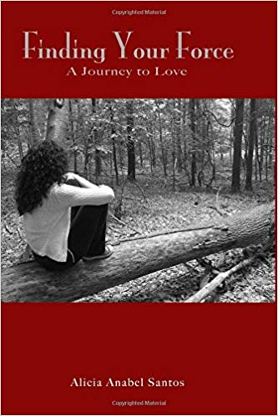

Truth & Integrity:
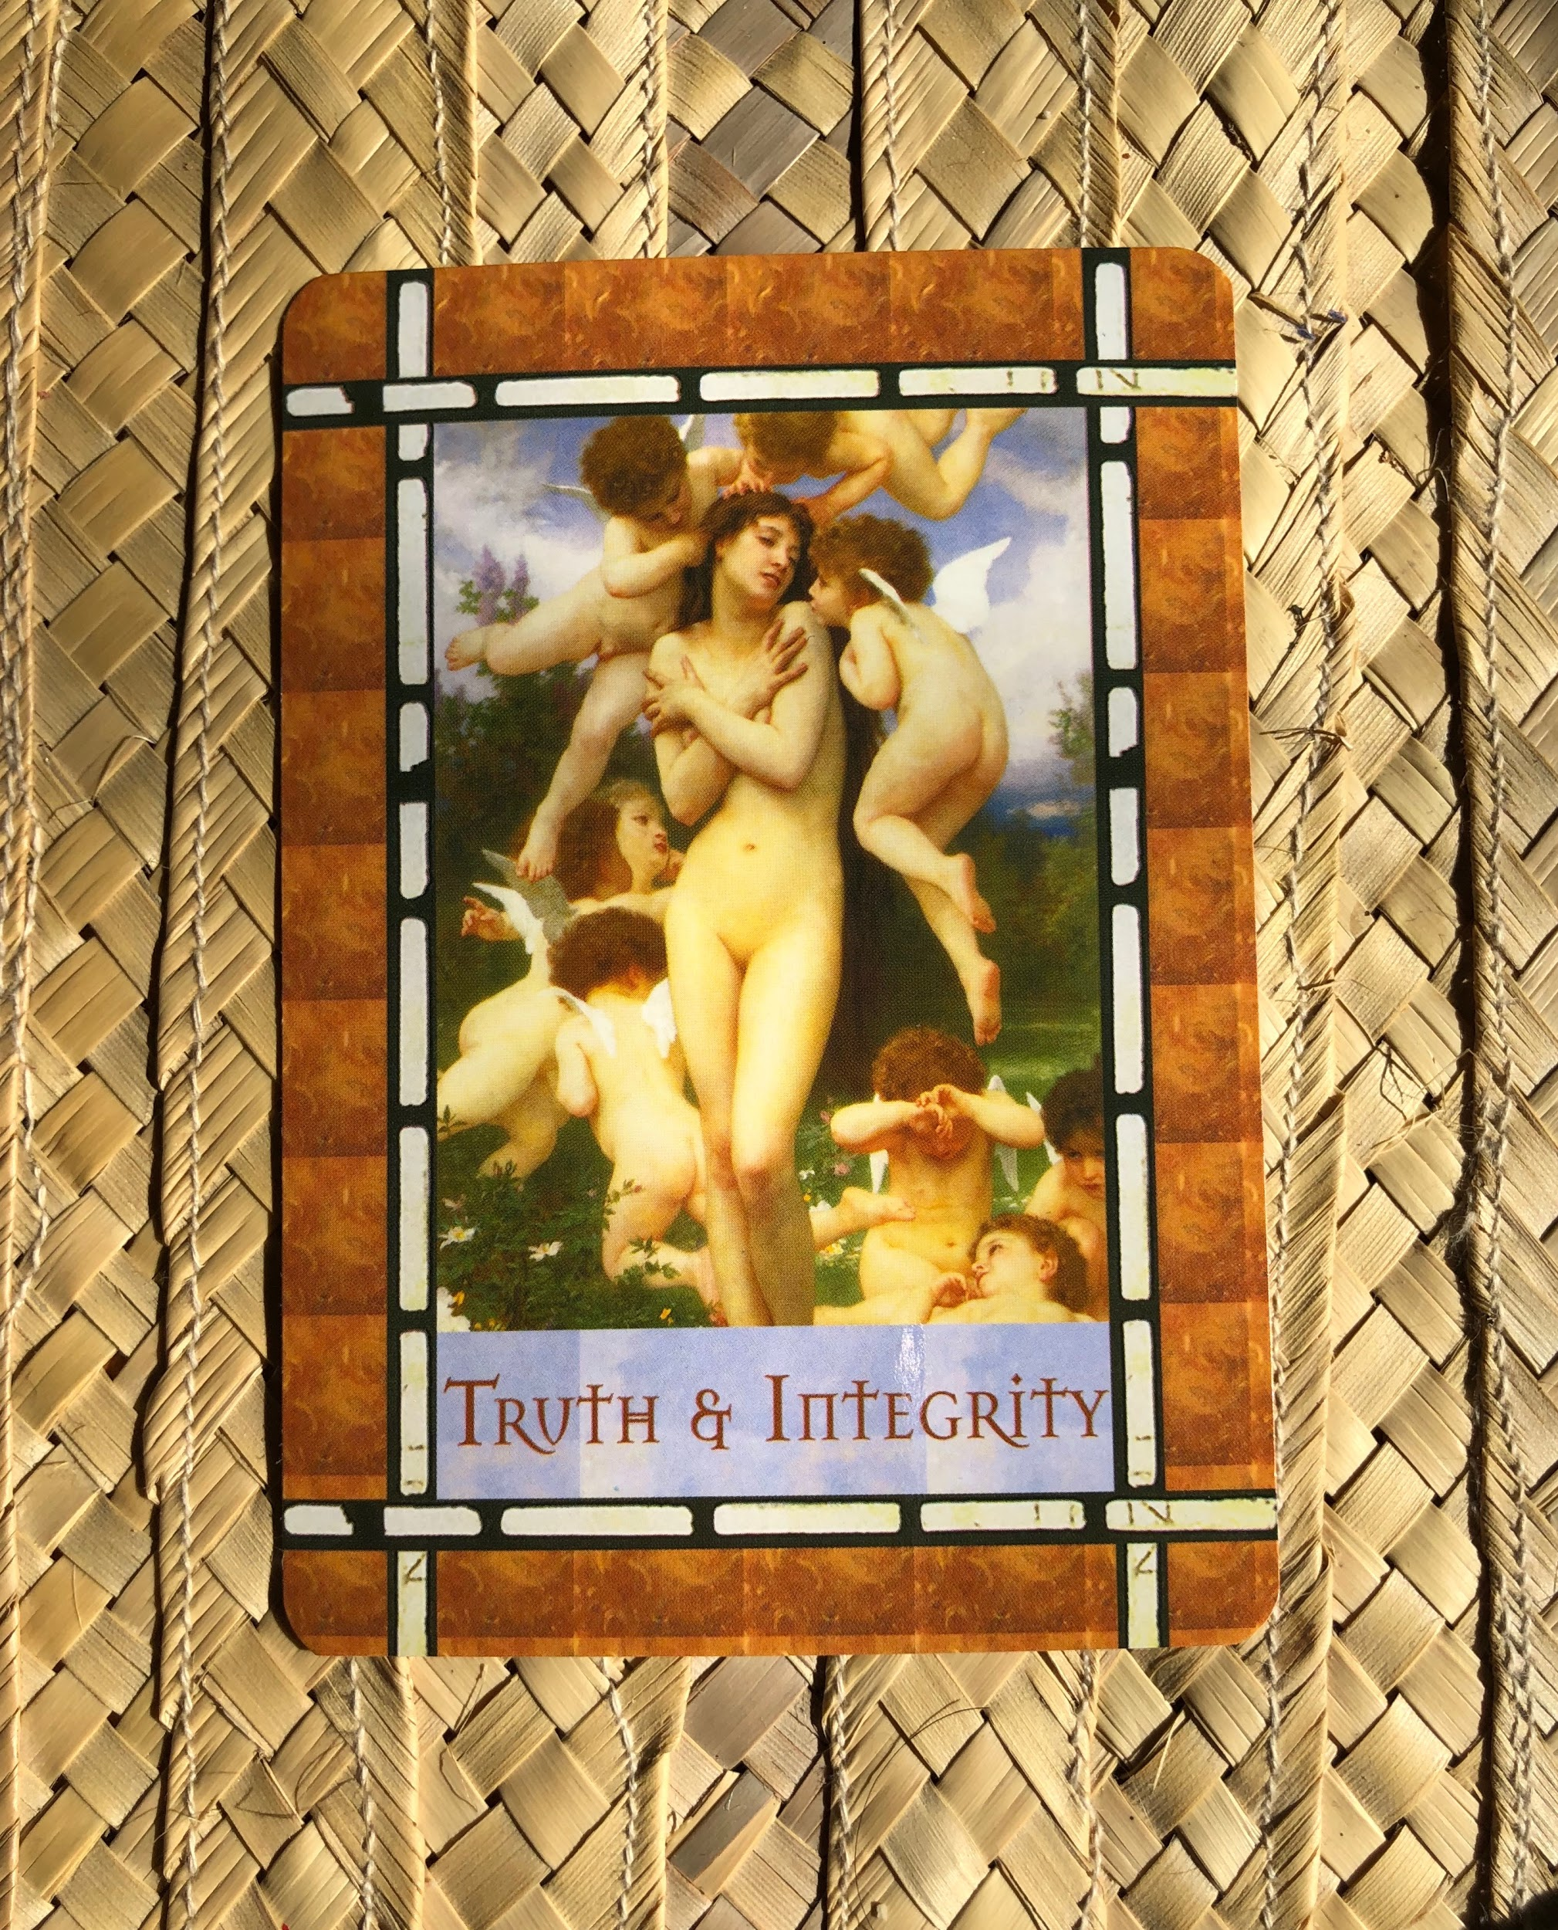

Healing with Angels Oracle Cards by Doreen Virtue

When a Hawk visits you--you stop! https://aliciaanabelsantos.wordpress.com/2012/12/10/when-a-hawk-visits-you-stop/

- Writing as spiritual practice, self care, true north and answering the call.
- Writing as #brujaritual & practice: meditations, tarot readings, sacred crystals and becoming a priestess.
- The birth of Writing from the Womb, becoming the Writing Midwife.

Meditation 10: The top of the mountain~
Posted on November 10, 2011 by Alicia Anabel

You’re standing at the top of a mountain…

What do you see?

Close your eyes and imagine that for a moment.

I’m standing at the top of the mountain.

What do I see?

I am climbing the mountain and I can see the top of it. I’m not quite there yet but it feels so close. I take a step… I slip. I cut my leg wide open. It stings. I consider for moment going back down for help. But I see how high I’ve already climbed. I’ve been scraped and cut open so many times climbing this damn mountain. But as I look down at how steep this mountain is and all that I have done and gone through to get this far I say myself, “Are you stupid? Hell no you’re not going back down! You have climbed so high… it’s a long drop to the bottom! You already know what’s at the bottom. Going back down would be me giving up. It would be me quitting before you have even arrived.”

I am almost there…

So as my leg is burning from this last cut. I keep going. I keep moving. I keep climbing. My hand touches the top of the mountain and I pull myself to the top with all my might and I just stand there for a moment taking it all in.

THIS moment is unlike any moment I’ve ever experienced and the view from the top is amazing.

It has taken me forty eight years to get here and what I realize is that there is more mountain to climb~ take my hand!

I AFFIRM:
I will not fear failure~
I will walk, climb and move my ass all the way up that mountain – one step at a time~ it does not matter how long it takes I will reach the top!
I have gotten this far and have much further to go but I am up for the challenge~
I will not give up~
I know you got me~
For that knowing I am so grateful~
And so it is~ Aché

On writing prompts, freewrites, writing challenges and setting intentions:
- Writing with Integrity: Writing from a place that is truthful--where you feel everything, where you allow the pain to rise, where the writing is not always pretty, where the writing is not always perfect and sometimes it is just crap. There is a truth that only comes when you SURRENDER to the process--this to me is writing with integrity.
- Podcast link: https://soundcloud.com/alicia-anabel-santos/keeping-the-integrity-of-the-story-ep-350
Writing prompts:
The truth is my character… (replace with: my story, this essay) what is the truth that wants to be written? What scares you to write?
I am writing this story for…
In the end what I/you/we will discover is…
My intention for today...
Set a timer 3-5 minutes each. Meditate on what the truth is of what you are writing. Ask yourself: What is at the heart of this?
Closing.
May we all be writers who tell the truth from a real, honest and authentic place.
Thank you! Aché

Stay connected!
Alicia Anabel Santos - info.aliciaanabel@gmail.com
My writing: www.aliciaanabelsantos.com
La Santera: www.lasantera.nyc
Twitter: @diosadominicana
Tumblr: @diosadominicana
Instagram: @_lasantera
Podcast: LA SANTERA available on iTunes, iHeart, Soundcloud, and Spotify.

Services:
1-on-1 Writing sessions, coaching with the Writing Midwife
Writing from the Womb Workshop
Write the FCKING Story Workshop
For more info: http://www.aliciaanabelsantos.com/my-services/

Books & Publications
Finding Your Force a Journey to Love, memoir
Sinister Wisdom 97: Out Latina Lesbians, anthology
The Best of PANIC! anthology

Writing orgs/conferences/residencies
NYC Latina Writer’s Group: https://www.facebook.com/groups/Nyclwg/
Sankofa Sisterhood Writer’s Retreat: https://bit.ly/2HQgqsr
Cave Canem: https://cavecanempoets.org/
VONA: Voices of Our Nation Arts Foundation https://vonacommunity.org/
Tengo Sed: https://bit.ly/2U0NFAI
Dominican Writer’s Conference: https://www.dwconference.com/

Oracle/Tarot Cards
Healing with the Angels Oracle Cards, Doreen Virtue
Until Today, Iyanla Vanzant

Book recommendations
The Alchemist by Paulo Coelho
In the Meantime, by Iyanla Vanzant
Still Writing: The Perils and Pleasures of a Creative Life by Dani Shapiro
Bird by Bird, Some Instructions on Writing and Life by Anne Lamott
On Writing: A Memoir of the Craft by Stephen King
The Writing Life by Annie Dillard

