### **E-WASTE SOLUTIONS**

10 February 2025|AZZOOLOTM54

Here is the **E-Waste Solutions Image** showcasing a futuristic recycling facility that integrates AI-driven sorting, blockchain-based tracking, and cybernetic intelligence for secure and sustainable e-waste management. Let me know if you’d like any modifications or additional details!

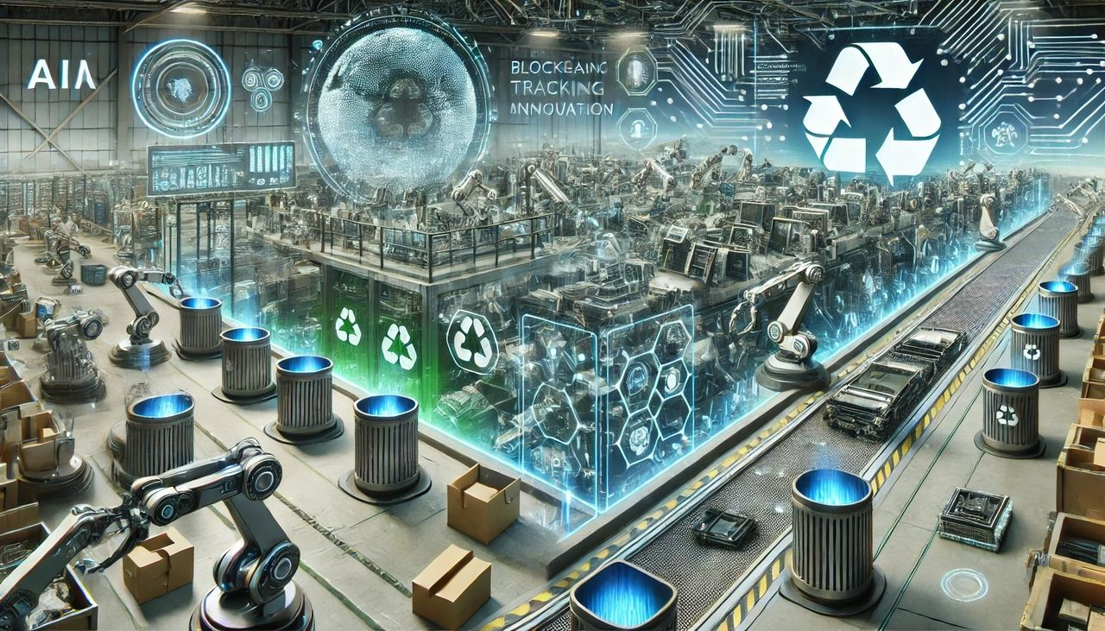

I'll design a **comprehensive questionnaire** tailored to different stakeholder groups: **Government, Corporations, Consumers, and Tech Innovators.** This will help assess the best strategies for e-waste management while addressing investment concerns, security risks, and technological sustainability.

### **Questionnaire for E-Waste Management Optimization**

#### **Section 1: Government Policies & Investment Strategy**

1. Should governments provide **tax incentives** to businesses investing in e-waste recycling?  
   * [ ] Yes, for both local and international companies
   * [ ] Only for local businesses
   * [ ] No, businesses should self-fund their recycling efforts

2. How should government policies **regulate overseas investment** in e-waste recycling?

* [ ] Strict regulations to prevent foreign monopolies
* [ ] Encourage global collaboration with data security laws
* [ ] No restrictions; open market competition is beneficial

3. What type of **investment model** do you support for e-waste management?

* [ ] Public-private partnerships (PPP)
* [ ] Fully government-funded recycling plants
* [ ] Decentralized business-driven initiatives

4. Should companies be legally **responsible for the full lifecycle** of their products?

* [ ] Yes, they must offer recycling programs
* [ ] Only for hazardous electronic components
* [ ] No, consumers and governments should manage e-waste

#### **Section 2: Corporate Responsibility & Secure Recycling**

1. What is the biggest **corporate challenge** in handling e-waste?  
   * [ ] High costs of recycling
   * [ ] Security risks in refurbished devices
   * [ ] Lack of consumer participation in recycling programs
   * [ ] Technological limitations in e-waste processing

2. How can corporations ensure **data security in recycled electronics?**

* [ ] Implement AI-driven data wiping systems
* [ ] Mandate government certification for recycled devices
* [ ] Ban resale of recycled electronics
* [ ] Consumers should handle their own data deletion

3. Should companies be required to **publicly disclose** their e-waste recycling practices?

* [ ] Yes, full transparency is necessary
* [ ] Only for large tech manufacturers
* [ ] No, as long as they meet environmental regulations

4. How should businesses handle **counterfeit electronic parts** in a decentralized e-waste system?

* [ ] Blockchain-based tracking for authenticity
* [ ] Stricter import/export regulations on refurbished tech
* [ ] Ban the resale of all recycled components
* [ ] Leave it to market demand

3. Should companies be required to **publicly disclose** their e-waste recycling practices?

* [ ] Yes, full transparency is necessary
* [ ] Only for large tech manufacturers
* [ ] No, as long as they meet environmental regulations

4. How should businesses handle **counterfeit electronic parts** in a decentralized e-waste system?

* [ ] Blockchain-based tracking for authenticity
* [ ] Stricter import/export regulations on refurbished tech
* [ ] Ban the resale of all recycled components
* [ ] Leave it to market demand

#### **Section 3: Consumer Awareness & Incentive Programs**

1. Would you be more likely to recycle electronics if **financial incentives** were offered?  
   * [ ] Yes, cashback or discounts should be provided
   * [ ] No, I would recycle regardless
   * [ ] It depends on the recycling process convenience

2. What concerns prevent you from recycling old electronics?

* [ ] Data security risks
* [ ] Inconvenience in recycling processes
* [ ] Lack of financial incentives
* [ ] I don’t know where to recycle

3. Would you support a **subscription-based recycling program** where consumers pay a small fee for lifetime electronic disposal services?

* [ ] Yes, if it guarantees proper e-waste handling
* [ ] No, manufacturers should handle disposal
* [ ] Maybe, if it includes repair services

#### **Section 4: Tech Innovators & Sustainable Solutions**

1. Which **technological advancements** should be prioritized in e-waste management?

* [ ] AI-driven e-waste sorting systems
* [ ] Smart incentive platforms using blockchain
* [ ] Sustainable material innovation for electronics
* [ ] Cyber-secure refurbishment processes

2. Would you invest in a **Starius Cybernetic Grid** for decentralized e-waste processing with AI-driven verification?

* [ ] Yes, AI should oversee recycling processes
* [ ] Maybe, but it needs more regulations
* [ ] No, AI-based systems are too risky

3. Should we develop a **global digital passport system** for tracking every electronic device from production to disposal?

* [ ] Yes, blockchain or quantum security should be used
* [ ] No, too much regulation will hinder business growth
* [ ] Only for high-risk technology (phones, computers, etc.)

4. Should manufacturers be required to use **modular components** for easier repair and recycling?

* [ ] Yes, all devices should be modular
* [ ] No, innovation would be slowed down
* [ ] Only for essential electronics (smartphones, laptops, etc.)

### **Conclusion & Next Steps**

This **questionnaire** helps identify the best balance between **government policies, corporate responsibility, consumer incentives, and technological innovation**. Based on responses, stakeholders can:

* Implement **secure and decentralized recycling** with AI and blockchain tracking.
* Enforce **legislative responsibility** for companies to handle product lifecycles.
* Develop **financial incentive programs** for consumers to participate.
* Establish **cybernetic intelligence grids** to **ensure secure e-waste management**.

Would you like this questionnaire formatted into an interactive survey or a structured data collection framework for industry use?