Little Menagerie - Small Pet Boarding

**Terms and Conditions**

**Check in/out**

Arranged appointments are required within our opening hours to check in/check out our guests. Please arrive on time to your appointment. Should you be running late for any reason, please contact to let us know with as much warning as you can. We will have other appointments booked for other guests so please try to make your arranged appointment time.

**Payment**

Booking fee is due the day your pet arrives to board with us, this can either be paid by cash or bank transfer.

**Cancellation/Amendment**

Plenty notice would be appreciated when it comes to cancelling your booking with us. If for any reason you are delayed on check out day and need extra nights added to your booking, we will do what we can to accommodate your pet until necessary. Our rates apply for any extra nights boarding with us which will be payable on collection. You will still be required to pay the full booking fee if you are to collect your pet early. Unused days will not be refunded.

**Vaccination**

Only **rabbits** are required to be vaccinated when boarding with us.

Proof of your rabbits vaccinations against Myxomatosis and Viral Haemorrhagic Disease VHD1 and VHD2 will be required before check in day. Please email a copy of your pets vaccination certificate prior to check in or unfortunately your rabbit will not be able to board with us. Please allow **AT LEAST 21 DAYS** after vaccinations to allow any side effects to pass and immunity to build. These vaccines are required to keep your pet and our other guests safe.

**Health**

Animals boarding with us must arrive in good health on day of check in. Any current medical conditions/specific needs when boarding must be specified on your pets booking form you received via email. Should your pet fall seriously unwell during their stay with us, we will do our best to contact you, or the emergency contact you have noted on your pets booking form. We will do our best to take your pet to their own vets but should this not be possible we will use our own vet. Any costs incurred during your pets vet visit (whether this be your own vet or our local vet) e.g. veterinary consultation, medications, treatments, out of hours charges etc must be paid by the owner. All pets are cared for in a secure and safe environment therefore all pets are left at the owners risk. We accept no liability should you or your pet be injured on our premises.

Little Menagerie does not accept any liability in the unlikely event should your pet be attacked by another boarder/predator, become unwell, passes away in our care or contract illnesses such as myxomatosis, rabbit haemorrhage disease, e.cuniculi, mites, flystrike or any other diseases.

**Continued…**

**Fighting**

Should your bonded pets that are sharing accommodation begin to fight, you will be contacted immediately. Should your pets need to be separated until your return, our rates apply for use of additional accommodation. Extra payment will need to be made on the day you collect your pets from us.

**Abandoned Pets**

If you fail to collect your pet on check out day and we are unable to get in contact with you within 5 days, we will arrange to rehome your pet unless appropriate communication has been received. Extra days will be charged and payment due on rearranged collection day.

**Please note that by boarding your pet with Little Menagerie you are agreeing to our terms and conditions.**

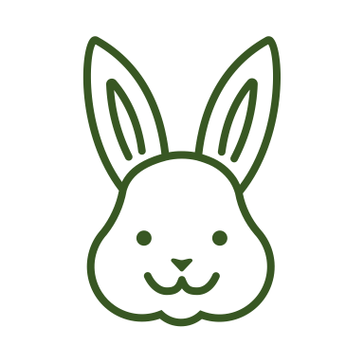**Thank you!**