THE TIMBERS
AUTHORIZATION AGREEMENT FOR AUTOMATIC WITHDRAWAL
I hereby authorize the Timbers to initiate debit and, if necessary, credit entries to my account indicated below for my Timbers water bill. I understand that the amount deducted will be my balance due indicated on the current bill. The withdrawal will take place on the 1st of each month or the next business day if the 1st falls on a holiday or weekend. I acknowledge that this authorization is to remain in effect until the Timbers has received written or verbal notification of its termination.
THERE WILL BE A SERVICE CHARGE IF FUNDS ARE NOT AVAILABLE
PLEASE PRINT CLEARLY
Name: _________________________________________________________________

Account # (TWSxxx): _________________________________________________________________

Address: _________________________________________________________________

Phone Number: _________________________________________________________________

Attach a voided check to form
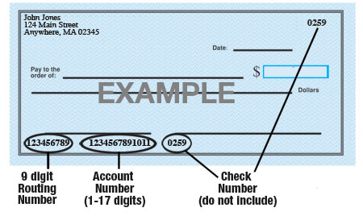

Name of Bank: _________________________________________________________________

9-Digit Routing #: _________________________________________________________________

Account #: _________________________________________________________________

Type of Account: Checking Savings (check one)

Attach a voided check to form

Date __________________________________________________________________

Signature ______________________________________________________________

Please email completed form to:
Clearwater Consulting
PO Box 761
Black Hawk, SD, 57718

