VIEWFIELD RURAL WATER ASSOCIATION
AUTHORIZATION AGREEMENT FOR AUTOMATIC WITHDRAWAL
I hereby authorize Viewfield Rural Water Association to initiate debit and, if necessary, credit entries to my account indicated below for my Viewfield Rural Water Association bill. I understand that the amount deducted will be my balance due indicated on the current bill. The withdrawal will take place on the 1st of each month or the next business day if the 1st falls on a holiday or weekend. I acknowledge that this authorization is to remain in effect until Viewfield Rural Water Association has received written or verbal notification of its termination.
THERE WILL BE A SERVICE CHARGE IF FUNDS ARE NOT AVAILABLE
PLEASE PRINT CLEARLY
Name: _________________________________________________________________

Viewfield Account #: _________________________________________________________________

Address: _________________________________________________________________

Phone Number: _________________________________________________________________

Attach a voided check to form
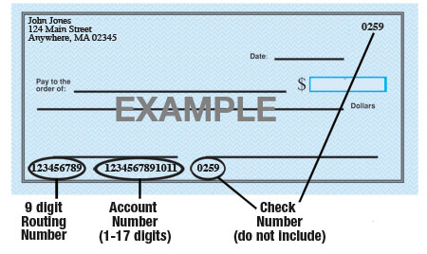

Name of Bank: _________________________________________________________________

9-Digit Routing #: _________________________________________________________________

Account #: _________________________________________________________________

Type of Account: Checking Savings (check one)

Type of Account: Personal Commercial (check one)

Attach a voided check to form
Date __________________________________________________________________

Signature ______________________________________________________________

Please mail completed form to:
Viewfield Rural Water Association
PO Box 568
Black Hawk, SD, 57718

