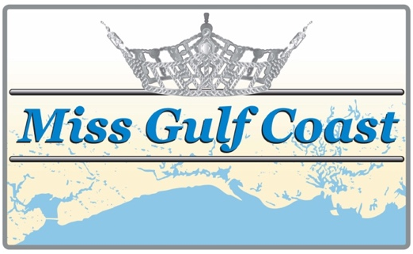
Miss Gulf Coast Pageant 2020

Candidate Application
Sponsored by: The Biloxi Lions Club
(Type or Print Clearly)

(Use additional blank sheet if necessary)

Last Name: First: Middle:__________________

Address: City: Zip Code:_______________

Contestant Birthdate: Age: Contestant Phone #:__________________

E-Mail: _______________________________________________________________________________________

Parent’s Names: Parents Phone #:_____________________

Honors held in Community and School: ________________________________________________________

______________________________________________________________________________________________

Hobbies/Interests: ____________________________________________________________________________

______________________________________________________________________________________________

High School Year Graduated: _____________________

Name of College or University Year: _________________________________

College Major: __________________________________________ Student ID: __________________________

School Presently Attending Grade: ______________________________

Career Ambition: _____________________________________________________________________________

Type of Talent: (vocal, dance, piano, etc.) ______________________________________________________

Title of talent selection: _______________________________________________________________________

Platform (If already selected): _________________________________________________________________

Sponsor: Contact Person:___________________________________

Address: City: Phone #: __________________________

DATE OF PAGEANT Saturday, February 1, 2020 GET ACQUAINTED PARTY
Saturday, TBA Sunday, TBA
Beau Rivage – Biloxi, MS

EMAIL APPLICATION AND ONE B&W OR COLOR PHOTO TO:
jayebrice@cableone.net

Entry fee is $75.00 and can be mailed to Jaye Brice, 1070 Judge Sekul Avenue
Biloxi, MS 39530. Payable to Biloxi Lions Club
For further information or questions call 228-374-8175

