62nd Miss Gulf Coast Teen 2020
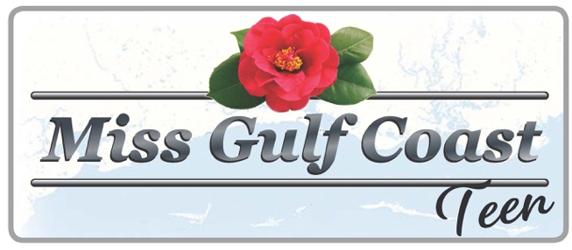
(formerly Camellia Queen Pageant)

Candidate Application
Sponsored by: The Biloxi Lions Club
(Type or Print Clearly)

(Use additional blank sheet if necessary)

Last Name: First: Middle:__________________

Address: City: Zip Code:_______________

Contestant Birthdate: Age: Contestant Phone #:__________________

E-Mail: _______________________________________________________________________________________

Parent’s Names: Parents Phone #:_____________________

Contestant Social Security # : _________________________________________________________________

Honors held in Community and School: ________________________________________________________

______________________________________________________________________________________________

______________________________________________________________________________________________

Hobbies / Interests: __________________________________ ______________________________________

______________________________________________________________________________________________

School Presently Attending Grade: ______________________________

Plans after High School: ______________________________________________________________________

______________________________________________________________________________________________

Sponsor: Contact Person:___________________________________

Address: City: Phone #: __________________________

DATE OF PAGEANT Saturday, TBA GET ACQUAINTED PARTY
Saturday, TBA Sunday, TBA
Beau Rivage – Biloxi, MS

EMAIL APPLICATION AND ONE B&W OR COLOR PHOTO TO:
jayebrice@cableone.net

Entry fee is $75.00 and can be mailed to Jaye Brice, 1070 Judge Sekul Avenue
Biloxi, MS 39530. Payable to Biloxi Lions Club
For further information or questions call 228-374-8175

Note: If you are interested in selling ads or have your own ad for our program,
please visit the club website at www.biloxilions.org for the forms

