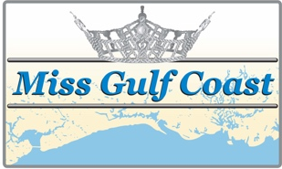
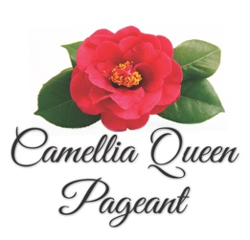
Sixty-Second Annual

Mississippi Camellia Queen Pageant
And
Miss Gulf Coast Pageant

Advertising space is now available in the 2020 Camellia Queen Pageant and Miss Gulf Coast Program Book!
Please support providing scholarships to these incredible young women and the sight and hearing projects of the Biloxi Lions club by placing an order.

You may submit artwork, a business card or text you wish printed. If you have specific needs, please call Melinda Claytor Freeman at (228) 365-7878.
Please Email your order to Melinda.freeman@bxs.com
Deadline is Thursday, January 2nd, 2020

Advertiser:______________________________________________________________

Address: ______________________________________________________________

City: _____________________________________ State: ___________ Zip: ___________________

Phone: ___________________________ E-Mail: _________________________________________

Contact Person: ___________________________________________________________________

Please check appropriate size:
Full Page ( 8 ½ x 5 ½) ______________ $100.00
¾ Page ( 6 5 ½ ) ______________ $ 80.00
½ Page. ( 4 ½ x 5 ½ ) ______________ $ 60.00
¼ Page. ( 2 ¼ x 5 ½ ) ______________ $. 40.00

Please bill me: (sign here) _________________________________________________________

Payment is enclosed: The Biloxi Lions Club
P.O. Box 196
Biloxi, MS 39533

Sold by: ______________________________________________________________________

